Tenacce and Salito sat in the room that Frank DeAngelo had called the recreation room except that there was little recreation to be had: no television, no pool table; just a couch, a few chairs—only one of which was comfortable—the card table and that well-worn deck of cards. Tenacce began dealing but stopped short.

“I’m startin’ ta get a little worried about the kid.”

Salito nodded. “Me, too.”

“I mean, he’s been locked up in that room for three days now.”

“That seems ta be the way he works, though. He did the same thing in France.”

“I’m also startin’ ta get a little antsy ta find out what’s in that book.” Tenacce shifted restlessly in his seat. “And I have ta tell ya, it concerns me more than a little that he won’t tell me what he’s gonna do with it.” As he spoke, he fingered his pistol, which he had continued to keep holstered against his left ribcage despite their seclusion.

“So what are you gonna do? Shoot ‘im?”

Tenacce suddenly realized where his right hand was. “I might,” he said.

A look of panic poured over Salito’s countenance.

“Relax. You know it’s just my nervous habit.”

“But you’re right. If it says what we don’t want it to ….”

“We’re gonna have ta do somethin’.”

Tenacce’s right hand began to move reflexively again but he caught it before it left his side.

“I think we should go check on ‘im,” said Salito.

“The worst he can do is tell us ta go away.”

They leapt up simultaneously. As they approached the door, there was a knock. The door opened and there stood Danny Tenacce, his face white, his eyes glazed as if he had seen a ghost, not from the paucity of food and sleep which he had endured while he was sequestered, but because of what he had learned and what he was about to tell them. He collapsed on the sofa as if at the finish line of a marathon. He sat sprawled, sinking deeply into the soft cushions, arms and legs spread wide and motionless, mouth open but unable to speak. Tenacce and Salito became alarmed and started toward him. His words, however, stopped both of them abruptly.

“You were right.”

“Come again,” said Tenacce, startled.

“You were right. Both of you. And McCleary.”

“About what?” Salito inquired.

“About everything.”

Salito moved forward and positioned herself facing Danny on the couch, grasping his left hand instinctively. “You mean about the book?”

“Yes. The book.”

Tenacce pulled a chair close to the two of them and leaned forward at the end of his seat. “So what did it say?”

“It’s a textbook. Of math and physics, mainly.” His words had suddenly become matter-of-fact..

Perplexed expressions appeared on the faces of Tenacce and Salito. Tenacce was the first to vocalize their confusion. “And how does that make us right?”

“Because he explains everything to her.” Danny’s eyes and his father’s interlocked. “You’d better bring over the leather chair and sit back.”

Tenacce did what was suggested. When his father was settled, Danny Tenacce righted his posture, pulled Salito toward him, and holding her hand tightly, took a deep breath.

“He arrives at the beginning from the end. Simple arithmetic—numbers, addition subtraction, multiplication, division—rigorously proven through number theory. Algebra and geometry, generalized. Calculus and linear algebra. Vectors and tensors. Covariant and contravariant derivatives and Christoffel symbols. Group theory, Lie algebra and topology—the most complex mathematical constructs—at times, drawn out in the sand with sticks; at other times, much to her delight, projected into the air as multicolored holograms; all of it communicated in such a clear, simple manner that a five year-old could understand. Then ‘write it in the way I have taught you,’ he would say. And she would record the information. On the papyrus. With a quill pen. He taught her to make ink. Those were the notes. The final draft came later, when she went to the cave.

“The symbols he uses—for numbers and mathematical operations.” Danny Tenacce waved his hands. “All very different than what we use today. That’s why it took so long. I had to read the text in its entirety to understand the nomenclature.

“With the mathematical foundation laid, he moves on to the physics. But here, the order is more conventional: classical mechanics, electromagnetism and waves; special and general relativity; quantum physics, quantum electrodynamics and quantum chromodynamics; then strings and branes.

“He explains how the physics leads to the chemistry and the chemistry to biology. Then he describes how it all happened.”

Salito regarded him with a mixture of intrigue and apprehension. “You mean how the world was made?”

“Our world and everything else.” His exhaustion had long since passed. Animated by the message and the interest of his audience, he drew in another voluminous breath, as if priming to deliver the entire narrative in a single exhaustive exhalation.

“In the beginning, there was God. And energy. Intense energy. All the energy in the universe in a ball the diameter of a Planck length—1.61619926 × 10-35 meters. 6.3629892 × 10-34 inches. Then he blew it apart, rapidly expanded space and all of the material in it, not just randomly but in a precisely calculated manner such that everything would end up exactly the way that he wanted it to. Fine-tuned the necessary parameters by the manner in which the initial explosion was executed. It was hot in that little ball before it exploded. Extremely hot. But as it expanded and cooled, the result would be the utopian state that was the reason for his creation. At least that was the plan. But for the plan to work, he needed some help.”

“Help,” Tenacce exclaimed. “He’s God. Why would he need help?”

“Maybe help wasn’t the best choice of words,” said Danny. “Let me explain. For every matter particle in nature, there’s an antiparticle, a particle that possesses the same mass but other properties that are precisely the opposite of its partner. The electron, with its electrical charge of -1, is paired with its antiparticle, the positron, a particle with the same mass but with a charge of +1. Quarks have antiquarks. Neutrinos have antineutrinos. Muons, antimuons, and so forth. And for the plan to work, the particles and antiparticles had to be separated. He entrusted this task to his highest archangel, Satan, a being endowed with mind and will and energy like Himself. But as you know, once empowered, Satan sought to annex God’s prize creation for himself. To do this, he interjected a few quanta of energy, in just the right way, near the beginning, in an attempt to steer the clump of energy, that was to become the earth and mankind and its supporting structures, to himself. Of course, God recognized it within a few Planck times but the damage was done.

“It’s just chaos theory. Just as McCleary described it. You start with a system in a given state—call it O. You establish a set of rules that the elements of the system will obey and set the system in motion. At time, t, it will be in state P. Obviously, if you start with a different set of conditions, set it in motion in a different way or alter the system as it evolves, you’ll end up with a state—call it R—that almost certainly differs from P. The earlier you make the alteration, or the longer you wait, the farther from state P your system, R, will wind up. In our world, a subset of that difference equates to things like hurricanes and earthquakes; pain, disease and death; and human behavior detrimental to the plan—in short, evil.

“Once God discovered the plot, he infused quanta of his own, into the system, and continues to infuse them, in an attempt to get things back as close as possible to perfection. But because of what was done to displace God’s original trajectory, state P—that originally intended state of perfection—can never be obtained. At least not completely.

“Fortunately, God possesses an exponentially greater store of energy available to alter the course of chaos than does his foe. Inevitably, Satan’s energy store will become depleted and he will cease to exist. Realizing this, Satan’s sole purpose became, and remains, to disrupt the plan of the Creator in the most sinister ways possible.”

“By throwing in more quanta, I guess. Knock things further off course?” conjectured Salito.

“Correct. But there’s another piece. Satan developed a mechanism to replenish his dwindling store of energy. You see,” he looked at Salito, “as you pointed out previously, the main means by which God redirects the trajectory is through humans. He gives us a soul. The soul interacts with the brain. The brain is part of the body which is part of the physical universe. The body’s just an inanimate machine. It’s the soul that makes it animate, allows us to actually have experiences. The original design was for all the experiences to be good. Euphoric actually. Pleasure in its purest form. We all know that Satan took care of that. But the soul has another role: to influence human behavior in a way that moves the course of chaos back toward its original goal. Of course, altering the physical world requires energy. God endows the soul with the energy to accomplish this task. But once that energy enters the physical world, it’s up for grabs. If it’s used in the way God intended, when the physical life of the person ends, the energy goes back to God. If not—well—you know where it goes. And Satan uses that energy to recharge his stores and further carry out his machinations.”

Salito released her grip on Danny’s hands and faced him squarely. “But he’s God. Why doesn’t he just … fix it. Force things back on track.” She appeared annoyed.

“Well … Because. It’s not that easy. Not easy? It’s impossible, actually. He’s got an adversary. A formidable one. Do you have any idea how many alternate universes he had to pinch off just to get to the point we are today? That’s why it took so long. I mean, it’s akin to a miracle that we’ve gotten this close. And it’s ongoing. Both of them firing in quanta. Jockeying for position. The cosmic battle of good versus evil …” He felt her silence and the touch of her hand on his again. He looked up and saw her smiling.

“I see you’re finally catching on,” she said.

Danny Tenacce grinned in admiration. “Now I see why you’re such a good detective.”

Tenacce leaned back and issued the same sardonic half-grin that appeared on his face when he was about to question a suspect who he knew was guilty. “Is this stuff for real? I mean, you’re makin’ this up, right?”

Danny shook his head.

“You mean scientists have discovered evidence that this stuff is actually happenin’?”

“They have, but they don’t recognize it for what it is. Oh, they’ve described most of the phenomena all right; defined most of the laws such that results of events can be predicted with great precision—at least to the limits of their knowledge. But they have no idea *why* these things are the way they are.

“Quantum physics mainly. According to quantum physics, empty space is not empty. The so-called vacuum is roiling with activity. Particles, also known as quanta, are constantly being created and destroyed. Everywhere. In pairs. To keep the total amount of mass/energy in the universe constant. A particle comes into existence, then an antiparticle pops up, combines with it, and poof, they annihilate each other. An antiparticle gets thrown in, a particle is created almost immediately thereafter. It combines with the antiparticle and then they’re gone. Physicists have puzzled over how something can be made out of nothing, puzzled over it with no answer until they finally threw their hands up and said, ‘That’s just the way it is.’ But you know where the particles and antiparticles are coming from.”

Tenacce and Salito nodded that they did.

“Then there’s superimposition of states. Common sense tells you that you should be able to predict at what location you’ll find a particle at all times. However, quantum mechanics and experiments have suggested that this is not the case. If you measure a particle’s location, you’ll find it all right. It’s just that you can’t predict exactly where you’ll find the particle before you make your measurement. Instead, you can only specify a probability of finding a particle at a given location. And it could conceivably be found anywhere in the universe. Here, let me show you.”

Danny rose from his place beside Salito, pulled a whiteboard toward the sofa so that both Salito and Tenacce could see and scribbled a crude version of the following diagram on the board’s plastic surface:

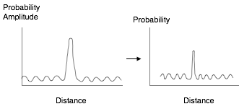

“The graph on the left plots a thing called probability amplitude vertically versus position in space on the horizontal axis. You take the probability amplitude for each point in space and square it (i.e. multiply it together with itself—with its complex conjugate actually; they’re complex numbers, but that’s beyond the scope of this discussion). Then you plot that squared probability amplitude versus position in space. What you get is the graph on the right, a graph of the probability of finding a particle (displayed on the vertical axis) at each position in space (plotted on the horizontal axis). Frequently, the probability is high that you’ll find a particle over a narrow range of locations, as seen in the right-hand graph.”

He drew another diagram on the whiteboard:

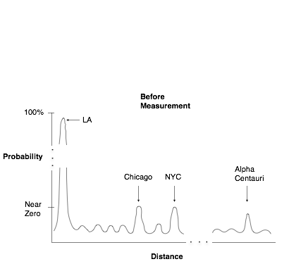

For example, if you’re measuring the location of an electron in a laboratory in Los Angeles, most likely, you’ll find it in that laboratory, within about an angstrom radius. But there’s a tiny chance that you might find it in Chicago or New York or on Alpha Centauri. Then you make a measurement and find the electron on Alpha Centauri. The probability function after the measurement looks like this:

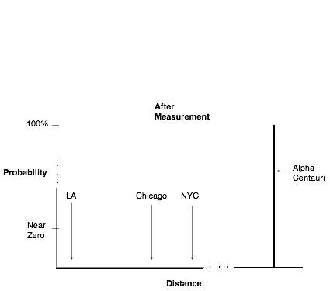

“After the measurement, the particle is found with one hundred percent probability on Alpha Centauri and zero percent probability everywhere else. It’s wave function is a so-called Dirac delta function—a flat line along the x-axis except for a spike at Alpha Centauri with no width, infinite height and an area of one—meaning that all of the probability is concentrated at one point. Before the measurement, the particle seems to be everywhere at once, its position state being a superposition of every position in the universe. The measurement seems to ‘collapse the wave function.’ At least that’s how many physicists describe it.”

“Kinda like the tree falling down in the forest thing,” said Tenacce.

“Exactly like it,” Danny replied. “It’s as if the particle isn’t real (that is, has no definite position—or momentum) unless you measure it. But did the measurement somehow cause the particle to settle into one place? Or are wave functions just mathematical tools to predict the results of experiments? Physicists have puzzled over these questions for decades. The explanation given by the Copenhagen interpretation of quantum physics, the most widely accepted interpretation, is *that’s just the way it is*. But we know why this is so.

“It’s because of 1) the way God put things in motion in the beginning, and 2) the alterations made to that initial trajectory by infusion of quanta into the system by God and Satan since then. Let’s face it, if God and the devil have the power to create and annihilate particles at will, then they can annihilate an electron with a positron in your LA lab and create an electron on Alpha Centauri. It would look just like your electron was everywhere before your measurement but your measurement somehow caused it to appear in Alpha Centauri. And the energy balance of the universe would remain the same before and after the manipulation. An alternative scenario is that the wave function of the entire universe, which has evolved deterministically according to the Schrodinger equation since the beginning of time and includes all the electrons in the universe *and* your measuring apparatus, is such that an electron was destined, from the beginning, to be present in Alpha Centauri and not in your LA lab at the time of your measurement. Again, it would be like the electron suddenly disappeared from your LA lab and reappeared in Alpha Centauri because of measurement.

“A gentleman named Bohm probably came closest to understanding it. He said that, like in classical physics, the universe is made of particles with a definite position at all times. And like in classical physics, each particle also has a definite velocity (that is, speed and direction of motion.) The difference is that, in Bohmian mechanics, the velocity is determined by the wave function. The same wave function that I described for you a few minutes ago. Bohm conceived of a thing called the quantum potential, a potential energy field determined by that wave function. The quantum potential creates a (nonlocal) force on particles that changes their velocities and guides them to where they’re supposed to go. Because the quantum potential is determined by the wave function, and its information content is therefore the same as the wave function, the behavior of particles reproduce the same experimental results as predicted by standard quantum mechanics.”

“Whatda ya mean ‘nonlocal’?” Tenacce inquired.

“I mean the force doesn’t have to ‘come in contact with’ the thing it’s acting on to influence it. For example, suppose you have a particle on earth and a particle on Alpha Centauri. Now picture a cloud of energy hovering over (but outside) the universe that creates a force that changes the velocity of both particles simultaneously. That force would be considered nonlocal. Does that help?”

Tenacce and Salito nodded that it did.

“Now back to the wave function. The wave function is governed by an equation called the Schrodinger equation. In the Schrodinger equation, the state of a system is determined by the preceding state and a thing called the Hamiltonian, which in the Schrodinger’s view, is constant. So the state of a system evolves deterministically in time, from the state that came before. And before that and before that. All the way to the initial state, at the beginning of time. You’d think that, if everything was determined, you ought to be able to predict the results of a given experiment, but you can’t. The reason is that the configuration of particles at the beginning of time was determined by a wave function such that their positions were indeterminate. Since you can’t know the position of particles at the beginning, you can’t determine their positions with certainty at later times either, later times to include times when experiments are done.

“Note that the etiologies of quantum randomness in Bohemian mechanics and the scenario described in the book differ. In Bohemian mechanics, the etiology for that randomness is the unknowable initial random position distribution of particles. On the other hand, in the scenario described in the book, both the initial push by God that set the universe in motion and the initial configuration of particles are definite. What causes randomness in this scenario is the infusion of quanta into the system thereafter—brought about by God, Satan and that little piece of himself God gives to humans—an infusion spurred by free will, and therefore, not predictable.”

“So this Bohm is some kinda Grand Poobah of physics or somethin’?” Tenacce waved his thick paws in the air in nebulous fashion for emphasis.

“Was. And no, he wasn’t. He got run out of the country by McCarthy for being a communist and not many physicists actually believe his theory has much merit.”

Tenacce raised his surprised brows, the hairs at their upper margins curling slightly with animosity at the mention of communism.

“I didn’t think much of his theory either. Until a few hours ago. But then *he* predicted it.”

Tenacce lifted himself upward with a grunt. “Who?”

“The author of the book. He tells her, ‘there will be one who finds the answer but will not know what he has found.’ Although he doesn’t give us a name, I think he may have been speaking of Bohm. I’ve got to admit, Bohmian mechanics explains some things that have no good explanation in the standard, or Copenhagen, interpretation of quantum mechanics and bears an uncanny resemblance to what’s explained in the book.”

“Like what?” Tenacce inquired, flopping back in his chair again.

“Like the measurement problem. I’ve described it before. The wave function of a particle is rolling along, evolving in time, deterministically, then you make a measurement, and boom, the wave function collapses and the particle picks a position to be in. Randomly. But why should the wave function behave in one way most of the time, then suddenly change its behavior when a measurement takes place. After all, the measurement device is just a bunch of particles, too. And the measurement, itself, is just a group of interaction of those particles that the human mind picks out and artificially labels as something special.

“In the Bohmian scheme, like I said, particles have definite locations at all times. The wave function—and I’m talking now about the wave function of the entire universe, which again, has been evolving deterministically from the beginning of time—tells a given particle (by determining its velocity) where to be at the time of measurement. At the same time, it determines the position of the particles that make up the measuring device, thus determining the result of the measurement. Then the wave function goes on its merry way, evolving deterministically, just the way it did before and during the measurement. At least that’s what Bohm would’ve said early in his career.”

“What would he have said later,” Tenacce asked.

“I’ll get to that—later,” said Danny. “Meanwhile, the book would say that the results of measurements are due to the way God put things in motion in the very beginning plus or minus the result of the quantum marble game being played by God and Satan (and humans, by a loan of willful energy from God) ever since.

“I think I like those explanations better,” commented Salito.

“Which explanations?”

“Those of Bohm and the book.”

“I think I do, too,” said Danny. “At least since this afternoon. Or evening. Or morning. What time is it, anyway?” He surveyed his dimly lit surroundings but the windowless walls offered him no diurnal cues.

Tenacce glanced down at his watch to help. “10:05,” he said. “No, that can’t be right.”

He glanced down again and noticed that the second hand was motionless. He shook his wrist, examined the watch, and frowned. “The damn thing’s stopped.” Then he shrugged and looked up at Danny, suddenly untroubled again. “Oh, well,” he said. “So is that it?”

“Not by a long shot,” replied Danny. Then he twisted his body back to the whiteboard and produced a hand-drawn diagram that looked something like this:

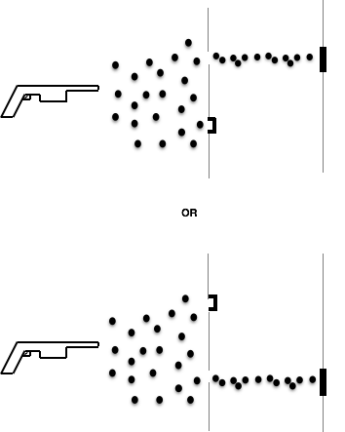

“Next up is the double slit experiment,” he said.

“Fire bullets from a machine gun at a wall with two thin slits in it, one on the right and one on the left. Put another wall behind the slitted wall to serve as a detector. When a bullet hits the back wall it makes a dent to show you where it hit. Now close the left slit, leaving only the right open and shoot the machine gun. What happens? Well, it depends on how big the slits are, how close they are together and how far away the backstop is. But let’s suppose your slits are just a little wider than the diameter of your bullets, the slits aren’t too close together and the backstop is not too far away. What you get is a band of dents on the detection wall behind the right-hand slit. Cover the right hand slit and fire the gun and you get a row of dents behind the left-hand slit. Now open both slits and fire the gun. What do you get?”

“Two rows o’ dents, one behind each slit,” offered Tenacce.

Danny drew the picture on the whiteboard:

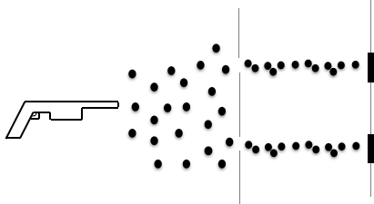

“Correct,” he said. “Now do the same experiment with a laser that fires light particles or photons (or quanta, as they’re also called.) Put a white screen that can detect the photons behind the wall with the slits in it. If a photon hits the detection screen, it leaves a black mark. Now close the left slit, leaving only the right open and shine the light. What happens? As you might expect, you get a band of black on the detection screen behind the right-hand slit. Cover the right hand slit and shine the light and you get a band of black behind the left-hand slit. Now open both slits and shine the light. What do you get?”

Tenacce was quick to answer. “Two bands, one behind each slit.”

Danny made a sound like a game show buzzer. Tenacce scowled. Danny drew another picture on the whiteboard:

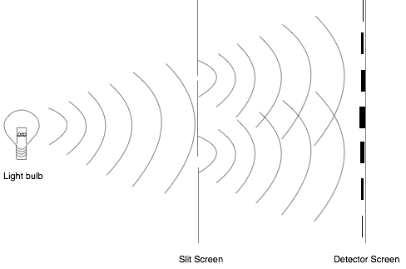

“That’s what you’d think. But what actually happens is that you get an interference pattern, a series of alternating black and white bands across the whole detection screen, denser in the center than at the periphery, like you’d would expect if the light were waves that went through both slits simultaneously. The black bands represent areas where the peaks of waves that went through each individual slit added together to produce an even bigger peak. The white bands represent areas where the peak of a wave going through one slit combines with the trough of the wave going through the other slit to cancel each other out.

“Now decrease the intensity of the beam to allow only the smallest possible units of light (individual photons or quanta) to be emitted sequentially, one at a time. When only one slit is left open and these single particles of light are fired at the wall, they hit the detection screen and cause a black spot, one at a time, but if you fire a lot of them, they wind up creating a black band behind the open slit.

“Next, open both slits and fire photons, one at a time, at the wall. What happens?”

“You get the band thing,” responded Tenacce, eager to redeem himself.

Salito issued an impish grin. “Some of us call it an interference pattern.”

Danny marked up the whiteboard again:

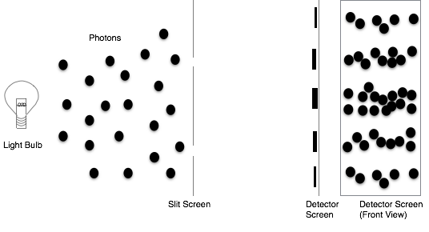

“That’s correct. The photons hit the detection screen one-by-one. But if you send in enough of them, you get an interference pattern—or the band thing, or whatever you want to call it—just like when you shined the light in a beam, sending in gazillions of photons simultaneously.”

“Woe,” cried Tenacce, making a stop sign his hands. “Ya said ya get the interference pattern because the light acts like waves?”

“That’s right.”

“So how does one o’ these photons, that’s a particle, make an interference pattern, like a wave? And a wave that’s gotta go through both slits at once ta make the interference pattern ta boot.”

“Those are great questions. And two of the greatest mysteries in quantum mechanics. Probably the main mysteries to which Feynman was referring.”

Tenacce shook his head in frustration. “It’s like they can’t make up their mind.”

“Who?”

“The photons.”

“They can’t decide whether they’re particles or waves,” said Salito.

“So which are they?”

“Both. At least they can be, though not at the same time. At least that’s what those who ascribe to the Copenhagen interpretation of quantum mechanics would say. The particles behave like a wave when both slits are open, a situation in which an observer would have no way of knowing which slit the particle goes through. And they behave like particles when only one slit is open, a situation where the particles can only go through one slit and an observer would necessarily know which slit the particles passed through. Some physicists say that’s just the way it is; shut up and calculate is their mantra. Others say that observer knowledge somehow causes the particles to behave one way or the other.”

Salito’s lips curled downward with dissatisfaction. “I don’t get what the observer has ta do with it. How does an observer make anything happen?”

That’s what bothered Bohm. Bohm’s answer was that he or she (the observer) doesn’t have anything to do with it. You see, to Bohm, all particles have a definite position and each particle of light—each photon—only goes through on slit at a time. It’s the wave function that determines the particles’ velocity, and therefore, where they go. And the velocity of the particles in the brain of the observer as well, a brain that makes him or her cover or not cover a slit. But it’s not the covering or uncovering of a slit that causes the particles to behave in certain way. It’s the wave function of the universe that determines the velocities of the particles being studied and the particles that make up the slit and the particles that make up the observer’s brain and causes them all to behave the way they do; at the time of the measurement and at all other times—a wave function that’s determined by its state immediately before. And the state before that and the state before that, all the way back to the beginning of time. At least—according to renowned physicist John Bell—that’s the logical conclusion of Bohm’s theory as it was originally expounded. Superdeterminism is what Bell called it. (I’ll amaze and confuse you with his work in a little while.)

“In contrast, later in his career, Bohm conceived of what he termed the implicate and explicate orders. The concepts are a bit nebulous but the implicate order is said to be a higher dimensional, deeper, more fundamental order that is unknowable to humans, an undivided whole that incorporates the wave function of the universe. The explicate order is basically the world in which we live. The implicate order is said to be enfolded and unfolds to give rise to the explicate order. The explicate order, in turn, enfolds back into the implicate order. And this movement, which Bohm calls the holomovement, takes place constantly and rapidly—perhaps at sub Planck times—at a subquantum level, the quantum mechanics with which we are familiar being but a limiting case of the holomovement just as classical physics is a limiting case of quantum mechanics and relativity. According to this theory, then, one might say that opening or closing the slits are events that occur in the explicate order. Which then enfold back into the implicate order. Which changes the wave function of the universe. Which unfolds again to determine the velocities of the particles. Which determine where the particles go. Which determine what kind of pattern the particles make on the screen.”

Danny inhaled and exhaled deeply to recover from the state of end expiratory exasperation in which his concatenated explanation had left him.

“Next question,” said Salito quickly. “Why don’t the bullets make the interference pattern?”

“Because particles—even macroscopic particles like bullets—aren’t exactly … particles.”

“What are they then?”

“They’re waves.”

“When I see a ball, I see a ball. I don’t see no wave.”

“That’s because the wavelength of the ball—and other macroscopic objects—is so small that you can’t see its wave behavior. Or detect it by any means.

“Why is that?”

Danny Tenacce turned back to the whiteboard. “A physicist named de Broglie figured it out in 1927. Parenthetically, de Broglie developed Bohemian mechanics before Bohm did—a theory he called pilot wave theory—then abandoned it.” He erased his diagrams and wrote some equations in their place.

where

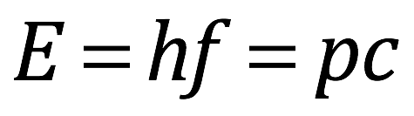

= energy



= Planck’s constant =

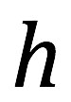

= frequency of a wave

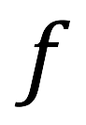

= mass () x velocity ()

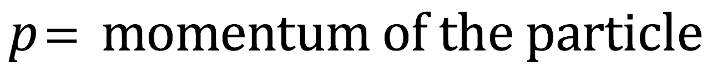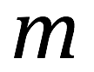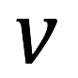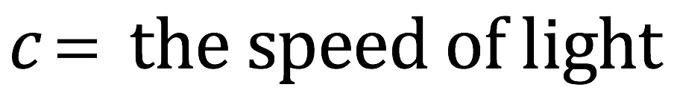

where

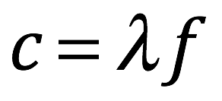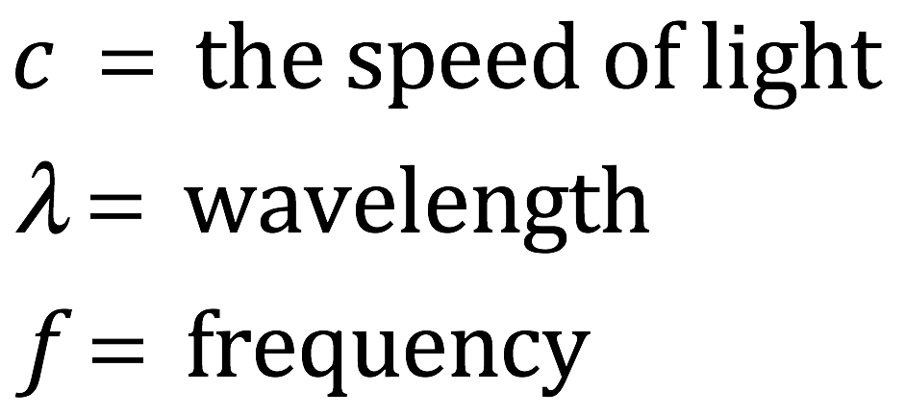

“Therefore, , and .

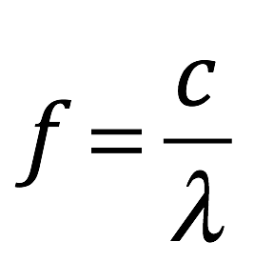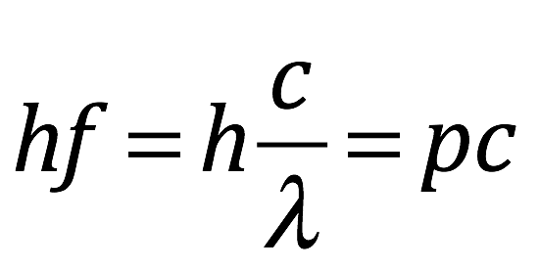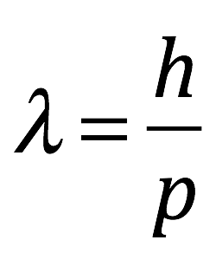

“Say our bullets are 22 caliber, have a mass of 4.2 grams and have a speed of 965 meters per second. That means that the wavelength of one of our bullets is

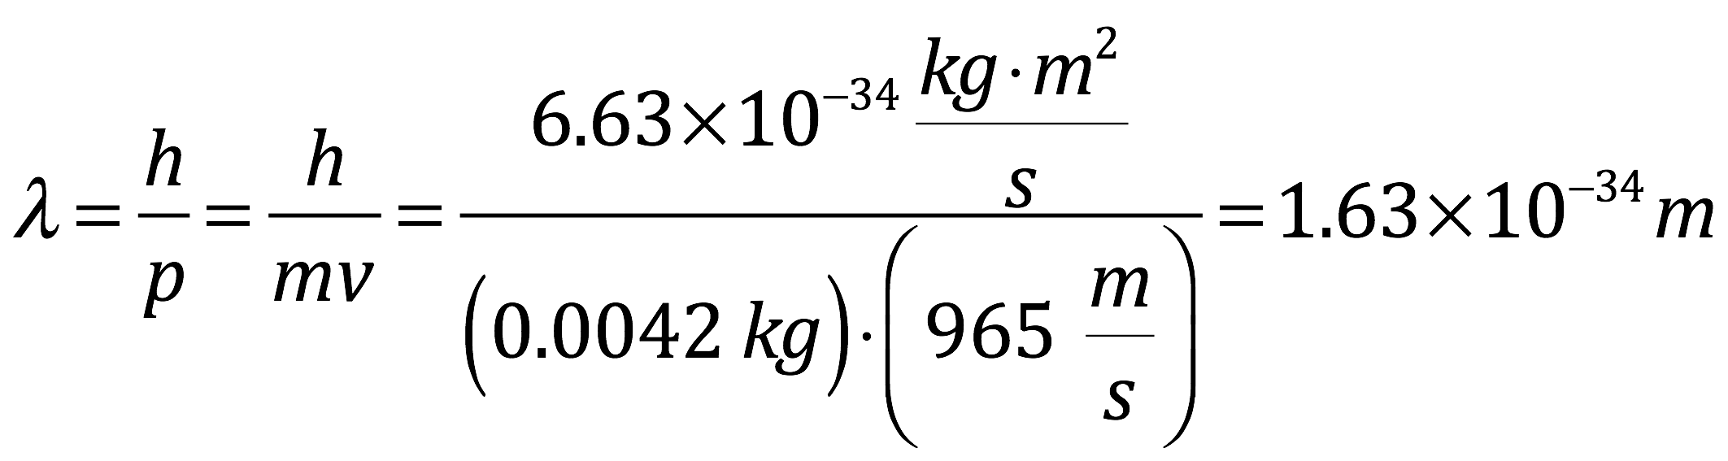

“So that means that the separation between black bands on the screen is meters. Obviously, there’s no way that you could see this separation. Or resolve it in any other way. The wave functions of all of the particles of lead in a bullet add up to make one large spike of probability amplitude that’s concentrated over an approximately 5.6 millimeter area and tiny side lobes to the function that create an interference pattern whose peaks are too close together and too weak to detect. So the bullets appear to be in just one place and behave as such when subjected to the double slit experiment.

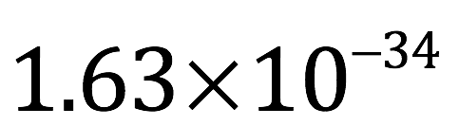

“It turns out that electrons, other atomic and subatomic particles, and everything else are actually waves. The reason that tiny things like electrons look like particles is because they’re really wave packets, blip-like waves of probability amplitude sharply localized in space with side lobes extending throughout the rest of space such that their probability amplitudes are effectively zero except at the site of the blip. And as I just told you, the reason that macroscopic objects appear localized is because their wavelengths are so short.”

Tenacce grimaced with concern. “So I’m guessing’ from that smirk on your face that there’s more ta this story and it’s gonna get worse,” he said.

“Considerably,” Danny replied.

“Next put a tiny device at slit A that can determine whether or not a photon passes through that slit. Open both slits and fire the photons at the wall one-by-one. What happens?”

“Ya get the band thing,” Tenacce shouted before Salito could react.

“Aaarrrnnnt,” Danny buzzed. “You get one band behind each slit, just like you would if you opened one slit at a time.

Tenacce threw up his hands in disgust as if he had lost another game of Pokemon on his cellphone. “How’s that?”

“That’s the million dollar question. You know the kinds of things that traditional quantum physicists would say. Some would say that that’s just the way it is. Others would say that knowledge of the path of the particles by the observer, given to the observer by the detector behind the left-hand slit, causes the particles to behave like particles while the observer’s lack of knowledge about the particles’ path that occurs when the detector behind the left-hand slit is left open, causes the particles to behave in a wave-like fashion.

“On the other hand, Bohm—at least the early Bohm—would say that the wave function of the universe, which has evolved deterministically since the beginning of time, determines the velocity of the particles being studied, and the particles that make up the slit, and the particles that make up the observer’s brain, and the particles that make up the detector behind the left-hand slit and causes them to behave like they do, at the time of the measurement and at all other times. The later Bohm would have said that the details of the experimental setup are features of the explicate order that enfold and feed back onto the implicate order, causing a change in the waveform of the universe. Which unfolds and determines the velocities of the particles. Which determine the paths taken by the particles. Which determine the pattern seen on the screen.”

Danny could see that Tenacce and Salito were troubled by this and were about to start at him. He cut them off before they could. “Then there’s entanglement,” he said.

He turned to the whiteboard and drew a cartoon-like version of the following diagram:

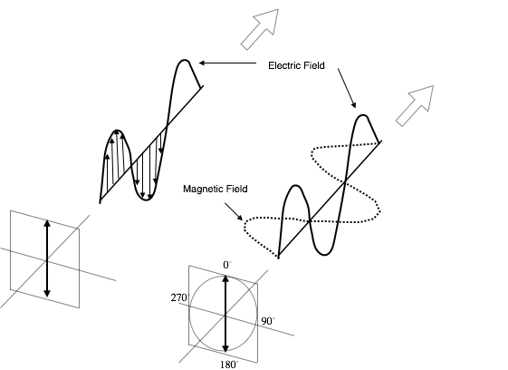

“Consider a photon, a particle of light. It’s electromagnetic energy and consists of an electrical field and a magnetic field.” He pointed at the diagram. “The strength (or amplitude) of the electric field wavers back and forth regularly (that is, oscillates) in the x-z plane. The amplitude of the magnetic field oscillates in the y-z plane and the photon moves in the z direction. The electric and magnetic fields always oscillate in directions perpendicular to each other and the direction of motion of the photon is always perpendicular to the direction of oscillation of the electric and magnetic fields. According to the conventions shown in the diagram, if the electric field oscillates in the x-z plane, we say that the photon’s plane of polarization is at 0 degrees. Or, another way of saying it is that the photon is polarized in the zero degree direction. Now suppose we rotate the plane of polarization clockwise such that the new plane of polarization makes a 45 degree angle with the x-z plane. The angle of polarization of the light is now said to be 45 degrees. Rotate the polarization plane 90 degrees and the angle of polarization is 90 degrees; Rotate it 123 degrees and the angle of polarization is 123 degrees, and so forth.

“There are devices called polarization filters that function as follows: they will let a photon through 100% of the time if it is polarized at the angle at which the device is set; it will block the photon 100% of the time if it is set at an angle 90 degrees different from the angle at which the photon is polarized; and it will let the photon through some but not all of the time, if the angle of polarization differs from the filter’s setting by some angle other than 90 degrees, the probability of it getting through being a function of the angle of difference. Individual photons will either get through or not get through but if you send in enough photons, then the percentage that get through will be the same as the probability of an individual photon getting through (or close to it). And one more thing: once a photon passes through a filter, it assumes the polarization angle at which the filter was set. That is, a photon that’s polarized at 45° before it reaches a 90° filter will emerge from the filter polarized at 90°, if it passes through. In the vernacular of standard interpretation of quantum mechanics, the interaction with the filter (which essentially constitutes a measurement, if we care to look) causes collapse of the photon’s wave function to 90°.

“Now photons can be split into what are called entangled pairs. The details of how this is done are not important. What’s important is how the entangled pairs behave. Say you create the pair in a lab in Chicago and send each member of the pair off in opposite directions, one to LA and the other to New York. You put a filter in the path of each photon in both the LA and New York laboratories, and just behind each filter, you put a detector. If the photon gets through the filter, it will register on the detector. Set the filters in both laboratories to 0°. Check to see if the photon got through in each lab. Do this over and over again for many photons. If all of the photon get through and register on the detector in one lab, then all will get through and register on the detector in the other lab. If no photons get through in the lab on the east coast, then they won’t get through in the lab on the west coast either. Now set the filters to another angle but make sure it’s the same in both labs and check the detectors. The same thing happens; if all of the photon gets through in one lab, they’ll also all get through in the other, and visa versa.”

“That’s easy enough ta explain,” said Salito. “When the photons get entangled, they get sent off with some kinda program about how they’re gonna act when they get measured in a certain way.”

“That’s kind of what Einstein—and Podolsky and Rosen—said. But what happens if you set the filters in each lab to different values?”

“Hmm.” Salito regarded him with uncertainty.

“Why don’t ya tell us, Professa,” Tenacce cracked.

Do you want the long version or the short version?”

“The long version,” Tenacce and Salito said together, with confidence.

“Remember, you asked for it,” Danny warned.

Danny erased the diagram on the whiteboard and drew a table:

|  |  |  |  |  |  |  |  |  |
| --- | --- | --- | --- | --- | --- | --- | --- | --- |
| Case | A=0° | B=120° | C=240° | AB | BC | AC | Sum  AB+BC+AC | Avg  (AB+BC+AC)/3 |
| 1 | A+ | B+ | C+ | 1(++) | 1(++) | 1(++) | 3 | 1 |
| 2 | A+ | B- | C+ | 0 | 0 | 1(++) | 1 | .333 |
| 3 | A+ | B+ | C- | 1 (++) | 0 | 0 | 1 | .333 |
| 4 | A+ | B- | C- | 0 | 1(++) | 0 | 1 | .333 |
| 5 | A- | B+ | C+ | 0 | 1(++) | 0 | 1 | .333 |
| 6 | A- | B- | C+ | 1(++) | 0 | 0 | 1 | .333 |
| 7 | A- | B+ | C- | 0 | 0 | 1(++) | 1 | .333 |
| 8 | A- | B- | C- | 1 (- -) | 1 (- -) | 1 (- -) | 3 | 1 |

“What you’re saying is that there is some program or some set of instructions that tells the photons how they should be polarized when measured at any given angle and that this state is a definite state that exists even in the absence of us measuring it. For simplicity, let’s choose just three angles: angle A = 0°, B = 120° and C = 240°. But you could do it for each degree of a circle, or every half degree or for every possible measurement. The argument I’m going to make would still be valid.

“We want to set the filter in the lab in New York to one of the three angles and set the filter in the lab in LA to another different one of the three. We shoot one of a pair of entangled photons to each lab and see if the photon gets through the filter and reaches the detector in each lab. If there’s some program, some hidden set of properties that a photon possesses, then it definitely—with 100% certainly—will or will not pass through a polarizing filter at a given setting. For three angles, a photon can posses only one of eight possible programs, as listed in the table. For example, A+B+C+ means the photon will pass through filters set at any of our three angles; A-B+C+ means it will not pass through a filter set at ‘A’ but will pass through filters set at ‘B’ and ‘C’, and so on. We can only measure one angle at a time and we randomly choose at which of the three angles we’re going to set the filter in each lab. There are three possibilities: 1) set the filter in one lab to A = 0° while setting the filter in the other lab to B = 120° (listed as AB in the table) 2) set the filter in one lab to B = 120° and the filter in the other lab to C = 240° (listed as BC in the table) or 3) set the filter in one lab to A = 0° and the filter in the other lab to C = 240° (listed as AC in the table).

“Now we send a few million pairs of entangled photons to each lab with the above three combinations of filter settings, collect data then use a computer program to analyze it. The program works as follows: it checks each experiment and sets up a table with two columns and a row for each experiment. In the left hand column, it puts which two filters were used. It doesn’t matter which lab uses which filter (e.g. it doesn’t matter whether you use the A filter in New York and B filter in LA or the A filter in LA and the B filter in New York; it puts AB in the left-hand column). If the results in the labs in both New York and LA match (i.e., photons in both labs either both reach the detector or both don’t reach the detector), then it puts a 1 in the right-hand column. If, on the other hand, the results differ in the labs (e.g. the photon reaches the detector in New York but not in LA), it puts a 0 in the right-hand column. Then it sorts the data by detector combination, and for each detector combination, figures out what percentage of the experiments result in a match for each detector combo. If there is some program which specifies definitive, hidden patterns of polarization properties for the photons, then the probability of a match should be 1/3 or 33.3%.

“You can see this from the table. For example, suppose the entangled photons are working under program 6, or case 6 in the table, A-B-C+. That means that it will not pass through and register on the detector if filters A or B are used but will if filter C is used. Thus, if the AB filter combination is used (e.g., filter A is used in New York and B is used in LA), results will match and the computer will register a 1. However, if the BC or AC combos are used, there will be no match and the computer will register a 0. Now we said that the detector combos (AB, BC or AC) are chosen randomly. That means that if you repeat the experiment enough times, each filter combination will be chosen an equal number of times. It turns out that, on average, 1 out of every 3 experiments will result in a match. And if you look at the table, this is true for cases 2 through 7. For case 1 (A+B+C+) and case 8 (A-B-C-), the photons are either polarized at all three angles or not polarized at any of the three angles. So there’ll be 100% agreement no matter at what angle you measure them.

“You can see from all this, that for any combination of filters used, there’ll be at least 33.3% agreement.”

“So is that what’s actually found?” Salito quickly inquired.

“No,” replied Danny curtly.

“And why the hell not?” Tenacce was agitated now. Salito sighed.

“You really want to know?”

“I wouldn’ta asked ya if I didn’t.”

Now it was Danny Tenacce’s turn to sigh. “The probability of agreement in measurement of entangled photons in LA and New York depends on the difference between the angle of measurement in the two places; varies according to square of a function called a cosine. So I need to tell you about some trigonometry—sine and cosine—then tell you about vectors, then tell you about how probabilities are calculated in quantum mechanics.”

He cleared the whiteboard. The marker squeaked as he produced another diagram:

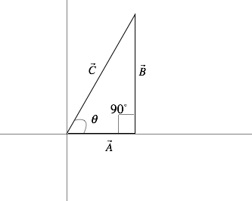

“So let’s do a little trigonometry and talk about vectors for a moment. Let’s start with a right triangle, like the one in the diagram. A right triangle is defined as one that has a 90° angle.

If you have such a right triangle, with one of its angles other than the 90° angle being , we can define two useful functions—actually, several—but there are really only two that I need to talk about now: sine and cosine. Cosine equals the length of the side of the triangle that touches (or is, as they say, adjacent to) the angle divided by the length of the hypotenuse (which is the side opposite the right angle). In this case: where the little bar over A and C indicates that they are vectors and and are the lengths of vectors A and C, respectively. Similarly, sine equals the length of the side of the triangle opposite the angle divided by the length of the hypotenuse. In this case: .

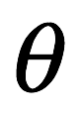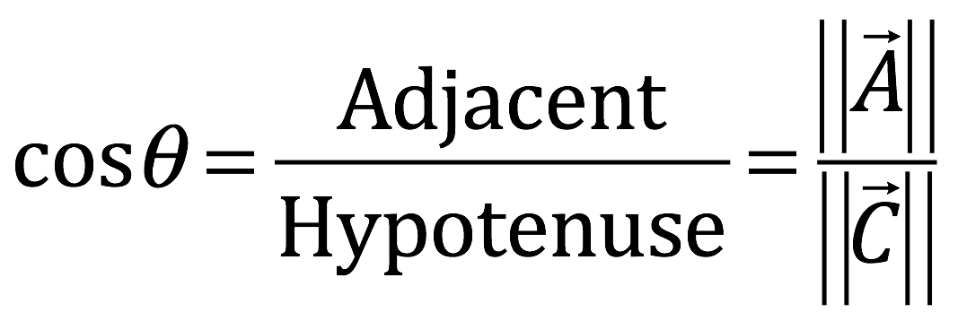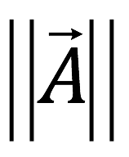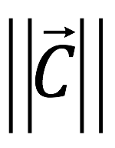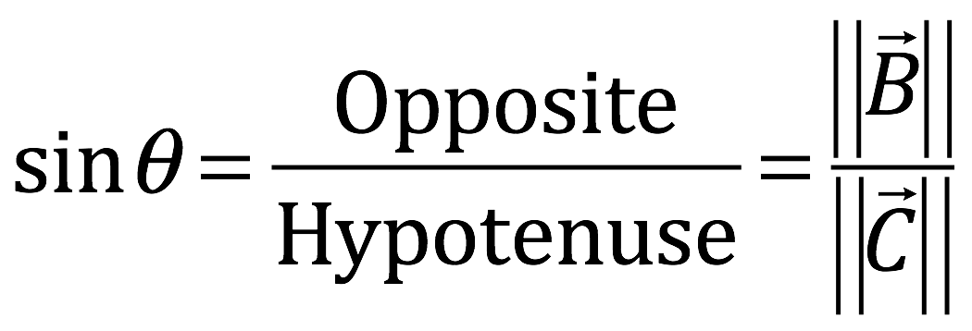

“Another important relationship associated with right triangles is called the Pythagorean theorem. The Pythagorean theorem states that that the square of the length of the hypotenuse equals the sum of the square of the lengths of sides adjacent to the right angle. In the diagram, .

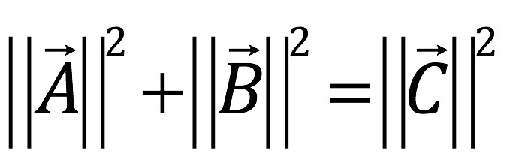

“Next I need say a few words about vectors. We talked a little about vectors when we figured out what bank Peterson was directing us to but I’ll refresh your memories.

“Vectors, in a general sense, are just an ordered collection of elements. Usually, the elements give the length along an axis that specifies a specific dimension. The easiest way to visualize this is to consider vectors in our everyday physical space. In this space, the dimensions would be something like forward, sideways and upward. We could use the x-axis to represent position in the sideways direction, the y-axis to represent the forward direction and the z-axis to represent the upward direction. I’ll talk about exceptions later but, in our familiar three dimensional physical world, the following facts are pretty much true: 1) the axes are straight lines 2) the axes are perpendicular to each other 3) the distance between each unit on each axis is the same and 4) the standard Euclidian geometry that’s taught in high school applies. A coordinate system such as this is referred to as a Cartesian coordinate system. To make things simple, we’ll just consider the x and y axes.

“In this simple setup, we can consider a vector to be a mathematical entity that has size (or magnitude) and direction. Let me draw one:

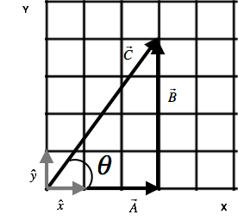

“As suggested by the diagram, you can add vectors graphically. To add vectors A and B by this method, you lay out vector A and place vector B with it’s origin at vector A’s end. You then connect the origin of A with the end of B. The line that forms this connection is the vector sum of A and B.

“Vectors can also be broken down into components. Each vector can be thought of as a linear combination of unit basis vectors. A unit basis vector is a vector 1 unit long in the direction of each of the axes and is usually written with a hat over it. In this case, the basis vector in the x-direction is and the basis vector in the y-direction is . Referring to the diagram, we can express as follows:

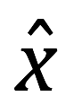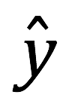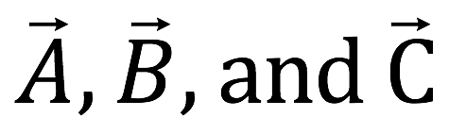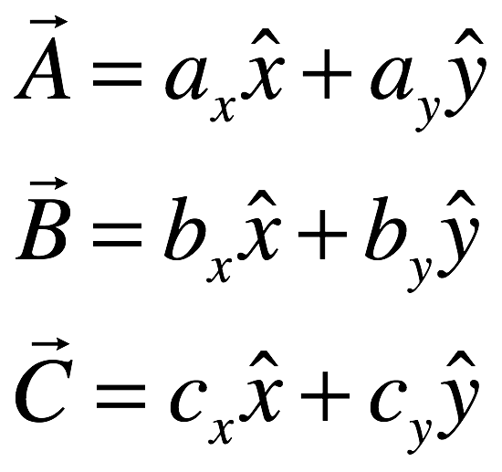

Where are called coefficients, numbers by which you multiply the basis vectors to tell how long the component vectors are that make up the vector.

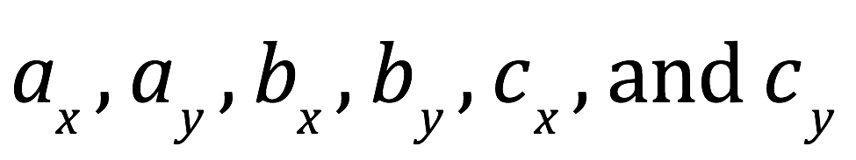

“In the diagram, ax= 3, ay= 0; bx= 0, by= 4; cx= 3, cy= 4. Frequently, vectors are represented by putting their components within parentheses or brackets. For example, in the diagram, is represented as (3 4). Furthermore, vectors can be expressed as column vectors or row vectors. The technical differences aren’t important for our purposes here. For our purposes, I’ll just show you what they look like. in row form is . In column form, it’s .

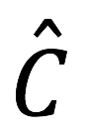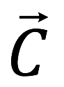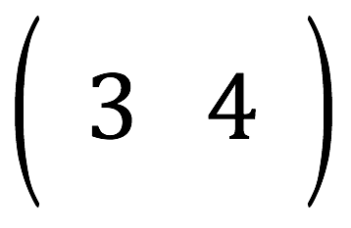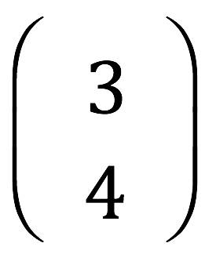

“What we’ve been talking about so far are vectors in space, vectors where the units on the coordinate systems used are things like centimeters, meters or miles. However, you could represent anything on those axes. In quantum mechanics, the thing represented on the axes is called probability amplitude of a certain property of a quantum particle.

“Recall that in quantum mechanics, at least the conventional interpretation of it, a particle or quantum is not in a definite state until it’s measured. For an electron, for example, there may be a 30% chance that it’s at position a, 20% chance that it’s at position b, 5% chance that it’s at position c, and so on. The only constraint is that the probabilities have to add up to 100%. And recall that I told you that you get those probabilities from squaring the probability amplitudes that make up a thing called the wave function. Position is a continuous variable. Therefore, to get the probability function, you have to square the value of the wave function (i.e., the probability amplitude) at every position.

“The case of polarization of a photon is simpler. You choose two angles of polarization that are orthogonal to each other (called a basis). These are the angles that you’re going to measure. The probability amplitudes for those angles define the state of polarization of a photon. This can be represented by a vector called a state vector. If you square a probability amplitude, you wind up with the probability that the photon will pass through a filter oriented at the angle associated with that probability amplitude.

“For example, take a photon polarized at 45°. We’re going to measure it in the 0°-90° basis. Since we’re measuring in the 0°-90° basis, the state vector must contain probability amplitudes that will yield correct predictions about how often the photon will pass through a filter set at 0° and how often it will pass through a filter set to 90°. The state vector that does this is . So the probability of the photon passing through the 0° filter is and the probability of the photon passing through the 90° filter is . As expected, the total probability is 1:

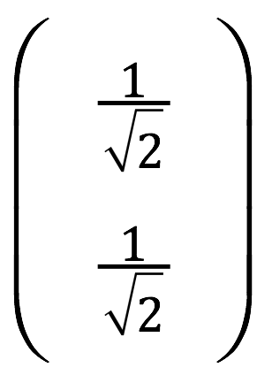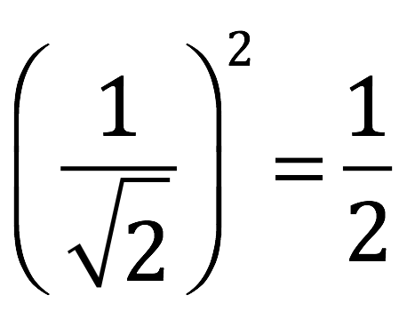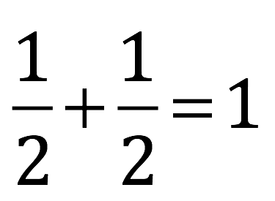

or if you like percentages better:

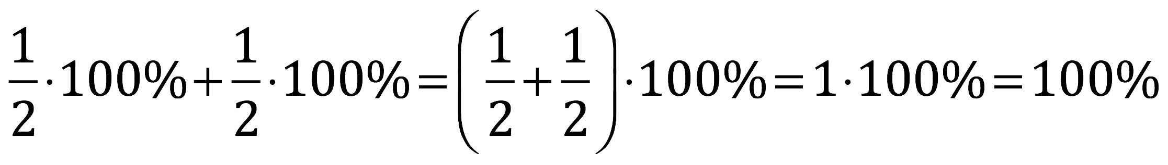

“As an aside, I have to tell you (because I had difficulty relinquishing my turds at age three, and consequently, am OCD as hell) that, in quantum mechanics, the coefficients of the vector states are actually complex numbers. That is, they consist of a real and an imaginary component. The imaginary component is just a real number multiplied by which is represented by the letter ‘i’.”

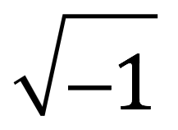

Salito furrowed her brows. “I thought you couldn’t take the square root of minus one.”

“You can. By definition, it’s .”

Salito remained concerned. Danny continued. “Complex numbers can be graphed in what’s referred to as the complex plane where you plot the imaginary component on the y-axis and the real component on the x-axis.

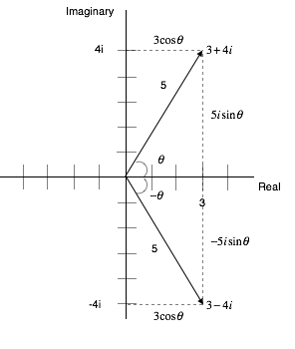

You can think of each point in the complex plane as being represented by a vector with real and imaginary components. Each complex number has what’s called a complex conjugate which consists of the same real component but the opposite complex component. For example, the complex conjugate of the complex number is . By definition, squaring a complex number means multiplying it by its complex conjugate. Notice that if you do this, you get a real number:

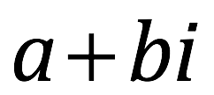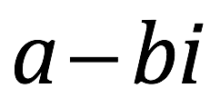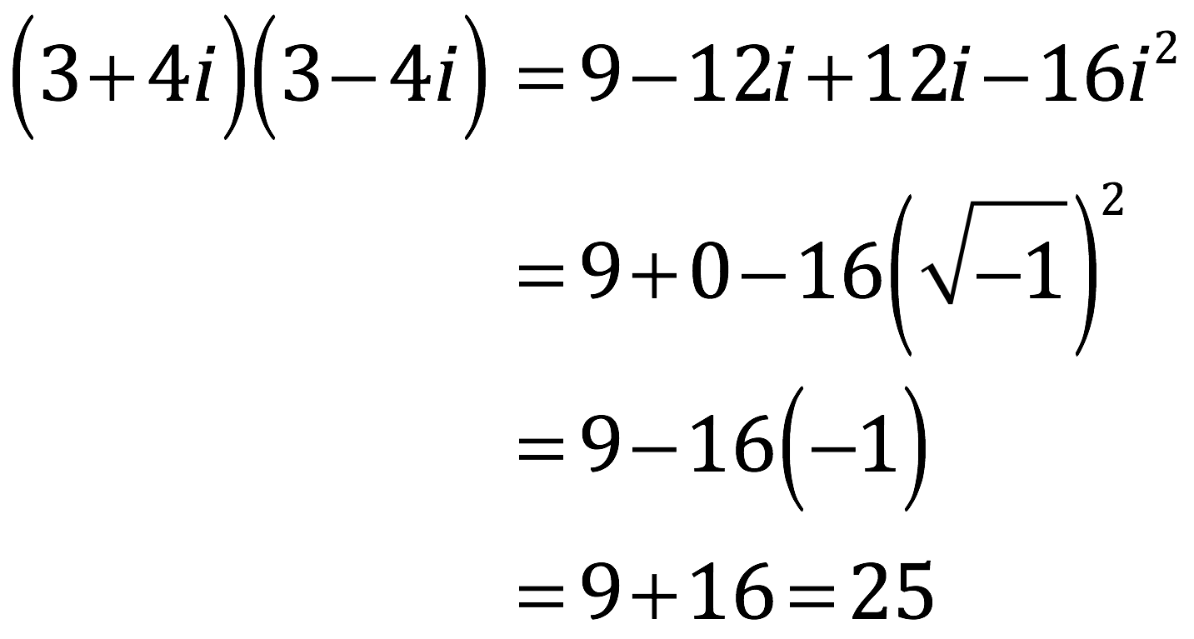

or more generally,

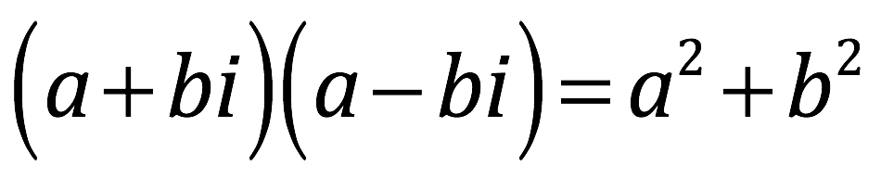

“Obtaining a real number under these circumstances is fortunate because, as I’ve mentioned, probabilities in quantum mechanics are the square of probability amplitudes which, in turn, are complex numbers. It would not be a good thing if the number we got for a probability were imaginary because neither I nor anyone else that I know of understands what an imaginary probability means. But here’s the good news: in the case we’re considering, the imaginary parts of the coefficients are zero so all we have to deal with is real numbers.”

Danny noted his father’s eyes cast far off into the distance.

Danny cleared his throat. “Getting back to what I’m supposed to be telling you,” he said. Tenacce’s head snapped back—from its superimposition of thoughts of his wife and sausage and pasta and the murder case that he had not yet solved—to the whiteboard. Danny continued.

“In quantum mechanics, a quantum state can be written as a linear combination of basis vectors—which are unit vectors pointing in the direction of each of the axes (properties) you’re considering. Each basis vector is multiplied by a probability amplitude which reflects the chances of that property being present. To simplify the math, basis vectors are usually chosen so that they are each one unit long and are all orthogonal to each other (a so-called orthonormal basis).

“In the case of polarization, consider a photon polarized at some angle, , about to be measured in the 0°-90° basis. Its state can be described by a vector, , in terms of 0° (vertical) and 90° (horizontal) orthonormal basis vectors , respectively.

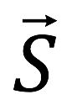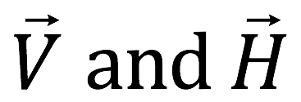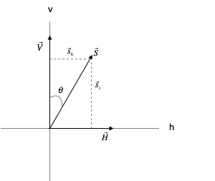

“The equation for this vector is

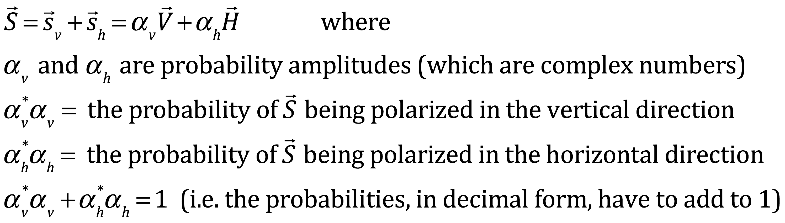

“The little star (*) indicates the complex conjugate that some of you,” Danny turned toward his father, “may or may not have heard me discussing just a minute ago.”

He turned back toward the whiteboard. “From the picture, you can see that

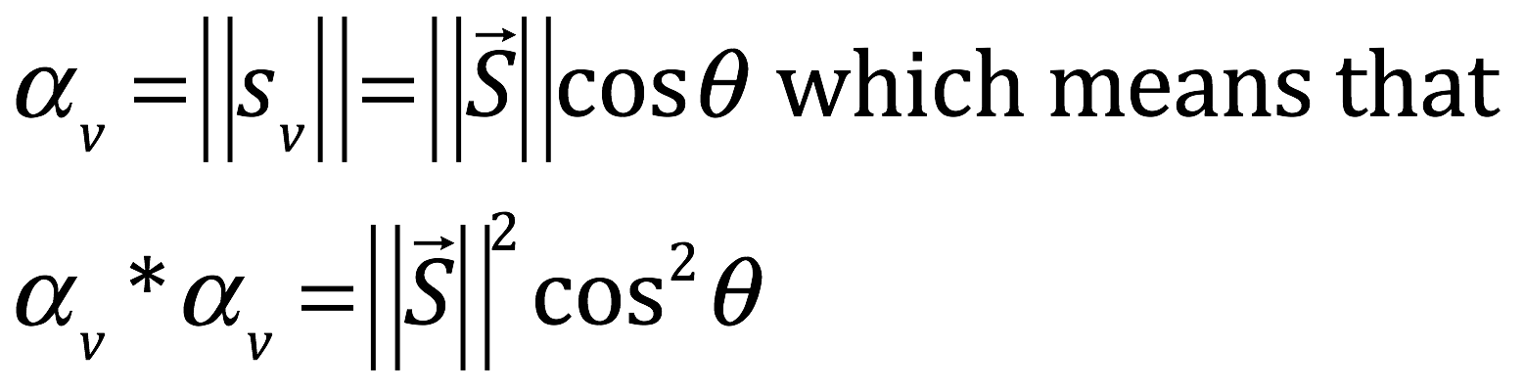

“Say the endpoints of the vectors V, H and S all lie on a unit circle (that is, a circle with a radius 1 unit in length.)

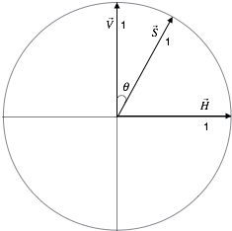

That means that vectors V, H and S are all 1 unit long. Therefore,

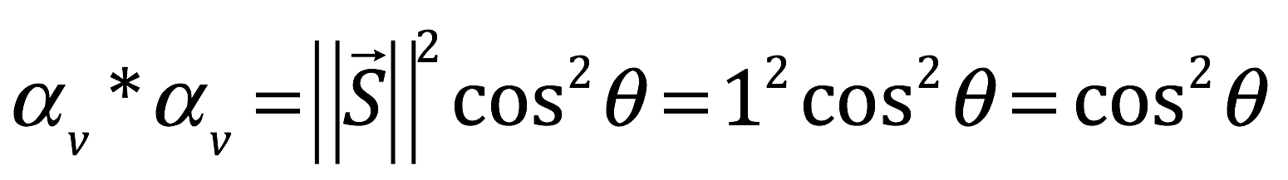

“That means that the probability of the photon passing through a vertical filter is given by . That’s a general result. The thing that determines the probability of the photon passing is the angle between the polarization of the photon and the filter setting. Think about it. If you rotated both vectors clockwise maintaining a separation between the vectors of , you’ll get the same result. That’s because if you also rotate the axis system clockwise, you’ll be figuring out the same problem.

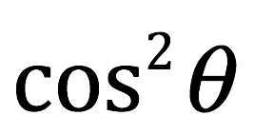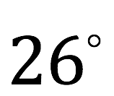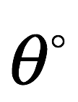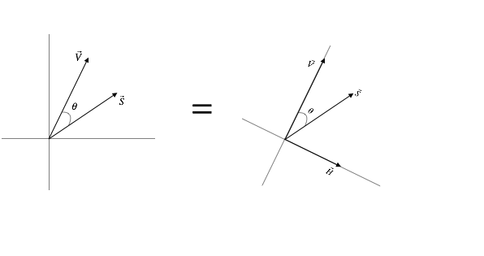

“Now let’s get back to the original table and original problem that we started with.”

“Finally,” gasped Tenacce.

Danny forged ahead, not revealing the fact that he felt the same way. “Recall,” he said, “that in our experimental setup, we’re dealing with entangled photons. Frequently, that means that the two photons have polarizations that are orthogonal (that is, their polarization angles differ by 90°). However, because of the manner in which we’ve prepared them, in our case, they’ll both have the same polarization. Remember also that once a photon is measured at a particular angle, it becomes polarized at that angle. So if one of a pair of entangled photons passes through a filter in LA set at A=0°, then it becomes vertically polarized.

“Now let’s consider the probability that its entangled counterpart, which is also vertically polarized, will pass through a filter set at B=120° in New York. The difference, , between the polarization angle of the photon (0°) and the angle at which is being measured (120°) is 120°. So that probability is given by . You can look up . It’s -0.5 or -1/2. Thus, = 0.25. Expressed as a percentage, that’s 25%, or as a fraction, 1/4. So the probability that both photons will pass through filters in LA and New York (and thus, that their measurements will agree) is 0.25.

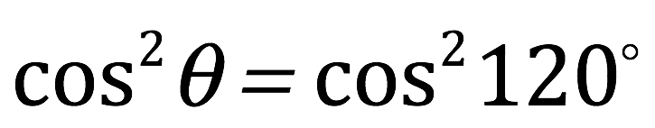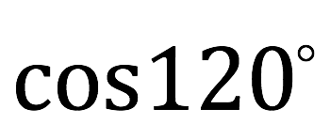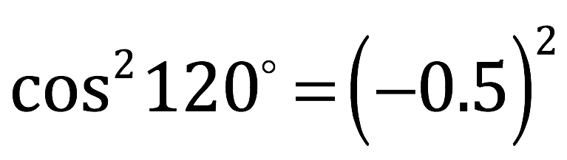

“Now what if the photon in LA does not pass through the A = 0° filter. That means that it’s polarized at 90°. The next question, then is what is the probability that its entangled partner will not pass through the B = 120° filter in New York. Well, it’s 1 minus (the probability that it will pass through the filter.) To figure that out, we’ve got to determine the probability that the photon will pass through the 120° filter. Fortunately, we have a formula for that. The difference between the angle of photon polarization and the angle at which it’s being measured is 90° - 120° = -30°. The cosine of -30° is and . So the probability that it will pass through the 120° filter is 0.75. Therefore, the probability that it won’t is 1 - 0.75 = 0.25. Ergo, the probability that both of a pair of entangled photons in LA and New York will not pass through A = 0° and B = 120° filters (i.e., that measurements will agree), again, is 0.25.

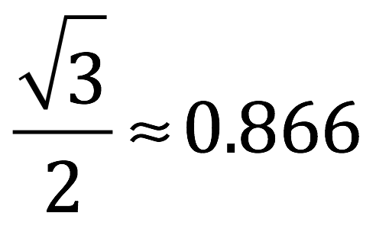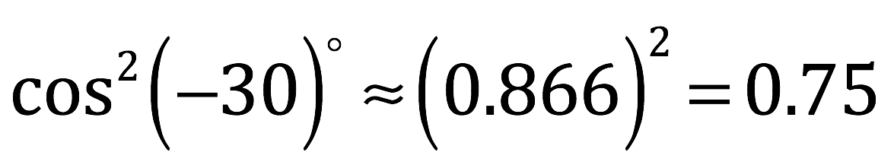

“Now the difference in angle between BC and AC is also 120°. Thus, the probability that both photons of an entangled pair will either pass through or not pass through both filters when the filter configurations are BC or AC (i.e., the probability that the measurements will agree) is also 0.25 (or 25%).

“So twenty-five: according to quantum mechanics, that’s the percentage of events in which both photons from an entangled pair will pass through filters, widely separated in space, whose angle settings differ by 120°. This is in contrast to 33 and a 1/3%, the percentage predicted by a so-called local hidden variables model in which photons are conceived as being in a definite state prior to measurement.”

“So which is it?” demanded Tenacce.

“Which is what?”

“Twenty five or thirty-three?”

“Neither,” Danny replied.

“Neither!”

“Whatta ya mean neither?”

“I mean that, to my knowledge, the experiment that I’ve out lined hasn’t been done.”

Danny waited until they were about to accost him before he resumed. “But experiments have been done that test Bell’s theorem, the underlying theorem that our hypothetical experiment also seeks to test. The fundamental concept is the same. It’s just the details that are different, for practical/technical reasons.”

“They confirm the predictions of quantum mechanics … and I’m confident that if the experiment that I’ve outlined were actually to be performed, the percentage of times measurements would agree in the LA and New York labs would be twenty-five percent, not thirty-three and a third.”

Tenacce and Salito considered the information for a moment.

“I still don’t understand how this happens,” said Salito.

“Ditto,” said Tenacce.

“The explanation according to standard quantum mechanics,” Danny replied, “is that the state of polarization of entangled particles is indeterminate. That is, until it’s measured. Then both photons instantaneously become polarized at the same angle.”

Salito thought out loud. “But how is that? I mean, it can’t be that one photon sends a signal ta the other cause you’re measuring both photons at the same time and the signal can’t go faster than the speed of light.”

Danny had long since ceased being surprised by her keenness. “No, it can’t. The standard interpretation is that, once the photons become entangled, their wave function becomes a combined wave function such that their polarizations are correlated. How this correlation comes about is obscure. That’s just the way it is. Shut up and calculate, remember? The Bohmian explanation is that the wave function of the system under consideration is the wave function of the universe, a wave function that incorporates the state of both photons and the experimental apparatus in both labs and the state of everything else, for that matter. And this wave function—whether it came to be in a predetermined fashion from the beginning of time or through the enfolding and unfolding of the implicate and explicate orders—causes the photons to move in such a way that the observed experimental results occur.”

“That’s weird,” Salito commented.

“It gets weirder. The granddaddy of quantum weirdness,” said Danny, “is the delayed choice quantum eraser experiment.” He turned to the whiteboard and drew a diagram that was a rough likeness of this:

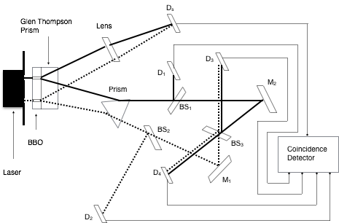

“You start with an argon laser and you fire single 351 nanometer wavelength photons at a double-slit screen. The photons go through both slits through a nonlinear beta barium borate crystal (BBO) which creates pairs of entangled photons each with half the energy (i.e. twice the wavelength, 702.2 nanometers) as the original photon. The possible paths of photons traveling through the upper slit are coded by solid heavy black lines; those traveling through the lower slit are coded with dotted lines. Each pair of entangled photons are then deflected by a Glen-Thompson prism either upward to detector or downward to another prism, PS. At prism PS, the upper photons (depicted with a solid black line) will be directed to a beam splitter, , and the lower photons (depicted with a dotted line) will be directed to a second beam splitter, . Photons that go to detector are called signal photons; those that go to PS are called idler photons.

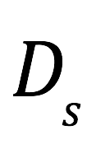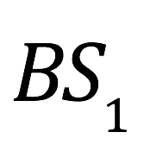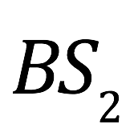

“At , half of the photons, originally from the upper (solid black line) source, will be deflected upward to detector while the other half will pass through to mirror . Similarly, at , half of the photons, originally from the lower (dotted line) source, will be deflected downward to detector while the other half will pass through to mirror .

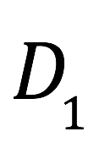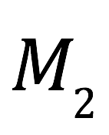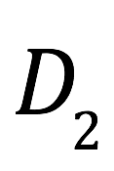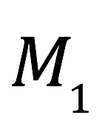

“If only detector were present (no prism PS), then signal photons from upper (solid line) and lower (dotted line) slits would hit the detector and an interference pattern would be created. However, with all the other elements in place, a single, wide band appears on . Why? I’ll delve into that later.



“Consider, first, what patterns emerge at detectors and . If an idler photon hits , there’s only one way it could have gotten there—from the upper slit, along the solid black path. Likewise, if an idler photon hits , there’s only one way it could have gotten there—from the lower slit, along the dotted path. So single, narrow bands are seen on detectors and . Note that if a photon hits one of these detectors, it imparts specific information about which path the photon took, to an observer (i.e., the experimenter). And because it’s entangled with its corresponding signal photon, as we’ll see, it influences the behavior of the signal photon.



“Next consider what happens if an idler photon passes through prism PS. Well, whether they follow the solid black path or dotted path, they get reflected off of mirrors and end up at a third beam splitter, . If a photon enters from the solid black path, it can either pass through to detector or be deflected to . If it enters from the dotted path, it can either be deflected to detector or pass through to . Either way, photons hitting detectors and can get to that detector either along the solid pathway or the dotted pathway. Because there’s no way to tell from which slit a photon hitting detectors and came, an interference pattern builds up on both of these detectors.

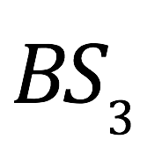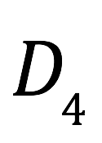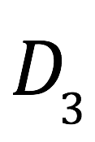

“Because entangled photon pairs are emitted at the same time, you can correlate the behavior of photons that hit with photons that hit detector , , or at about the same time. You can do this with a coincidence detector, which works as follows: when a photon hits a detector, it sends an electronic signal over a wire to the coincidence detector. If photons hit detectors and in close temporal proximity, the coincidence detector plots the position where the photon hit the detector, onto a graph called . If and register hits on the coincidence detector close together in time, then the position is plotted on a graph called . Similarly, near simultaneous coincidence registration from and plot the position of the corresponding hit onto graphs labeled and , respectively. This is how the experimental setup teases out the possible relationships between the behavior of signal photons and the behavior of the various types of idler photons from the otherwise amorphous blob of signal I said was found on the detector.

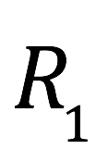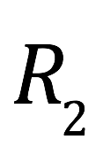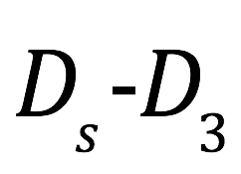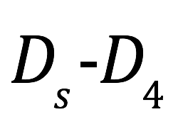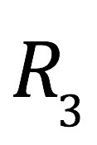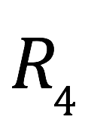

“And what do we find after this analysis is performed? We find that the and graphs show single peaks and the and graphs show interference patterns. and show single peaks because, as I alluded to just a minute ago, if the idler photon hits either or (to help create the and maps) then an observer analyzing the data knows exactly which path the photon followed. This is tantamount to the experimenter observing the photon. Some physicists have suggested that the reason that the wave function collapses and a classical pattern (instead of an interference pattern) appears on a detector in the simple double slit experiment is because the act of observation somehow disturbs the photon. From this experiment, though, it’s clear that this can’t be the case since nothing interacts with the signal photons on their way to the detector.



“What about and ? Well, activation of the and detectors in close temporal proximity to activation is what makes the and maps. Because both upper photons (that follow the solid black path) and lower photons (that follow the dotted black path) contribute to the interference pattern seen at and , and the experimenter (observer) doesn’t know which path the photons took to get to those detectors, just like in the simple double slit experiment without an observer, an interference pattern is seen at . It seems, then, that the thing that determines what pattern the photons make on the detector is whether or not the experimenter (observer) has knowledge of which path entangled idler photons take.”



Joe Tenacce thrusted his torso upright in arthritic discomfort, making a “T” with his hands before Danny could utter another word. “Hold on,” he said. “It looks like, from your picture, that the distance that the freons—”

“Photons, Lieutenant. Don’t pretend you don’t know what they are.”

“OK, photons,” Tenacce conceded. “The picture looks like the distances the photons travel ta , , and are all longer than the distance ta . Is that right?”



“That’s right,” Danny confirmed.

“And since they’re all light, they all move at the same speed—the speed o’ light—correct?”

“Correct.”

“So the photons that go ta , , and get there after the tangled up photon has already hit the detector at , right? I mean, it’s gotta be true since they gotta travel a longer distance goin’ at the same speed.”



“OK.” Danny was smiling now.

“So how the hell does somethin’ that’s already happened get changed by somethin’ that happens later?”

“Answer that question and there’s a million-dollar prize waiting for you in Stockholm.”

Tenacce and Salito stared at the diagram on the whiteboard in silence.

“Physicists that subscribe to the standard interpretation of quantum physics have about as much to say about the cause of the phenomena observed in the delayed choice quantum eraser experiment as you do right now. Their answer is ‘that’s the way it is.’

“On the other hand, early Bohmians would say—and I’m starting to sound like a broken record—that the wave function of the universe, which has evolved deterministically since the beginning of time, determines the velocities of the particles that make up the experimental setup and the photons shot by the laser that become entangled; that these velocities determine the patterns the photons make on the detectors. And therefore, that these patterns were determined long ago. From the very start of the universe.

“Alternatively, according to later Bohmian theory—and I’m sounding like a broken record again—the experimental setup, which is part of the explicate order and was present before the experiment began, enfolds back into the implicate order. The implicate order, where the wave function resides, changes due to the experimental setup. Then the implicate order, that contains this wave function, unfolds and causes the observed pattern on the detectors.”

Tenacce slouched back down in his chair, even lower than he had before, similar to the way he had done in the classroom in his recalcitrant youth. “It seems ta me that this wave-form-o’-the-universe thing is just another way o’ sayin’ ‘that’s just the way it is.’”

“Exactly right. And Bohm made all kinds of attempts to figure out the nature of the wave function. He consorted with Indian gurus, dabbled in panpsychism and the paranormal, looked for the answer everywhere. Everywhere except where it actually was. But then, He predicted that it would happen this way—in the book. Bohm and other physicists—including myself when I was a budding physicist—couldn’t and haven’t been able to determine the essence of the wave function. But you know what it is. It’s simply the result of the way the little ball of energy was set in motion in the beginning and the effects of all of the quanta that have been introduced into, and taken from, the system ever since. Furthermore, Bohm spent the latter part of his life asking himself from where the wave function came. He never found out. But you know the answer to that question, too.”

Tenacce and Salito nodded that they did.

“So I guess,” said Salito after several seconds of contemplation, “what you’ve told us about—this quantum mechanics …” She parted her lips and allowed the words to trickle out cautiously. “It starts to open the door for the possibility that the miracles described in The Bible...”

“Might be true? Yes, leaves the door agape, actually. As I’ve discussed, quantum mechanics admits that a particle—say a molecule of water—can be in one place at one time, and in the next instant, be 100 meters away. The chances are minimal but not zero. So let’s see … if you had a 100 meter wide strip of water, average depth of the Red Sea is 490 meters, that’s a volume of 49,000 meters, times 100 cm per meter equals 4,900,000 cc, equals 4 x 106 cc, times 1 gram per cc, equals 4 x 106 g, divided by 18 grams of water per mole, equals 2.2 x 105 moles of water, times 6.02 x 1023 molecules of water per mole, equals about 1029 water molecules that would have to disappear from one place and reappear 100 yards away all at once. And you’d have to make that happen twice simultaneously to move two walls of water. So standard quantum mechanics would say that it’s not very likely. But standard quantum doesn’t take into account the mechanism of such movement. To be sure, it would take a mindful infusion of a massive number of quantum to accomplish the task, but as you said a few minutes ago: He is God, after all.”

“And the virgin birth?” Tenacce inquired, brows rising.

“That’s much easier. DNA is the genetic material that makes us who we are. It’s stored in the nucleus of every cell as chromosomes. A human being has twenty-three pairs of chromosomes, one pair of which determines gender. An XX pair makes you female. An XY pair makes you male. Egg and sperm cells, also known as gametes, are formed by a process of cell division called meiosis. You start with 23 paired chromosomes (which makes a total of 46). This configuration of nuclear material is called the diploid state. Next, the DNA from the chromosomes gets duplicated in a process called replication. So now you have 46 chromosomes that are duplicated and joined together at a site called a centromere. The two copies are called sister chromatids.

“Then the membrane around the chromosomes, called the nuclear membrane, dissolves. The cell forms a waist at its equator and each of the pair of chromosomes line up at that equator, in the center of the cell. How do they line up? These little organelles called centrosomes send out little cables made of protein, called microtubules which attach to the chromosomes and move them to the right place.”

The description elicited a brow rise from both Tenacce and Salito.

Danny continued. “In mitosis, the process where cells divide to produce two identical copies of itself, the chromosomes that originally came from the person’s father line up end-to-end with chromosomes of the same number that came from the person’s mother (called its homologue), then the sister chromatids get pulled apart and a new cell pinches off around the chromosomes …”

“Don’t tell me: the microtubules again?” Salito inquired.

Danny nodded. “Each new cell has a set of chromosomes that are identical to the cell from whence they came. Meiosis, the process of producing sex cells (or gametes), starts out the same: the DNA of each chromosomes is duplicated, forming two sister chromatids for each chromosome. However, the two parts that follow differ from mitosis. In the first part, meiosis I, homologous chromosomes from the mother and father align randomly on one side of the cell’s equator or the other. For example, the paternal thirteenth chromosome aligns on the north side of the cell while the maternal thirteenth homologue goes to the south side. Meanwhile, the paternal fifteenth chromosome aligns on the south side of the cell while the maternal fifteenth homologue aligns on the north side. However, both the thirteenth and fifteenth paternal chromosomes could have aligned on the north side while the maternal thirteenth and fifteenth homologues both migrated to the south side. The process is random. Biologists say that evolution has selected for this mechanism to introduce more variability into the gene pool. I don’t know. I’m not a biologist. (And I don’t think biologists refer to halves of a dividing cell as north and south; I just did that for purposes of illustration.) What I can tell you, though, is that when the cell divides, each new cell will have 23 instead of 46 chromosome (better known as the haploid state), with a mixture of maternal and paternal chromosomes in each new cell, each chromosome containing two copies of itself (that is, two sister chromatids.)

“That’s meiosis I. Next the two cells resulting from meiosis I undergo meiosis II. Basically, meiosis II is just a haploid version of the telephase (or cell splitting phase) of mitosis. The centrosomes send out the microtubules and make the 23 chromosomes line up end-to-end along the equator of the cell, one sister chromatid on each side of the equator. Then the microtubules pull the sister chromatids apart and pinches off new cells with 23 chromosomes each containing of one copy of DNA. No sister chromatids. So from the one cell with 46 chromosomes you started out with, after meiosis I and II, you wind up with four cells, each with 23 chromosomes. These four resultant cells are called sperm in the male. The situation in the female is a little different. In the female, one large ovum and three small cells called polar bodies form. The polar bodies die off. The ovum is the cell that ultimately has the potential to get fertilized and create a new human being.”

“You said it was simple. Don’t sound so simple ta me,” groused Tenacce.

“Hang tight. We’re almost there. When Mary …”

“You’re talkin’ about the Virgin Mary?” Tenacce’s catholic reverence for the Virgin Mother made him bow a little as he spoke.

“Yes. The contribution to Mary’s genome from her mother was a normal set of 23 chromosomes including an X chromosome. However, the paternal gamete that contributed to Mary’s genome failed to undergo meiosis. The initial fertilized ovum that was destined to become Mary contained three sets of chromosomes, a situation referred to as the triploid state. Normally, triploid embryos die before birth. However, in Mary’s case, when the initial fertilized ovum underwent its first division, the maternal chromosomes duplicated themselves but the paternal contribution did not. The division produced two cells: one with maternal and paternal contributions containing XX sex chromosomes, the other with maternal and paternal contributions containing XY sex chromosomes. The cells descending from the cell that contained the XY sex chromosomes migrated to the ovaries and ultimately became gametes. The cells that descended from the cell containing the XX sex chromosomes became the rest of Mary’s body.

“In the human female, gametes begin meiosis I before birth but the process becomes arrested until puberty. At puberty, a few gametes begin meiosis II at the beginning of each menstrual cycle (they don’t complete meiosis II unless they’re fertilized.) Under usual circumstances, only one ovum becomes available for fertilization each cycle; the others involute. In Mary’s case, one of her diploid gametes, called a primary oocyte, failed to undergo meiosis, due to a carryover mutation from her father. However, the proteins specified by Mary’s DNA created a milieu that caused it to be picked up by her fallopian tube and behave as if it were a fertilized egg (or zygote), beginning self-multiplication in the tube, migrating to the uterus, implanting itself there and, because of the presence of XY sex chromosomes, developing into a male offspring, a male offspring the least of whose accomplishments was the authoring of the book.”

Tenacce gazed at his son from under his skeptical brows. “I hate ta say it but it all sounds kinda contrived ta me.

“Agreed,” chimed Salito. “I mean, the father’s cell doesn’t undergo meiosis. Then inside the zygote, the maternal chromosomes duplicate but the paternal ones don’t. Then they line up just right so the chromosomes with XX and XY from different parents go to different cells. Then the cell with the XY chromosomes just happen ta migrate to the ovaries. Then everything goes just right and the unfertilized egg gets treated like its fertilized and winds up in a live birth?”

“You shouldn’t be surprised,” Danny replied. “After all, the information in the DNA of a single cell multiplies and causes the right receptors to appear on the surface of cells and the correct chemical signals to be released to cause cells to migrate past each other in the right way, with the right timing, and stop in the right place. It causes the correct genes to be expressed, and others to be suppressed, at the right time, so that some cells become nerve cells, some become heart muscle cells, some become skeletal muscle cells, others become cells of the GI tract, and they all get put together in just the right way to make a living, breathing human being. This happens about 353,000 times a day.

It’s like about a gazillion rows of dominos all set up in interlocking rows. Here are the rules: if two rows intersect, and domino 1 gets to the intersection before domino 2, then the dominos in the row containing domino 1 continue to get knocked down past the intersection while the shared domino at the intersection, having been knocked over, stops the process from continuing past the intersection in the row containing domino 2. On the other hand, if both domino 1 and 2 reach the intersection simultaneously, the domino in each respective row past the intersection gets knocked over, continuing the process. The goal of the game is to knock over the domino at the end of a line of dominos that marks the end of the entire mass of dominos. The only way for that last domino to get toppled is for a few dominos—just the right ones—to be knocked over, with just the right timing, at the beginning of the game. The sequence of DNA in the genome of the zygote is what specifies which dominos—if you will—need to be knocked over, and with what timing, to assure that the process produces a viable offspring.

“But the DNA configuration that led Mary’s father’s primary spermatocyte to forgo meiosis, and the maternal contribution to the zygote that was to become Mary to replicate, and the paternal contribution to that zygote not to replicate, and the chromosomes in the zygote to line up in the right way, et cetera, et cetera—that DNA configuration is part of the universe. And the movement of things that make up the universe is determined by the wave function. And you both know who and what determines the wave function.”

Tenacce and Salito nodded that they did.

“God recognized that the world needed saving, so he threw in a few quanta, in the right place and the right time, in such a way that it was suboptimal for the enemy to stop it, and the result was a savior who was created at the optimal time and in the correct place, to save the world.”

There was a hint of a wince as Tenacce tensed his back muscles and sat up in his seat. “You been talkin’ about DNA, genes and chromosomes and stuff. And ya mentioned evolution. So I’m guessin’ that means that the world wasn’t really created in seven days.”

“It all depends on your definition of days, and time in general.”

“My definition o’ time?” Tenacce was bolt upright now. “Tick, tock. Tick, tock … that’s what I mean. What other kind o’ time is there?”

“Relative time.”

By the expression on his father’s face, Danny knew he had better elaborate.

“A guy with a clock on the ninety-fifth floor of the World Trade Center watches another person, also holding a clock, zoom by in a rocket ship. The guy in the WTC, somehow, can look inside the spaceship as it whizzes by. To him, the clock of the guy in the spaceship is running slower than his clock. To be exact, for each second elapsed on his clock, the guy on the ninety-fifth floor sees seconds tick off on the clock of the guy in the rocket ship, where v is the velocity of the guy in the rocket ship and c is the speed of light.”

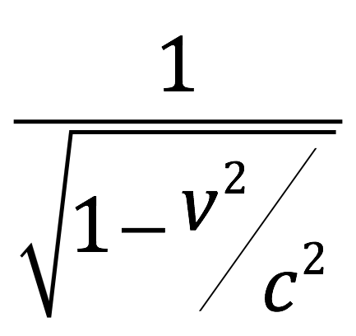

Salito frowned. “How’d ya come up with that?”

“You really want to know?”

Salito nodded.

“There’s a lot of math involved,” said Danny, his voicing trailing off into a high-pitched ellipsis. He stared at his father.

Tenacce beckoned with his hands to bring it on.

“Don’t say I didn’t warn you,” Danny said as he turned back to the whiteboard. He erased the complex diagram that was there and replaced it with something simpler:

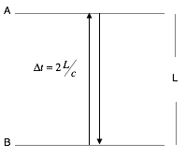

“You’ve got two mirrors separated by a distance, , call them A and B. You have a light sitting in the middle of the bottom mirror. Everything is at rest; nothing’s moving. You turn on the light for a split second, then turn it off. The light goes up, hits the top mirror, reflects off mirror A and returns to the bottom, to mirror B. There is a photodetector in the mirror B that detects the return of the light. The photodetector is hooked up to a contraption that makes a clock hand move one mark.” He looked at his father. “Tick, tock,” he said. “If you emit the next pulse of light at the same time the first one gets detected, what you basically have here is a clock. Obviously, this is unrealistic. You couldn’t actually make a clock hand that would move every time a light ray traversed a short distance like this, and if you could, it would be a blur. But just humor me for now.”

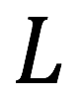

“We want to find a mathematical expression for how long it took for the light to make it’s up and down round trip—one cycle; one tick of the clock, if you will—so we can compare it later to how long it takes for one cycle (or clock tick) if we were to move with constant velocity. Well, you know that the speed of something is distance traveled divided by time:

where = velocity, = distance traveled and = time it takes to make the trip

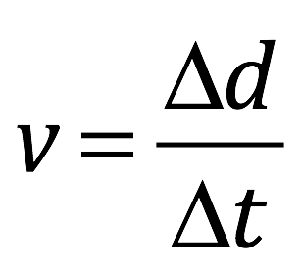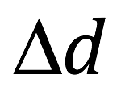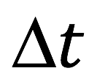

“We want to find so let’s rearrange things a little. First, multiply both side of the equation by then divide both sides by . This gives us .

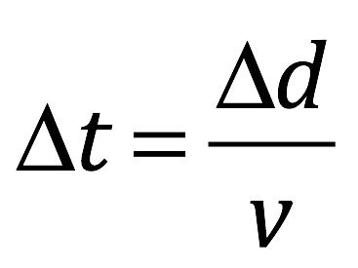

“The speed of light, which we’ll call “”, can be expressed in various units, but is about meters/second. It’s also invariant. Kind of like God—the absolute standard to which all other velocities are compared. Anyway, the in our equation is the speed of light, . The distance traveled,, is —one length, , going up and one coming down. Therefore, in this case, our equation becomes .

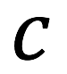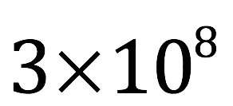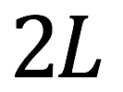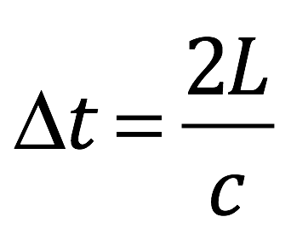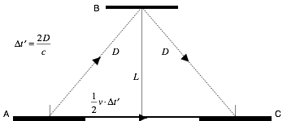

“Now consider what happens if we watch as the bottom mirror moves with velocity, , as it emits its light pulse. The setup is as I’ve drawn it. The mirror emits its pulse of light upward at an angle. The light reflects off of mirror B, downward, to the right, at the same angle at which it hit the mirror. Then the mirror travels quickly—very quickly—to the right, to a position where its photodetector can receive the downward reflected light pulse and determine the time, , that it took to make the round trip—one cycle, one clock tick—from the emitter to the detector. You can see just by looking at the diagram that the distance the light has to travel is farther than in the case where the mirror was at rest. Since the speed of light is constant, to us, it has to take longer for the light to complete its round trip in this so-called moving frame of reference than in the previous situation, where we watched the mirror give off and receive the light pulse, at rest with respect to us. How much longer? Let’s figure it out.

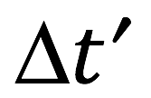

“The time it takes to make the round trip in this moving frame, , equals the distance it has to travel, , divided by the speed of light, . In this case, : going up and coming down add up to twice . But, from the diagram, we can figure out what is in terms of the speed of the mirror, , and (the distance between the emit/receive mirror and the reflecting mirror, when they are aligned.) For that, we need the Pythagorean Theorem.

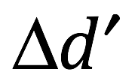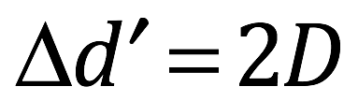

“In the diagram of our moving mirrors, is the vertical distance between the mirrors, same as in the resting frame of reference. The distance that the moving mirror travels between emitting and receiving the light pulse is velocity x time = distance = . The distance between where it emitted the light and the vertical line, , is one half the distance between the points where it emitted and received its light pulse. That distance is given by . From the diagram, we can also see that this is one side of a right triangle that is adjacent to a right angle. The other side adjacent to the right angle is , and the hypotenuse is . Therefore, by the Pythagorean Theorem, . Take the square root of both sides. That gives . Now we have some algebra to do.”

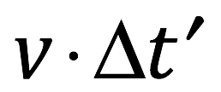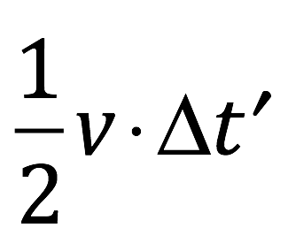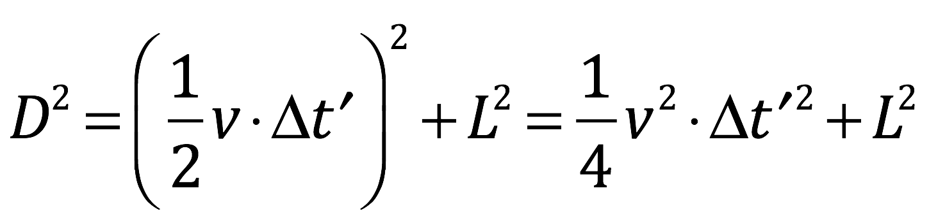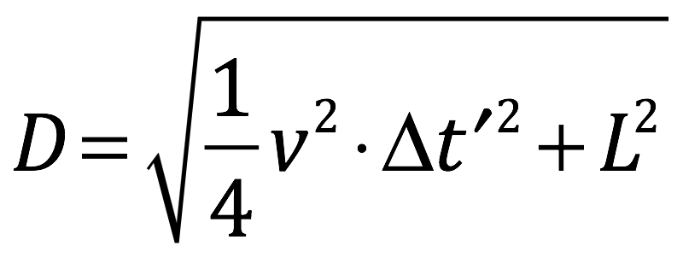

“Oh, great,” Tenacce moaned. “I flunked algebra.”

“You don’t seem to have had much trouble following things so far.”

“So far. Probably ‘cause you’re a lot better teacher than I had.”

“Complement accepted.”

Danny Tenacce was about to continue, then stopped abruptly. “I just can’t do it. I just can’t let it go.”

“What? Let what go?” Salito inquired.

“Speed and velocity. I’ve been using the terms interchangeably. But there’s a difference. Velocity is a vector. It has both a magnitude, or amount, and direction. Speed is a scalar. It has no direction. It’s just a number. The relationship is that speed is the magnitude part of the velocity vector. Say that you’re traveling with a velocity of 30 miles/hour due east. The speed, 30 miles per hour, is the magnitude. East is the direction.”

Tenacce rolled his eyes. “I’m glad we got that cleared up.

Danny turned back to the whiteboard.

“Recall that the time it takes to travel from the emission site to the reception site, , is twice D divided by the speed of light. That is, . Now substitute the value of from D above, into that equation. We get:

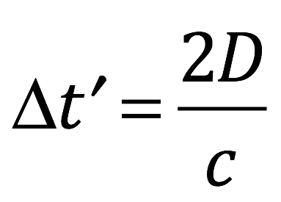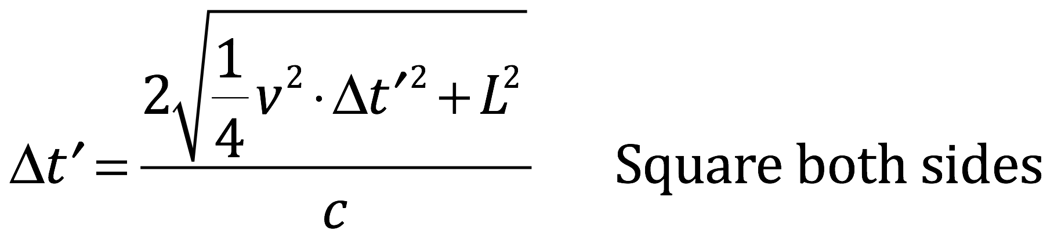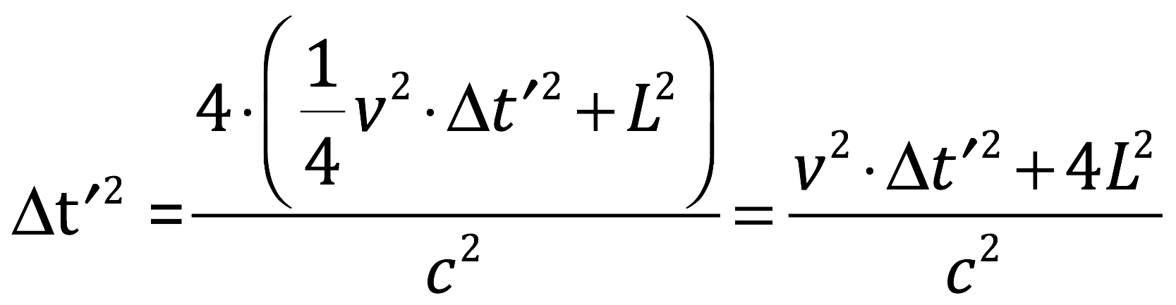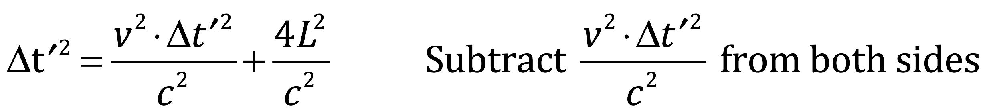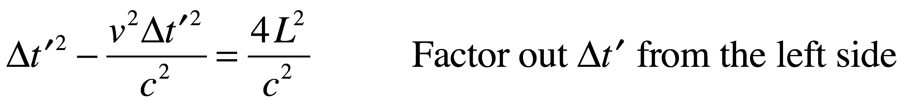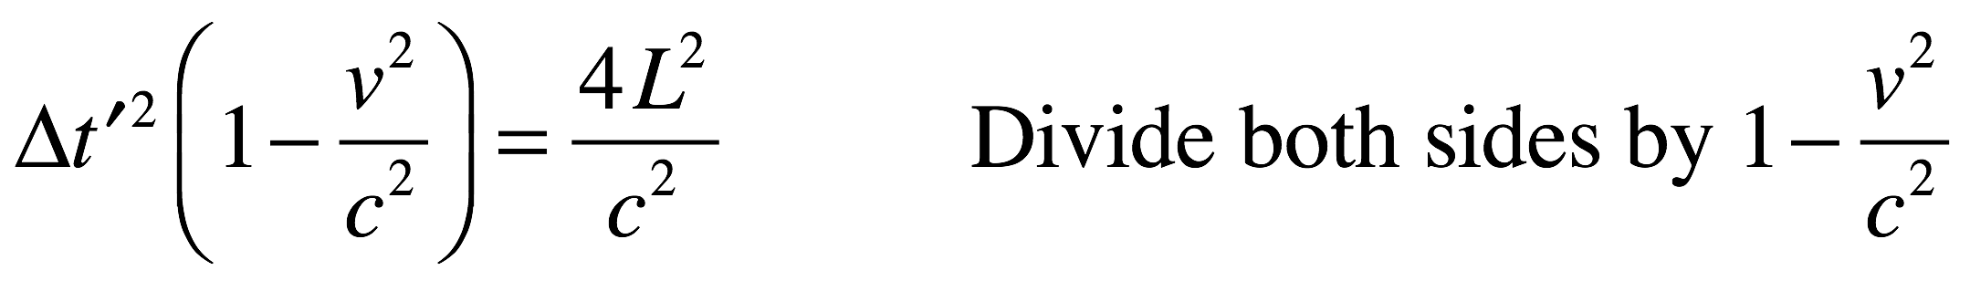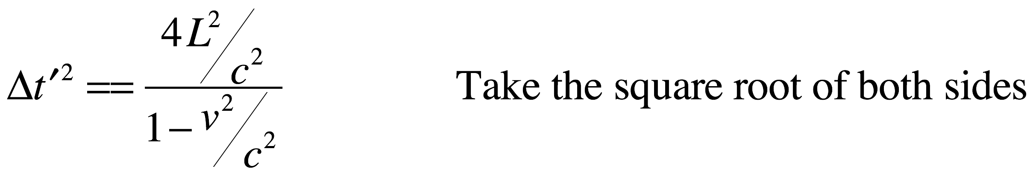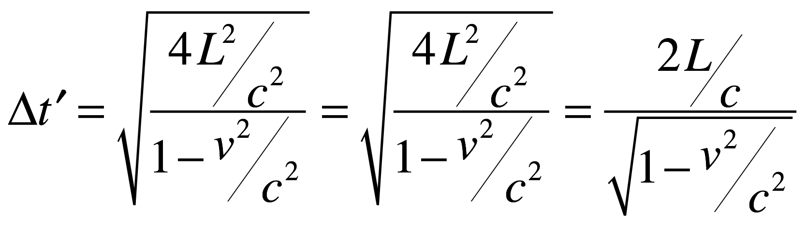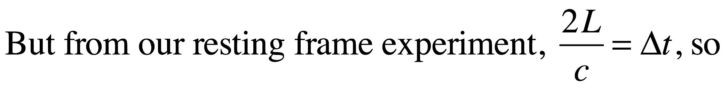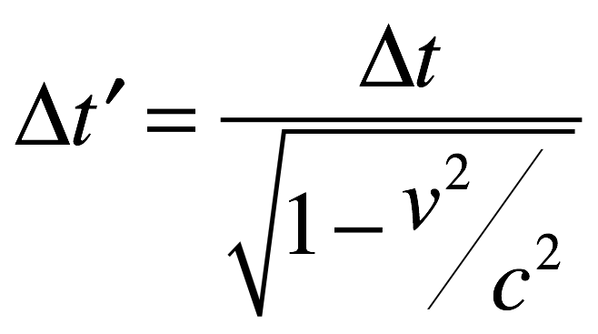

“If the mirrors are moving relative to us, then their velocity, , has some value greater than zero. So the fraction is greater than zero. This makes the denominator, , less than one. If we divide anything by a number less than one, it makes the result greater than the original something. That makes .

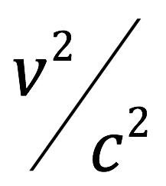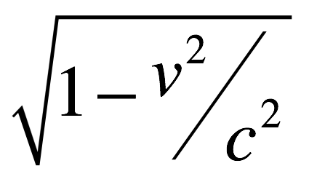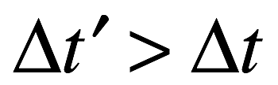

For example, let’s say our velocity is such that . How long will 1 second seem to last in the moving rocket. Well, . But . So . Therefore, to us watching, it takes twice as long for the moving mirror system to go through one cycle (or tick) as it did for the system we saw as being at rest.

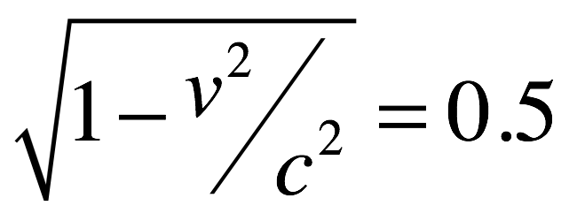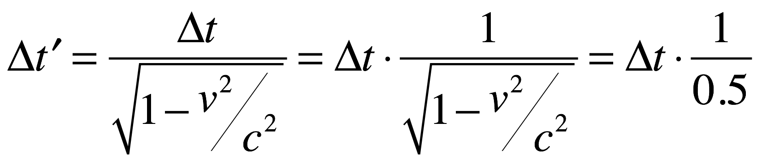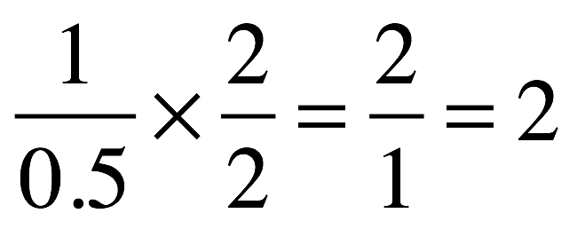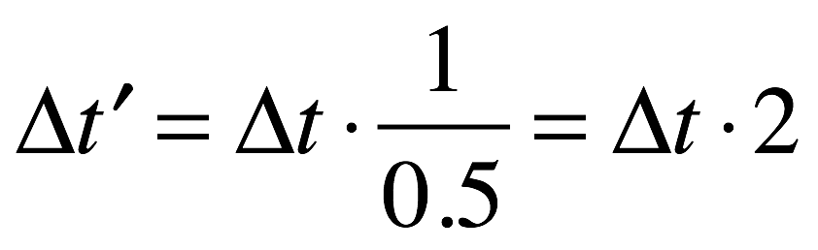

“In general, to us watching at rest, the moving mirror apparatus (i.e. the moving clock) takes longer between ticks (i.e. ticks slower) than the clock that is, to us, not moving.

“Note that it’s important to specify from what frame of reference we’re looking at things. If we were to take a moving frame of reference that was moving at the same velocity as what we previously called the moving mirrors, (call this frame ), then the mirrors in the frame of reference that we previously took (call it ) would now seem to be moving. In this case, we would think we were standing still and that time was moving slower in the other reference frame.

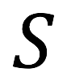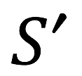

“Parenthetically, a similar thing happens with length. Length contraction, it’s called. To an observer watching an object move past with a substantial velocity compared to the speed of light, the object will be shorter while moving than it would be if it were at rest compared to the observer. I won’t go through the whole derivation but it’s similar to the derivation that you just endured. The formula, in case you’re interested, is:

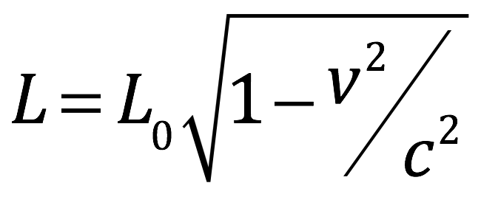

where

is the proper length (the length of the object in its rest frame),

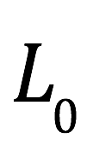

is the length observed by an observer in relative motion with respect to the object,



is the relative velocity between the observer and the moving object,



is the speed of light



“So I guess you’re sayin’ that God musta been movin’ pretty fast compared ta us and the rest of the universe when he created everything,” said Tenacce, pleased with himself.

“Not exactly,” Danny replied.

Tenacce exhaled with exasperation.

“What I’ve described to you is that which happens in what’s called an inertial reference frame. I used it to illustrate the fact that time is relative. It’s a much simpler situation than the one I need to tell you about to explain the discrepancy between the time course of creation offered in Genesis compared with that suggested by science.”

“You gotta be kiddin’ me,” Tenacce huffed. “You’d have ta be an Einstein just ta come up with the stuff that you called simple.”

Danny smirked. “Do you want me to quit?”

“Hell, no,” Salito exclaimed.

Danny Tenacce turned to his father. Joe Tenacce shook his head.

“All right. We’ll have to consider gravity, then. Imagine you’re in a spaceship in outer space. You’re locked inside and can’t see the outside world. Inside the spaceship, you have a light source on the floor and a light detector on the ceiling, both attached to clocks. The instruments on your control panel say that the spaceship is not accelerating (i.e. its velocity is not changing). How long should it take for light from the floor to hit the ceiling? Well, like discussed previously, velocity x elapsed time = distance traveled, so, dividing both sides of the equation by velocity, time elapsed = distance traveled divided by velocity: where

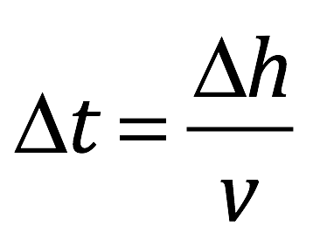

is the time it takes to get from the floor of the ship to the ceiling



is the distance traveled by the light (the distance from the floor to the ceiling)

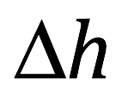

is the velocity of the object moving from the floor to the ceiling



Velocity, , in our setup is the speed of light, , so .

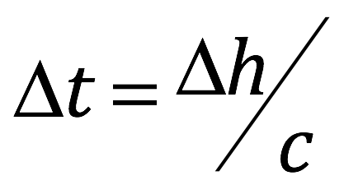

“Now suppose the spaceship starts moving with constant acceleration, , acceleration—as I alluded to—meaning that velocity changes “” units of velocity per each unit of time elapsed. How long should it take for the light ray to go from the floor to the ceiling in the presence of acceleration? Well, the light ray is emitted from the floor and it travels a distance, , but the ceiling with the detector isn’t there anymore; it’s moved. How much? The distance it’s moved is given by the equation .

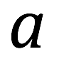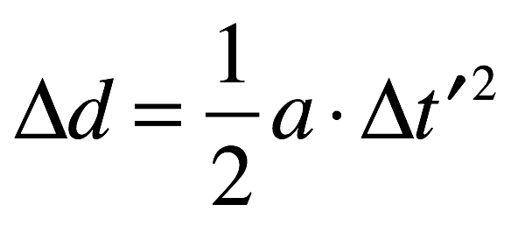

“How did I get that? First of all, we’re dealing here with constant acceleration. That means that velocity is increasing or decreasing the same amount at all times. Now, the displacement (or distance traveled) is equal to the average velocity times time: (e.g., if you’re moving at an average velocity of 60 miles per hour and you travel for two hours, then the distance you’ve traveled, , is 60 miles/hour x 2 hours equals 120 miles).

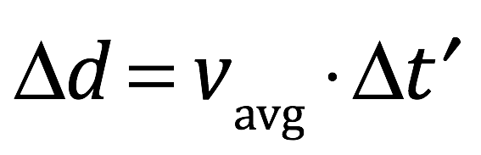

“Since our spaceship is traveling at constant acceleration, the average velocity is given by adding the initial velocity, , (the velocity you’re starting at) to your final velocity, , then dividing it by 2: .

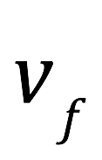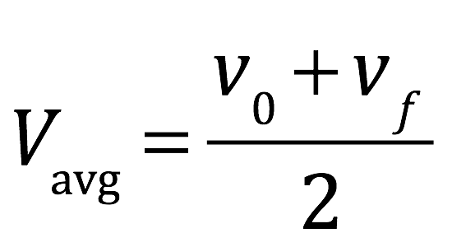

The change in velocity, between and equals the amount the velocity is changing per unit time (i.e. the acceleration, ) times the amount of time the ship is accelerating, in this case, . The change in velocity is given by subtracting the initial velocity from the final velocity, (e.g. if you start out going 20 miles/hr and you end up going 60 miles/hr, your change in velocity is final velocity minus initial velocity = 60 miles/hr - 20 miles/hr = 40 miles/hr). So

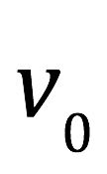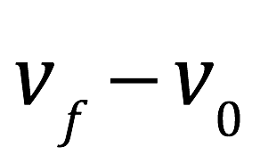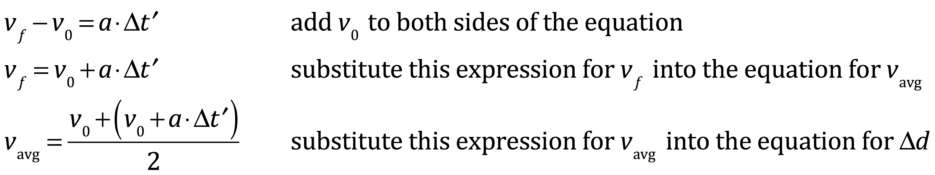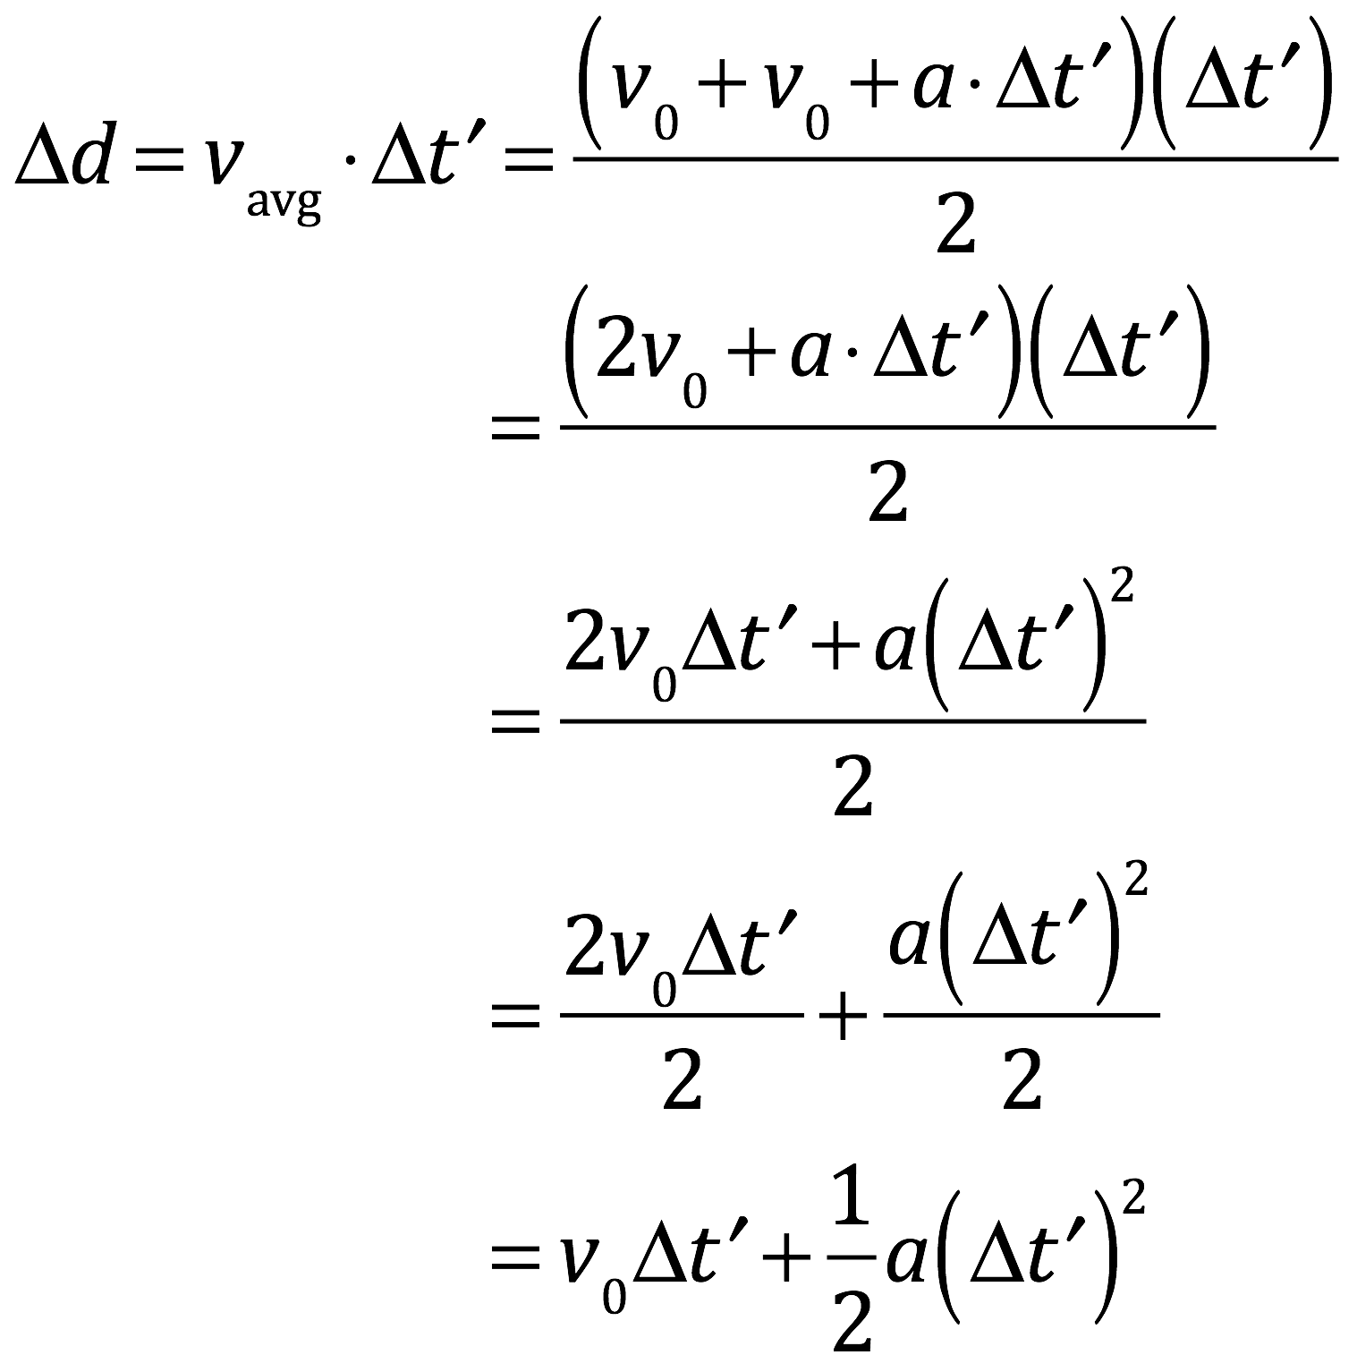

Let’s assume, for simplicity, that the spaceship isn’t moving when it starts. That is, . That gives

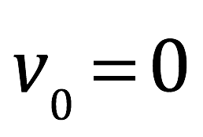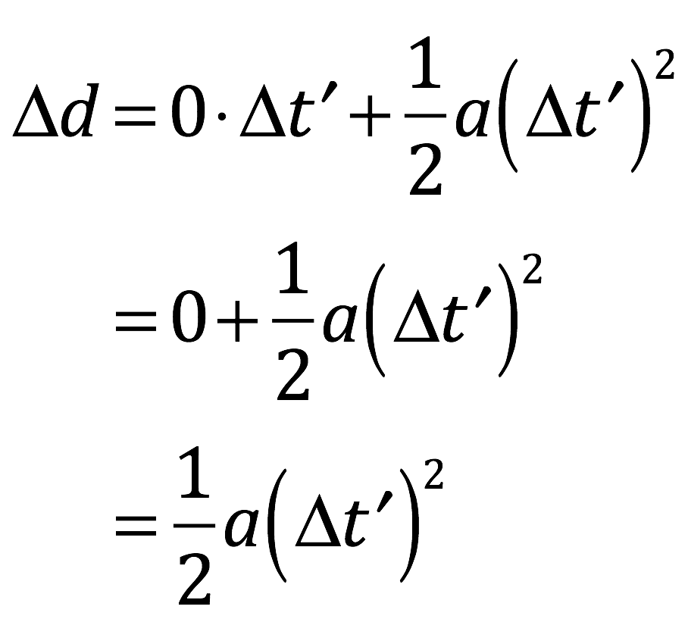

“Voila. That’s what we sought to prove.

“So now, the distance that the light in the spaceship has to travel in the presence of acceleration is the height of the elevator plus the distance it’s moved: . Which makes the time it takes to reach the detector on the ceiling . The time it takes to reach the detector in the nonaccelerating reference frame is given by . . That means that time runs slower when acceleration is present.

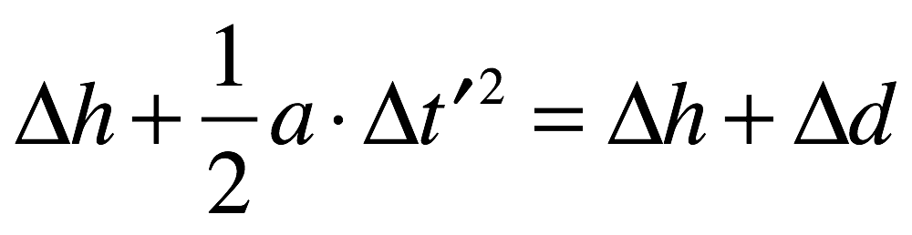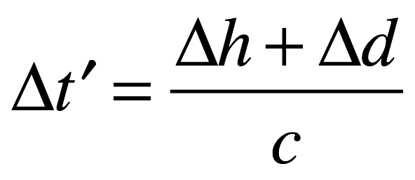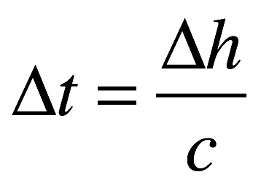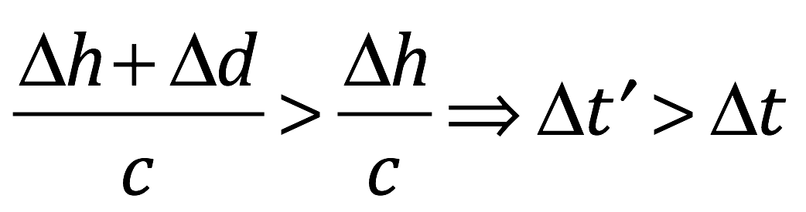

“It’s been shown time and again that experiments performed in a uniformly accelerating reference frame with acceleration, , (like our spaceship) are indistinguishable from the same experiments performed in a non-accelerating reference frame which is situated in a gravitational field where the acceleration of gravity, . Common sense confirms this. An elevator accelerates rapidly upward and you feel like you’re feet are being pulled down toward the floor. You step hard on the gas and your back gets plastered up against the seat like the seat is pulling you up against itself.

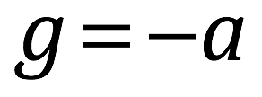

“Likewise, if you were on a merry-go-round spinning around at constant speed, and there was a wall on the side of the horse farthest from the center, you’d experience a tendency for your body to fly outward and a force from the wall pushing you back toward the center. The reason is that the motion of the merry-go-round creates an inward acceleration. You, on the other hand, want to keep moving in a straight line; the wall exerts a force on you that prevents that.”

Salito furrowed her brows. “Why is that?”

Danny’s answer was another diagram.

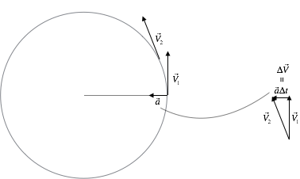

“Suppose you’re in circular motion with a constant speed. Your initial velocity is given by the vector which points straight up in the picture. After time, , you’ve moved around the circle and now your velocity is . The change in velocity, , is given by change in velocity per unit time, better known as the acceleration, , times the time over which the acceleration acts, : . As you can see, the acceleration points toward the center of the circle, perpendicular to the velocity vector. Now make smaller and smaller—infinitesimally small—until it’s almost zero. Do that and and you wind up with the instantaneous acceleration at the point of origin of the velocity vector. You can make the same argument for any short time interval anywhere on the circle. The result is always the same: the acceleration always points toward the center of the circle and this is so for every point on the circle.

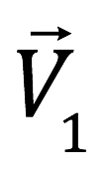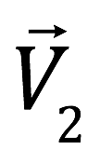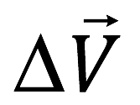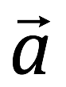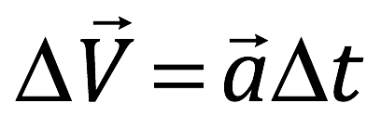

“So as you make your way around the circle, you’re subject to a constant acceleration, inward. We said previously that if you were in a rocket ship undergoing constant acceleration, you would have the experience of a gravitational force directed opposite to the direction of acceleration. Likewise, as you move around the circle, you would experience a force indistinguishable from a gravitational force directed outward.

“Horses on the periphery of the go ‘round are moving relative to an observer at the center. Therefore, from our previous discussion, to that observer at the center, a clock on that peripheral horse runs slower than hers.

“There’s also length contraction, which we also talked about. Say that our observer has two strings of the same length. She leaves one at the center of the merry-go-round, places the other on a horse at the periphery of the ride, returns to the ride’s center and sets the horses in motion. Then she measures the string sitting on the peripheral horse—don’t ask me how she does this; she just does. What does she find? She finds that the string on the peripheral horse is shorter than the string with her at the center.

Tenacce’s eyes flashed with disbelief.

“It gets more bizarre,” Danny said. “The circumference of a circle (C, the distance around its periphery) is given by two times the radius (, the distance from the circle’s center to the periphery) times pi (, which is about 3.14): . Say there are several rows of horses extending outward from the center to the periphery. The circular motion of a horse near the center will be slower than one at the periphery. Why? Because the distance (i.e., the radius) to a horse near the center is shorter than one near the periphery. Which means that the circumference traveled by the near center horse is shorter than the horse on the periphery. In the same amount of time, though. So the velocity of the near center horse is less than that of the peripheral horse. Now, the observer in the middle of the merry-go-round tries to measure the length of the strings used to measure distance along the path of the horse close to the center and the horse far from the center. Because of length contraction, what she finds is that the length of the measuring string used at the level of the close horse is longer than the string used to measure distance at the level of the horse on the periphery. And by the same logic, units used to measure length and time vary everywhere, depending on their location relative to the merry-go-round’s center.

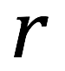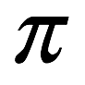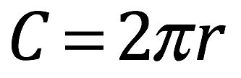

“From this, you have to start thinking: moving around in a circle like a merry-go-round creates an acceleration indistinguishable from gravity; it also changes the magnitude of the basic units of length and time; so maybe gravity has the same effect on space and time.

“Next consider these facts. Suppose you were inside a spaceship in deep space far away from anything else and the spaceship were moving with constant velocity. If you had a ball in your hand and you let go of it, it would just sit there next to your hand. That’s because both the ball and your hand are moving at the velocity of the spaceship and both will keep moving with that velocity unless some force interacts with one or both to change their velocity. Now suppose you’re in an elevator, holding a ball, and the elevator gets pushed off a cliff—a very high cliff—towards a massive body, in this case, the earth. You let go of the ball. What happens.”

“It just sits there,” Salito exclaimed like an enthusiastic student, seeking the approval of her teacher.

“Why?”

Tenacce joined the mix. “Because the earth is pullin’ on the elevator, causing’ it ta pick up speed. Me and the ball are pickin’ up speed at the same rate. I don’t even think I’m movin’. The elevator, me and the ball are pickin’ up speed at the same rate so we’re all gonna stay in synch unless somethin’ outside us changes that.”

“Why do you, the elevator and the ball all fall at the same rate? After all, your masses are different.”

Salito answered this one. “Because the force of the earth on each of ya is proportional to your mass. Force equals mass times acceleration. Newton’s second law.”

“I thought you didn’t like school.”

“I didn’t. I memorized it for a test once.”

“You’ve got a good memory. That’s right. Both of you. It’s because gravitational mass is equivalent to inertial mass.”

He erased the ink on the whiteboard and covered it with a new picture that looked something like this:

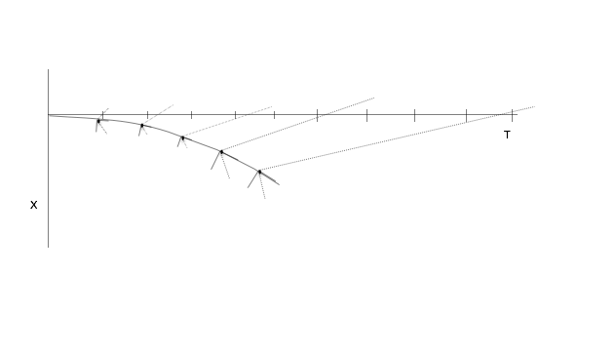

“Now check out this diagram. In the diagram, the horizontal axis is time. The vertical axis is displacement. Consider a person at “rest”. Her position doesn’t change but time marches forward. Thus, her course through spacetime is along the time axis. This is an inertial frame of reference; she is subject to no acceleration. The distance between the black tick marks are basic time units—light-seconds, for example, the time it takes for light to go meters. These units are nice and regular. The interval between them doesn’t change from mark to mark. This is an example of flat spacetime.



“The downward curve is the spacetime trajectory of an object under the influence of a so-called gravitational field, created by a mass—a person in free-fall in an elevator toward the earth, for example. As the good Lieutenant has already so eloquently explained, the person in such free-fall—just like the person at rest—doesn’t think he, or anything in the elevator is moving. His frame of reference is an accelerated one and moves along synchronously with the elevator. Thus, to the person in the elevator, time ticks along regularly, just like the observer at rest; the interval between the black dots along the curved trajectory is the same as the distance between the black tick marks on the time axis. Notice, also, that over a very short interval of spacetime along the curved trajectory (or anywhere else, for that matter), spacetime looks flat, just like the spacetime trajectory of the person at rest. It’s like there’s a little set of axes at each point in spacetime, including along the curved trajectory. The time portion of the little axes are pointed along the direction of motion. Now suppose the person on the curved trajectory sends out a light signal, at regular intervals, from each black dot on the graph, to the person at rest. To make things easy, we’ll choose each unit along the distance axis of the miniature axis systems to be meters and each unit along the time axes to be one light-second. The light travels at meters/second toward the observer at rest. So on your little set of axes, you move one unit (representing meters) in the negative x direction and one unit (one second) in the positive direction along the time axis. You draw a line with an arrow at its end from the origin of your axes to that point. That’s the path that the light ray takes in spacetime. It turns out, if you draw it, that light ray path makes a 45° angle with the negative x-axis, on the positive time axis side of that axis. In the diagram, the light ray path is depicted by the dotted lines. Note that, as time progresses, the dotted lines intersect the horizontal time axis at increasingly longer intervals. What this means is that, the observer at rest sees time passing slower along the curved trajectory when compared to her own frame of reference. Thus, the time dilatation produced by a gravitational field (or an accelerated reference frame like the merry-go-round) is reproduced by a curved time axis.



“A similar thing happens with space. As we’ve discussed, length contracts with increasing acceleration or increased effects of gravity.”

There was squealing on the whiteboard as Danny Tenacce erased and redrew.

“In this diagram

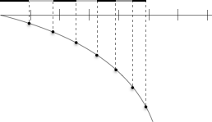

“the horizontal line represents the spatial axis of an observer at the center of a merry-go-round—or analogously—one infinitely far from a gravitational source. Note that the distance between tic marks (i.e., the length of spatial units) is uniform throughout this flat space-time dimension. The curved line represents the spatial axis of an observer walking outward on a merry-go-round or traveling toward a gravitational source. The distance between the tic marks on the horizontal line and the black dots on the curved line are the same. The alternating black and gray line segments represent the lengths of strings on horses on a merry-go-round—or unit lengths on a displacement axis—measured by an observer at the merry-go-round’s center, or an observer infinitely far away from a gravitational source. The closer to the right the strings are on the diagram, the closer to the periphery of the merry-go-round they’re located and visa versa. Similarly, the closer to the right the strings are on the diagram, the closer to a gravitational source they’re located. As we’ve said, and as is shown in the diagram, the farther from the center of the merry-go-round a string is, the greater its velocity around the circumference of the circle, the greater its inward acceleration and the shorter the length of the string segments are, from the viewpoint of the center of the merry-go-round observer. Likewise, from the frame of reference of an observer infinitely far from a gravitational source, strings—or if you like, length elements—get shorter and shorter as one gets closer and closer to the source. But it’s also evident from the picture, that shortening of basic length elements is indistinguishable from curvature of space.

“Indeed, the concept of a gravitational force is an illusion. What’s really happening is that foci of mass or energy (the two can be thought of as interchangeable) curve spacetime and objects moving through spacetime near those mass/energy sources follow the resulting curved pathway, hugging the curved coordinate system along as straight a path as possible, such a straight-as-possible path being better known as a geodesic.

“I spoke about there being a miniature coordinate system at every point in spacetime. This can be summarized by a thing called a metric tensor, , that tells you how long basic units of length are in each dimension. Take, for example, your standard piece of graph paper, which, basically, is a representation of a two dimensional Cartesian coordinate system:

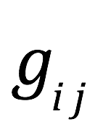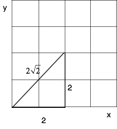

“At every point in this space, the distance between units are equal in all directions and axes at every point are at right angles. Because of these facts, the length of any tiny displacement on the graph, (called the infinitesimal displacement vector), at every point in the space, is given by , where and are the displacement vectors along each axis that you have to add together, as vectors, to get . , parenthetically, is referred to as a line element. That’s why the Pythagorean theorem works in this space. In the above diagram, then:

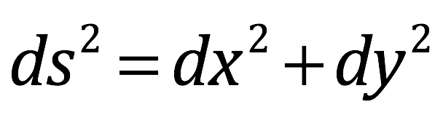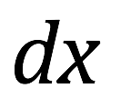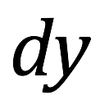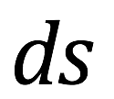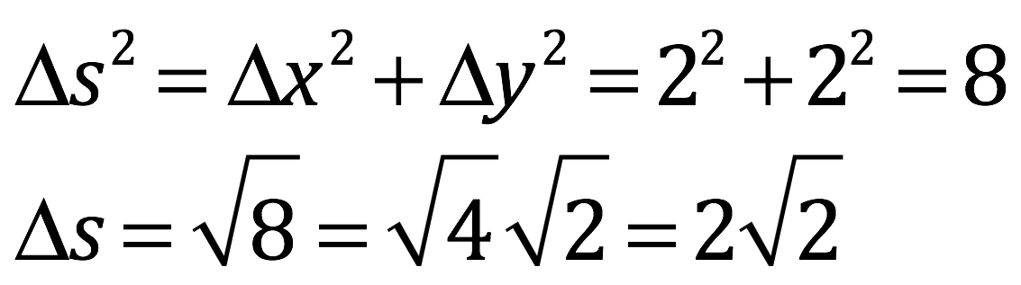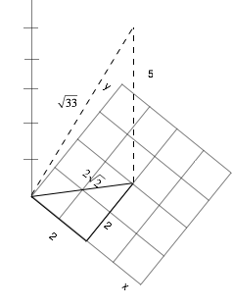

“But if we add another flat dimension, you can see from the diagram that the Pythagorean theorem, in expanded form, still works:

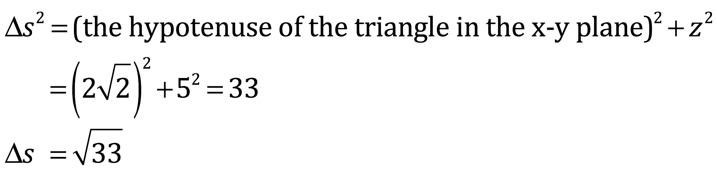

Hopefully, this helps you see that the square of the infinitesimal displacement vector for the 3 dimensional space I just described is . This equation can be represented in a couple of different ways that, in many situations, are more useful. The first is by looking at as a matrix:

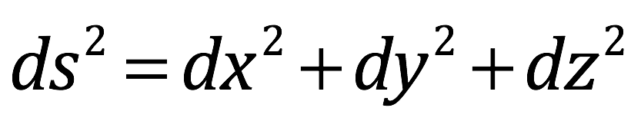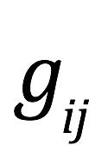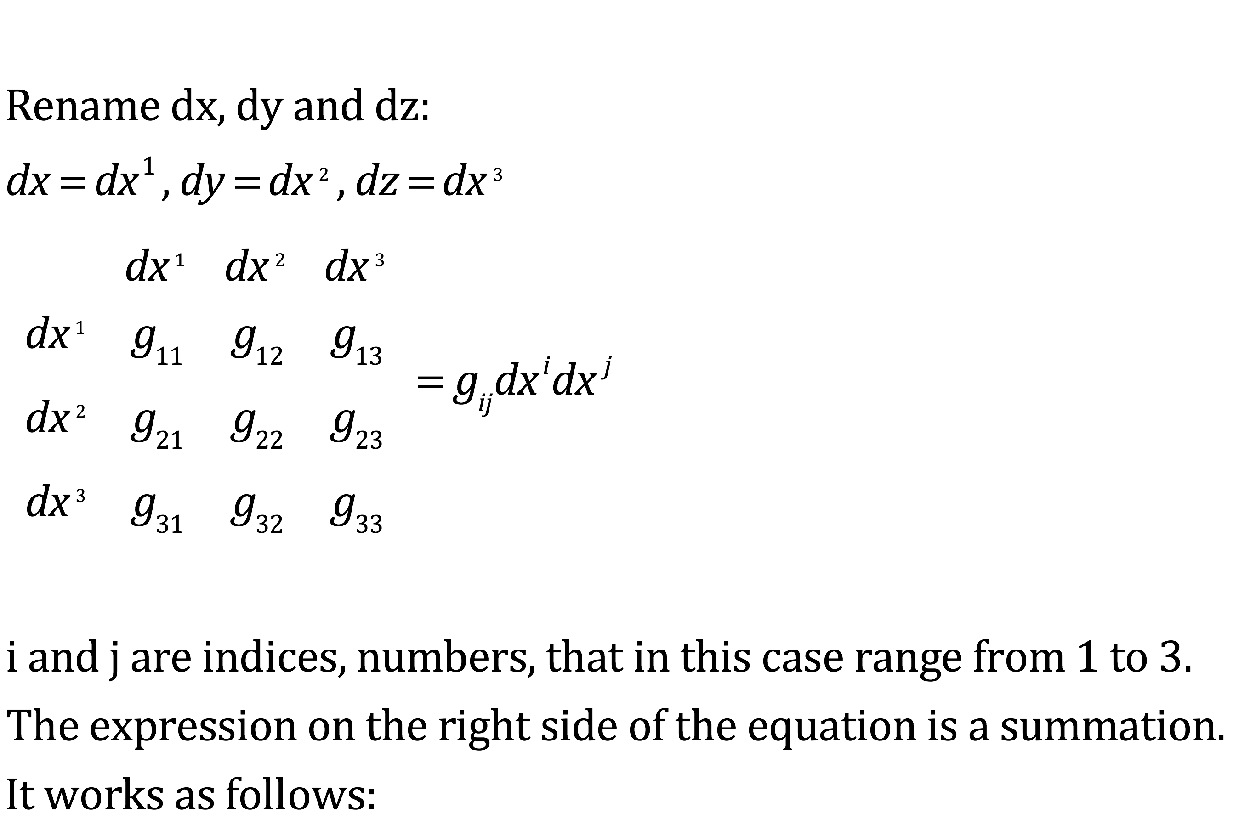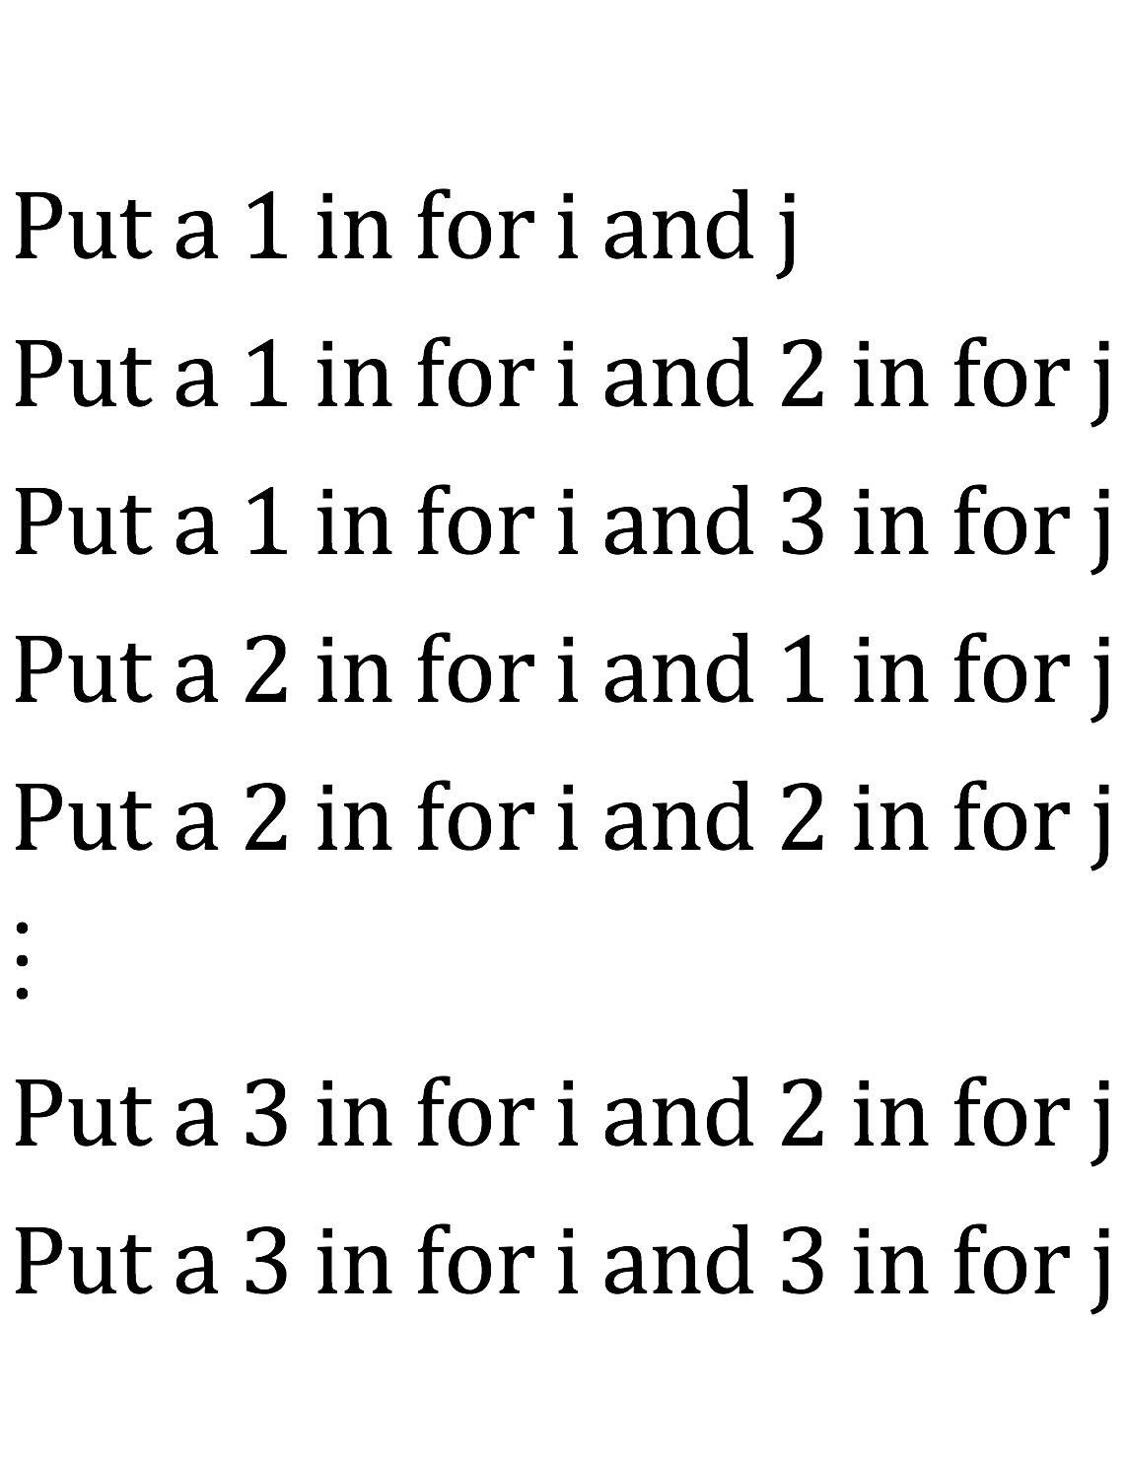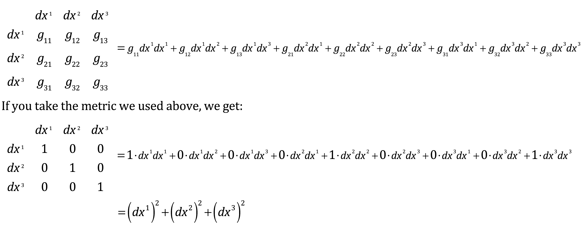

“Let’s go back to the 2 dimensional case for a minute and let’s go back to calling our infinitesimal coordinate displacements and . For any point in spacetime, if:

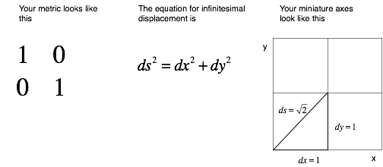

“That’s the metric associated with flat space. The metric associated with gravity-induced spacetime curvature is more complicated. As I’ve said, you can think of there being a little set of coordinate axes at every point in spacetime. A gravitational source will change the size of units on those little time and spatial axes depending on how close a given point in spacetime is to that source. Alternatively and equivalently, as I’ve illustrated, you can also think of mass/energy causing curvature of the time and spatial axes.

“Now the manner in which spacetime curves is given by the equation:

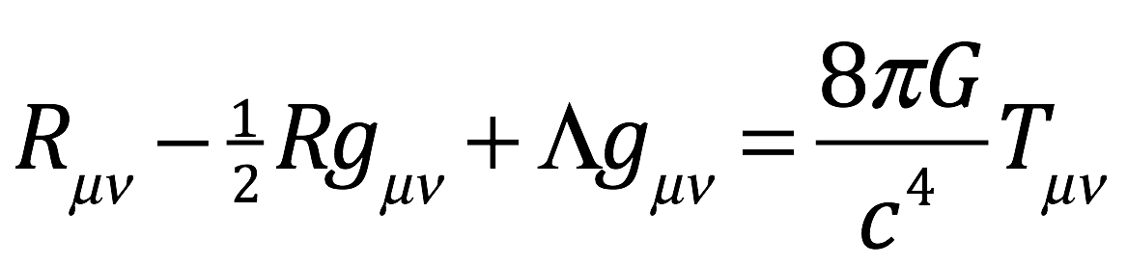

Where

is the Ricci curvature tensor

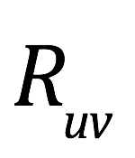

is the metric tensor

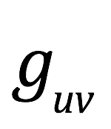

is the Ricci scalar

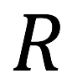

is the cosmological constant

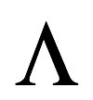

is Newton’s gravitation constant

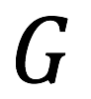

is the stress-energy tensor

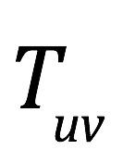

Tenacce grinned. “There’s a lot o’ stress and tension in that equation. Makes me tense just lookin’ at it.”

Danny Tenacce was facing the whiteboard but turned to his father and reflexively met his grin with the same expressionless face he usually used on students who, not comprehending the material he was teaching, attempted to counter their ignorance with humor.

“Yes,” he remarked flatly, “It would take an Einstein to derive this equation. The point I wanted to make by showing it is that the right side of the equation represents mass and energy and the left side of the equation represents the spacetime curvature caused by that mass/energy. I’ve already discussed how the metric is a description of the curvature of spacetime—tells everything there is to know about that curvature, actually. It turns out that the Riemann tensor, , is derived from the metric; the Ricci tensor, , is derived from the Riemann tensor; the Ricci scalar, , is derived from the Ricci tensor; and the terms , (the speed of light) are constants—just numbers. So it’s easy to see that the terms on the left side of the equation, indeed, reflect spacetime curvature.”

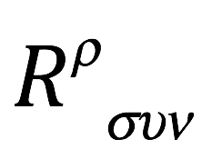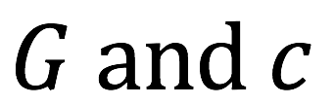

His stab at humor having been rebuffed, Tenacce assumed a sullen slouch. “Indeed,” he echoed, “but does any o’ this got a point?”

“Yes. The point is that time passes very slowly to God as compared to us. Suppose there’s a spherical, stationary, uncharged mass sitting out in deep space where there’s nothing else around it for a very long distance. You know from what I’ve told you that this mass will cause spacetime to curve and that curvature will be greater close to the mass than far from it. As one progresses farther radially outward from the mass, each spherical surface, or shell, will have that same spacetime curvature. To understand the metric associated with this arrangement, it’s better to use polar rather than Cartesian coordinates. Instead of thinking of space as a three dimensional box with x, y and z coordinates, imagine it as a three dimensional sphere with a gravitational source at its center. Each point in space can be expressed by a radial coordinate, , that’s the radius of the sphere; , an angular measurement along a line of latitude around the equator of the sphere; and , an angular measurement along a line of longitude. Here’s a picture:

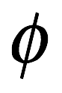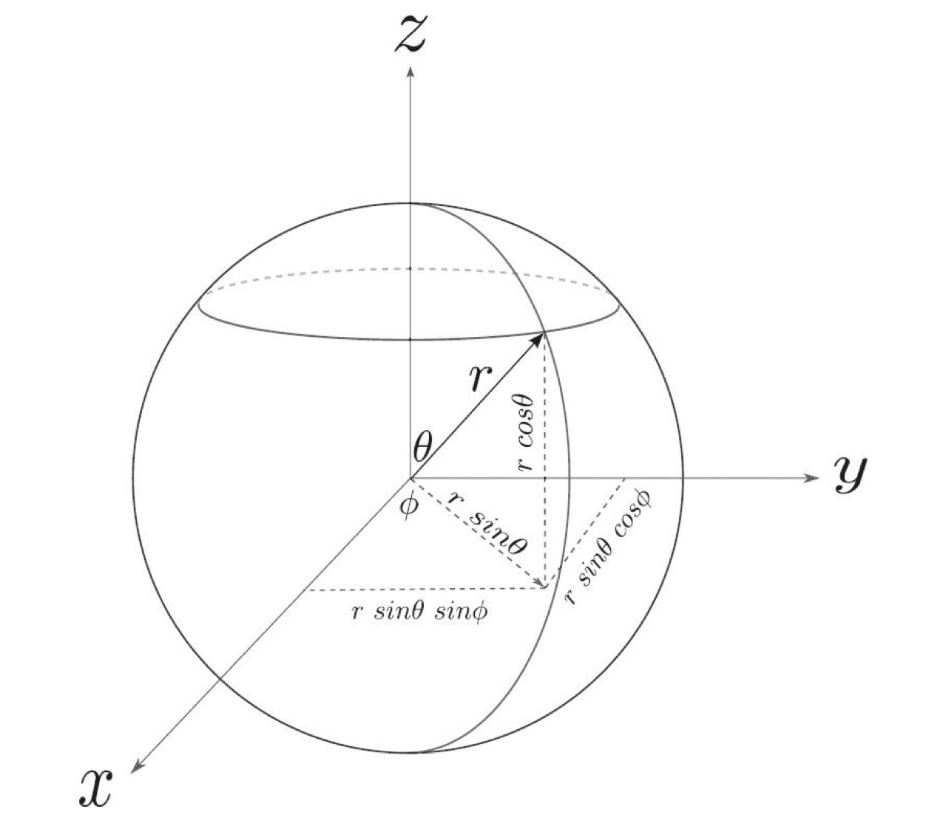

The metric for this spacetime, in polar coordinates, is:

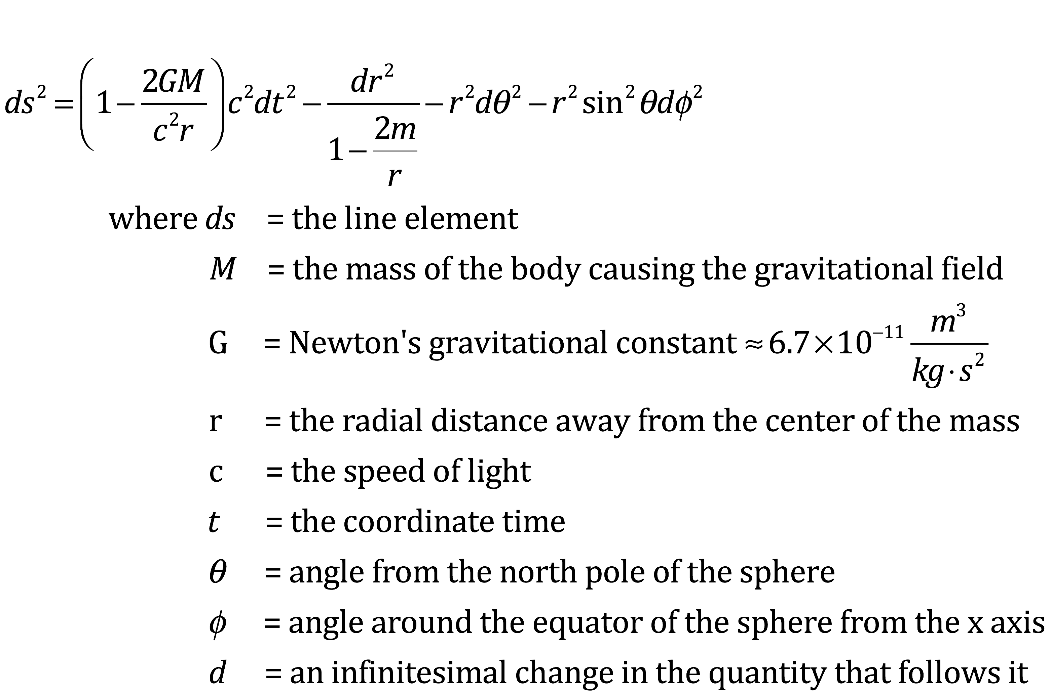

“It would take an Einstein to derive this equation. More like a Schwarzschild, actually. However, from it, we can determine how time dilation changes with distance from a gravitating body (i.e., a body with mass/energy that warps spacetime.)

“The effect of gravity only depends on how far you are from the center of the sphere; the angles don’t matter. Therefore, we can just consider concentric circles in the x-y plane and we’ll only consider the radial direction along the y-axis. We want to know how fast clocks tick at a distance very close to the center of the mass, , (where gravity is very strong) and very far away from the mass, , (where the gravitational effect is very weak.) Since we’re considering the effects of gravity on time at two fixed points in space, we aren’t going to be changing , , or . That means that . So the metric becomes:

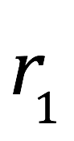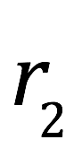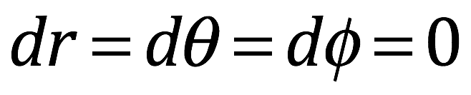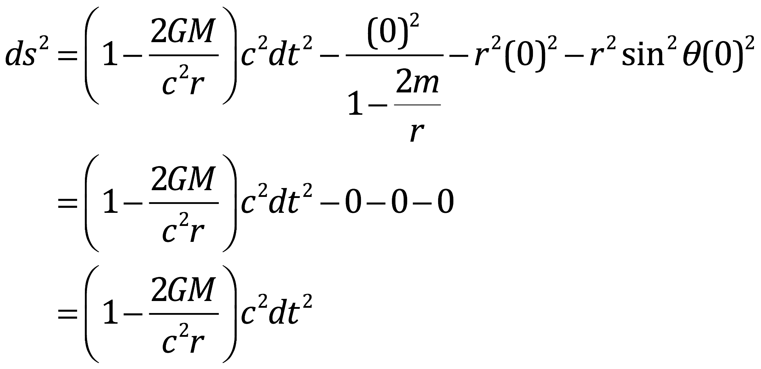

“Now I have to introduce a quantity called proper time, . Proper time is the time measured by observers in their own frame of reference. And observers measuring something in their own frame of reference don’t think they’re moving. For example, suppose you’re driving in a car at 70 miles per hour relative to observers on the side of the road. You have a bag of groceries in the car. To the observers on the roadside, the bag of groceries is whizzing by at 70 miles per hour, but to you, in your frame of reference (and that of the grocery bag), the bag of groceries is not moving. Now you have a clock with you in the car. The clock is ticking away. The time kept by that clock is, by definition, the proper time for you and that bag of groceries, and an infinitesimal time interval kept by that clock is called the proper time interval. That interval is invariant. Any observer in any frame of reference agrees that your clock measured that time interval.

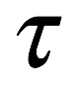

“There’s an important relationship between , the infinitesimal line element, and . It goes like this. For flat so-called Minkowski spacetime used in special relativity, the metric is:

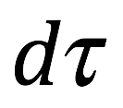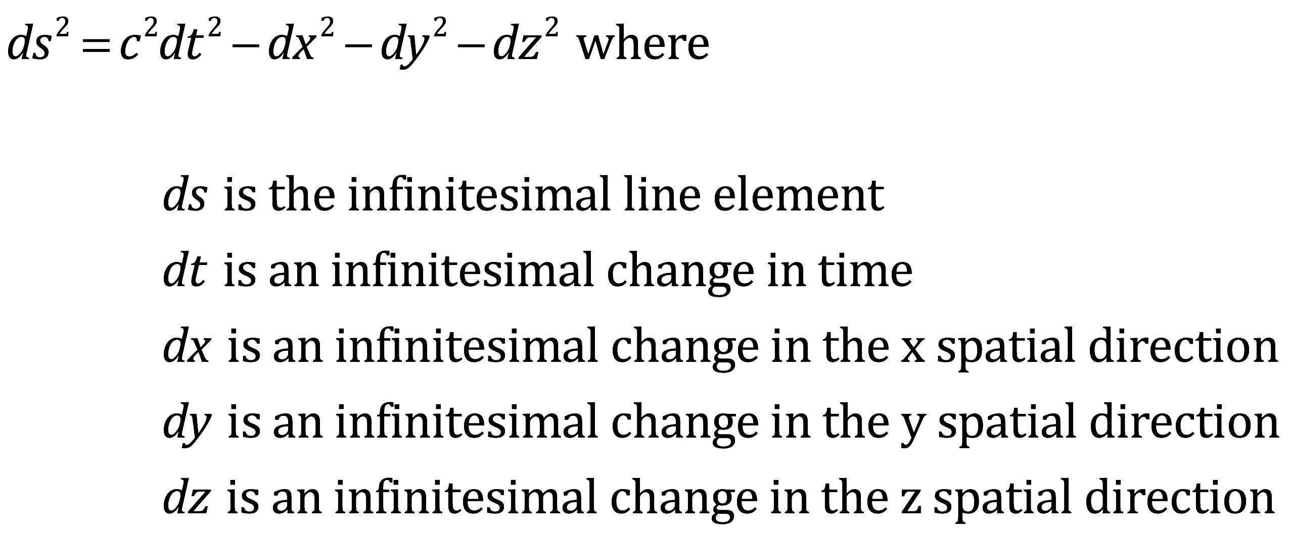

“As we’ve said, objects (like the bag of grocery bag and the observers themselves) aren’t moving in their own reference frame. To them, there is no change in spatial coordinates happening, infinitesimal or otherwise. So, , and . But the coordinate time, , kept by observers in their own reference frame, *is*, by definition, proper time, . Therefore, .

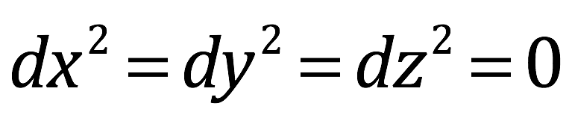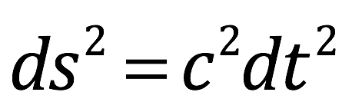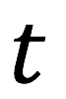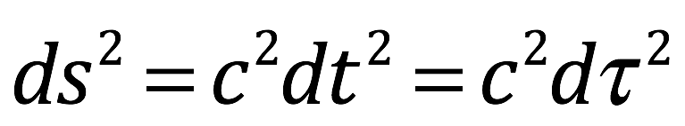

“Plugging that back into our metric, we have:

divide both sides by yielding

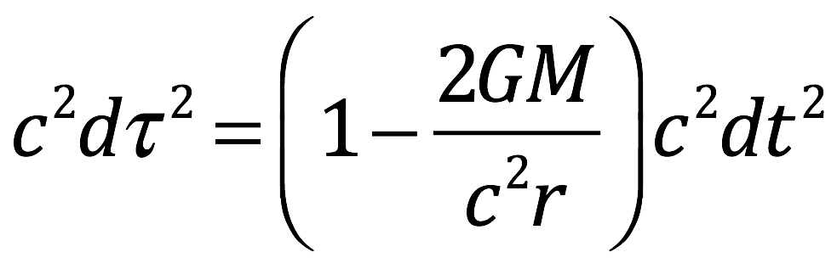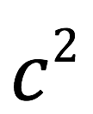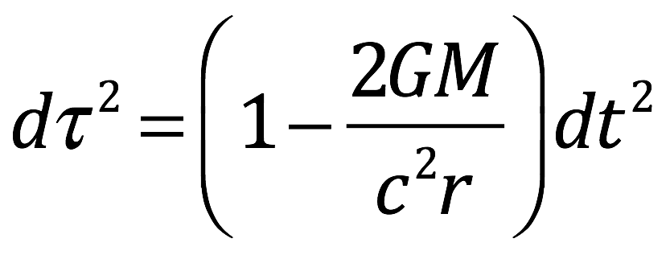

“In this equation, represents time as measured in the reference frame of an observer some distance, , from the center of a massive object, and represents time as measured by an observer an infinite distance from the center of the massive object, where gravity has no effect. What we want to know, specifically, is: if an observer close to the mass’s center, say at , measures a time interval of 7 days, and a second observer far away from the mass, say at , measures the same amount of time as 13.7 billion years, what mass does the massive object need to create this effect?

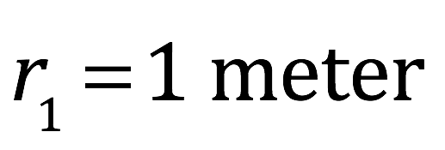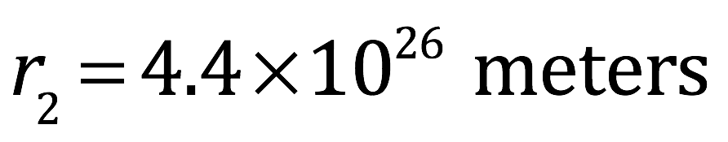

“So we know the following information:

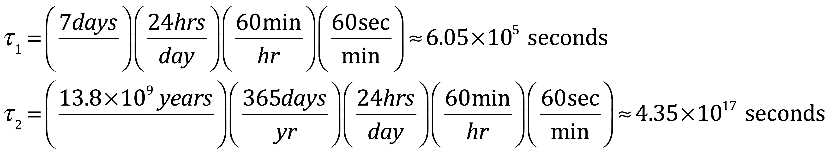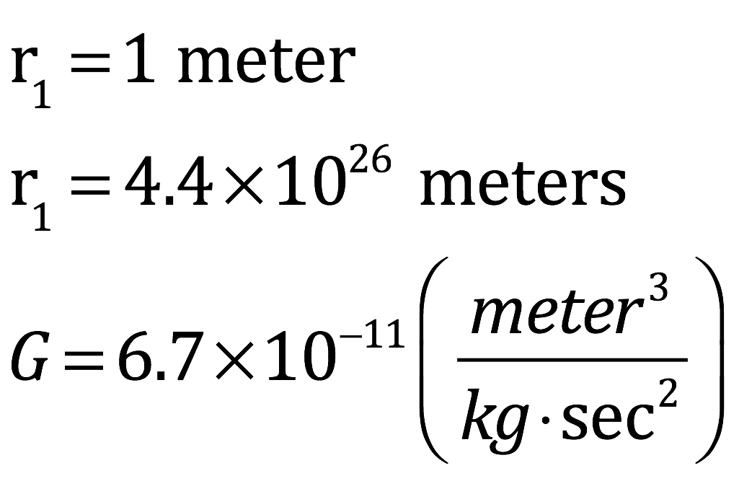

“We also know and so

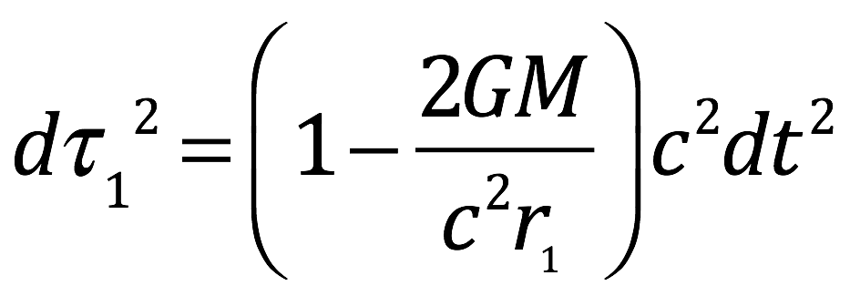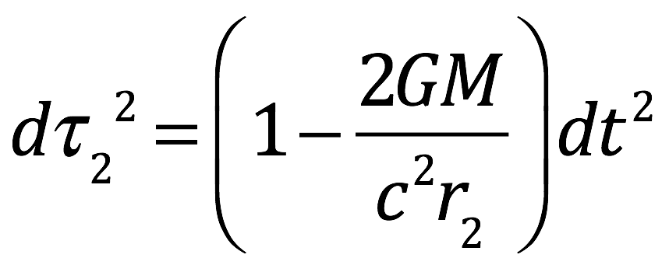

the terms cancel

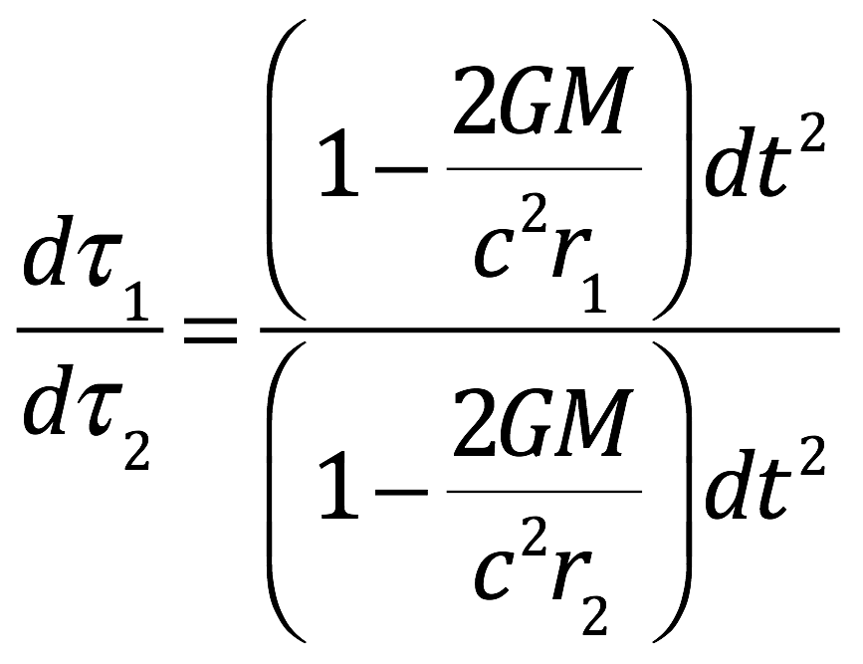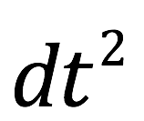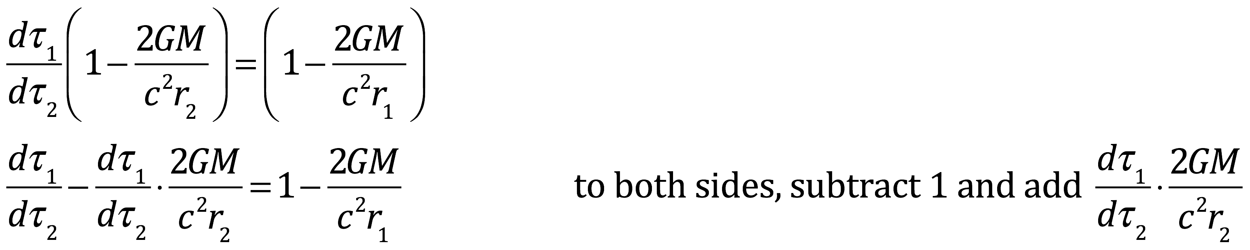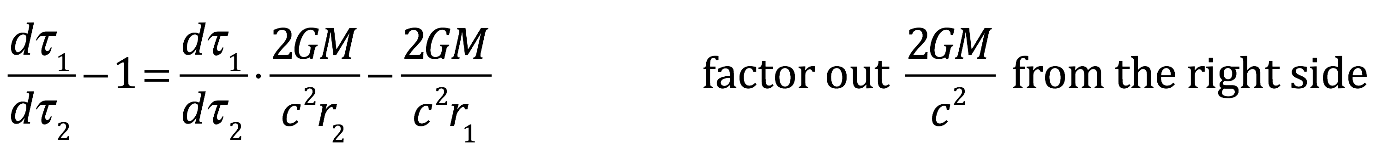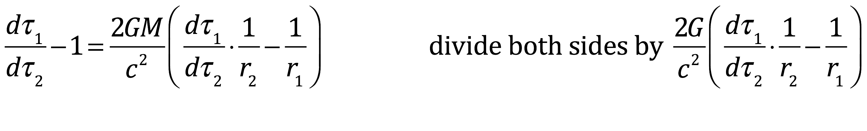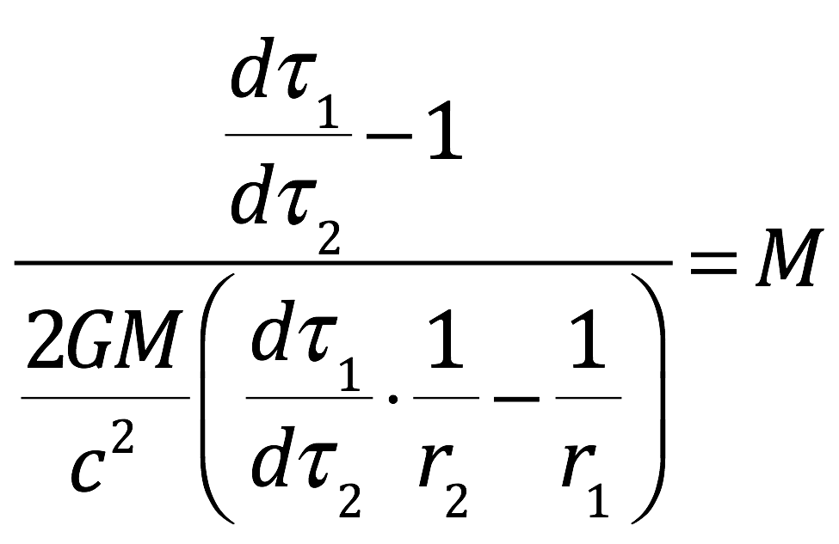

“Now let’s put in some numbers. . is almost zero. Therefore, . By the same reasoning, . But . That gives us

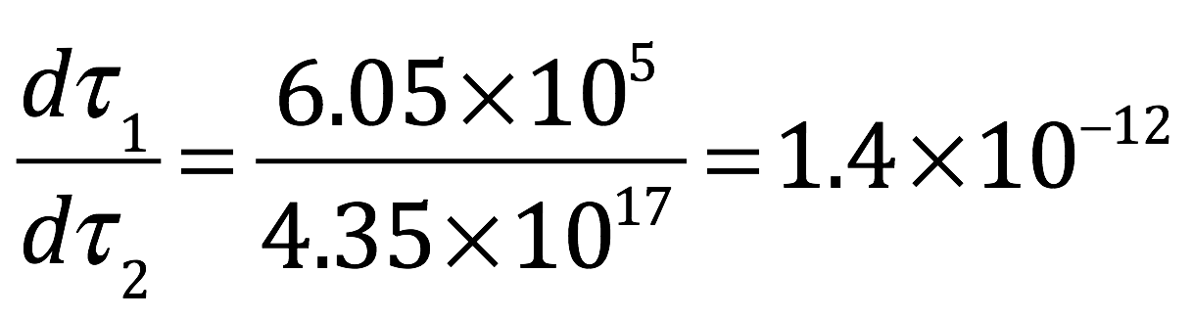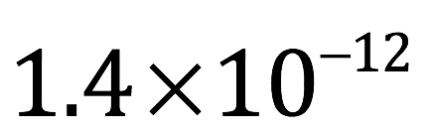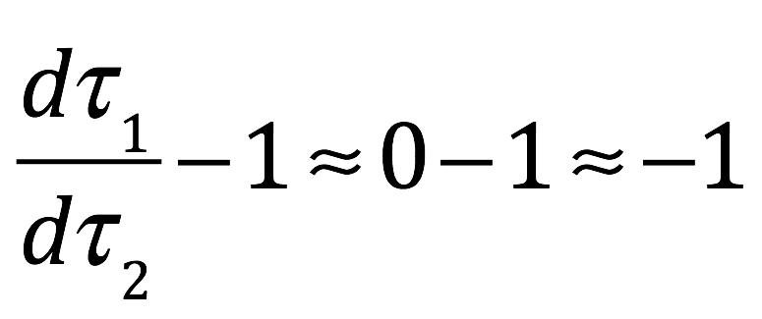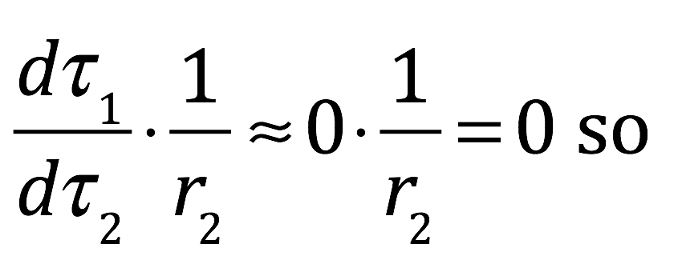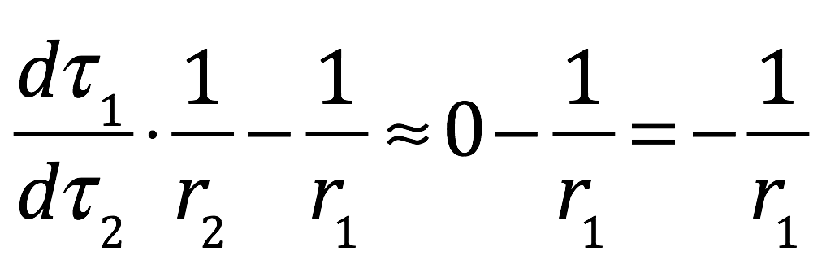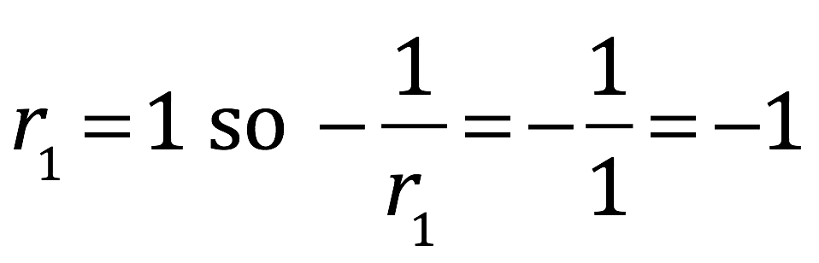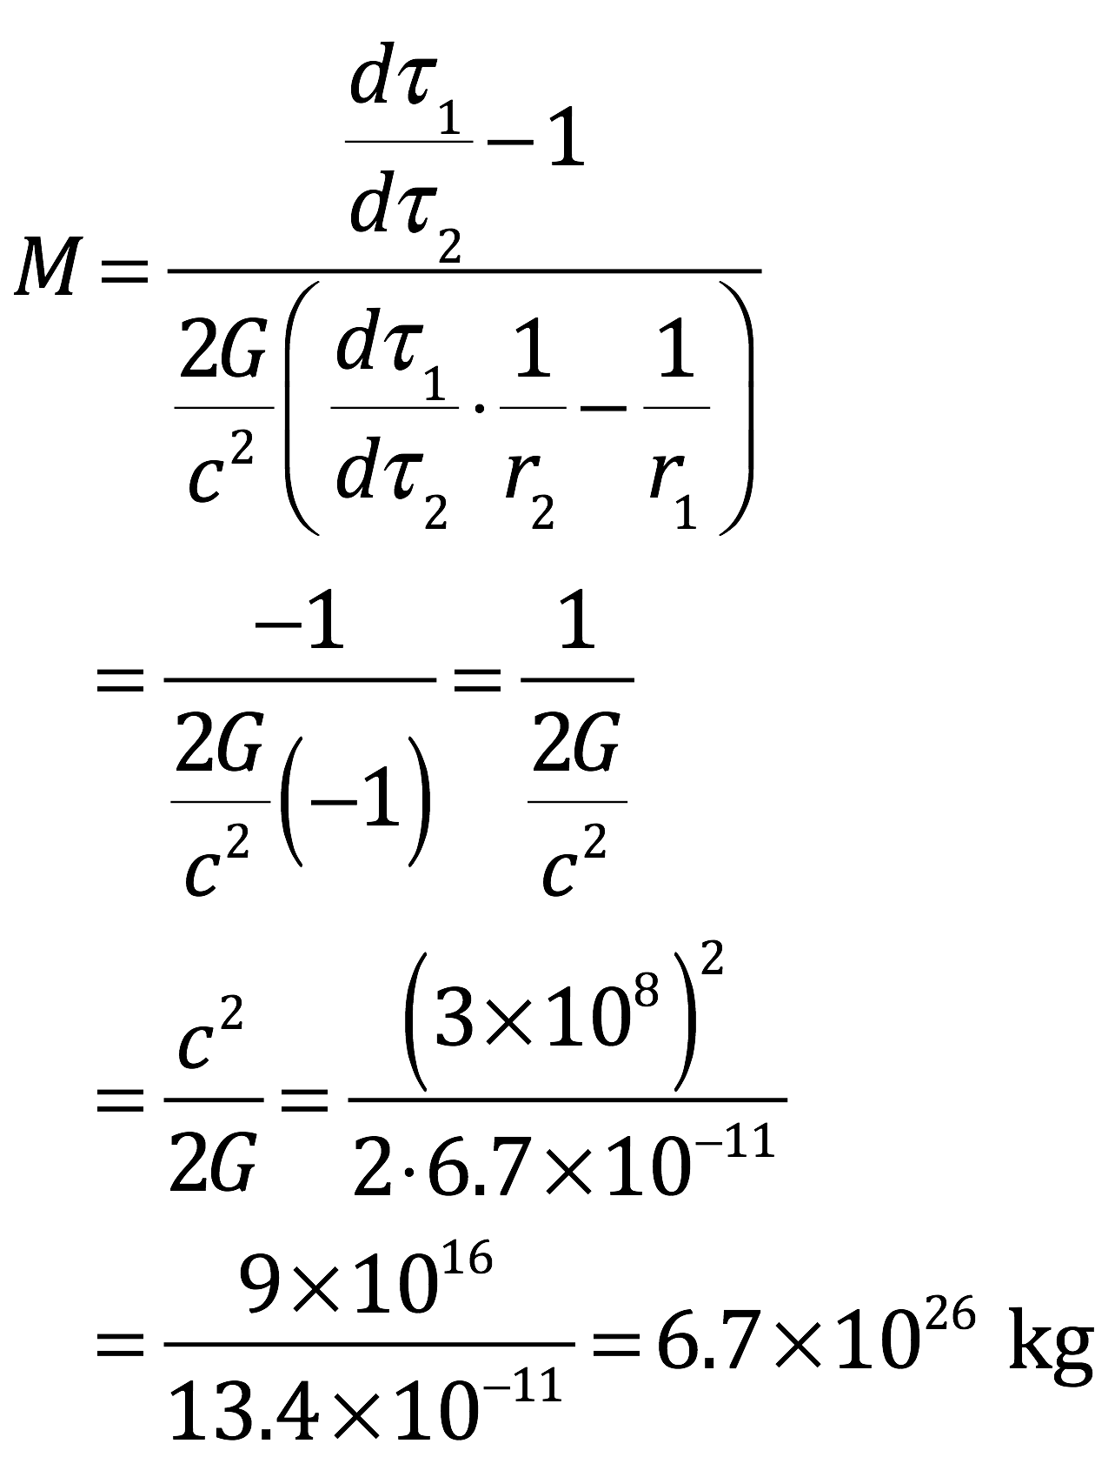

“So you’re tellin’ us that God weighs kg,” remarked Salito.

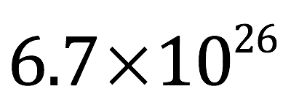

“Not exactly,” Danny replied.

Tenacce sighed deeply.

Danny erased the equations that covered the whiteboard and drew another one of his diagrams in their place.

“A setup that more closely approximates the actual situation is this: “We reside on a vesicle in spacetime called a brane. Our brane—call it the weak brane—has 3 dimensions of space, 1 of time and floats in a spacetime sea of 10 dimensions—9 of space and 1 of time (or 10 and 1, depending on how you look at things, but we won’t get into that here). Close to our brane is another 3 +1 brane (3 space and 1 time dimension) separated from us by a fifth spatial dimension. Call it the strong brane. This fifth dimension is very small, on the order of a Planck length, as I’ve told you, approximately meters meters (obviously, the diagram is nowhere near to scale.) The particles associated with the weak brane stay on the weak brane and those associated with the strong brane stay on strong brane. The particles within a brane can interact with each other but particles on one brane can’t interact with particles on the other. Gravitons, the particles that transmit the force of gravity, however, are an exception. They can move between, and interact with particles on, both branes.

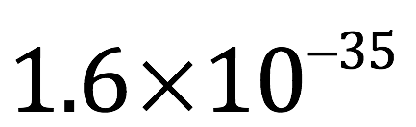

“Now the strong brane is called strong because it’s massive and it markedly curves spacetime.

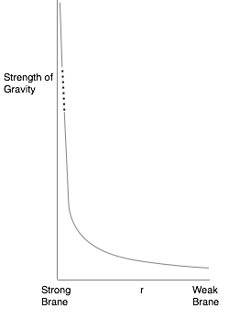

The curved line in the diagram is, roughly speaking, a graph of the strength of gravity along the fifth dimension (not nearly to scale). Note that it drops very sharply—exponentially—as one moves from the strong brane to the weak brane. Gravity is as strong on the strong brane as it would be very close to an enormously massive object—and time would move just as slowly. But because of the marked warping of spacetime, you only have to go about a Planck length before gravity is as weak (and time passes as quickly) as it would at a colossal distance from that enormous mass.

“Suppose God was located on the strong brane (perhaps we should call it the heaven brane) when he created our universe. He would say that the time it took to create us, on the weak brane, was a lot shorter than how long we would say that creation took. It’s not that simple, though. The mass is not distributed equally on the strong brane and the mass amount and distribution change with time. Also, the shape of the strong brane is irregular and changes with time. Furthermore, for an observer on earth, the rate at which time passes changes with the evolution of the universe; early on, when other matter was closer, time passed more slowly than now, when the universe is less dense and varies with the universe’s expansion rate. Thus, the rate of time passage varies with time, both for observers on the earth and on the strong brane. However, when all of these factors are taken into account, because of time dilation, the creation of the universe from the big bang to the dawn of man took six days (and one day of rest). At least from God’s point of view. On the other hand, from our point of view, it took 13.8 billion years.”

Tenacce’s lids and brows opened widely. “Branes and extra dimensions … do scientists actually believe this sh…”

“Published by two well-respected theoretical physicists from Boston—a woman and a man—in 1999,” replied Danny nodding.

Salito sat quietly contemplating all that had been said. Tenacce rubbed his five o’clock shadow, gazing through the diagram of the branes. Then he turned his attention back to Danny. There was obvious hesitation as the words came out.

“So all this stuff about evolution. I guess—”

“All true. Not exactly how he planned it when he set everything in motion, because of the antipathetic maneuvering of the evil one. But He salvaged it pretty well, don’t you think?”

Tenacce frowned.

Salito seemed less troubled. “I can see how the stepwise creation story resembles evolution and all,” she said. “But what about the discrepancies? You know, plants and fruit trees before the stars, birds before land animals, Eve from Adam’s rib and stuff like that.”

“Oh it’s true. The woman came from the man’s rib,” said Danny. He strained to keep his expression deadpan.

Salito glared. He grinned.

“Seriously, though. She asked that very question.”

“And what did He tell her?”

“In so many words? Imagine you were God, and you were trying to inspire your follower to transcribe the story of creation for all posterity. The problem is, your follower doesn’t know the first thing about atomic particles, energy, forces and branes. So you tell him about water and land and stars and domes, and he writes it down the way he understands it. He has no idea about DNA or natural selection, so you tell him about the process of evolution, in as familiar terms as possible, but he’s still so confused about what you told him about the water and stars and so forth that he gets a few of the details mixed up. And he can’t count any higher than ten because that’s all the fingers he has, so rather than telling him about general relativity and numbers like 13.8 billion, you talk about seven days instead. And after he writes it all down, you insight a few dreams and visions so he tweaks it a little to make it a little closer to the truth. But when he’s done, you’re pleased with his work, because you know that your typical audience isn’t a young woman with an IQ of greater than 200 from whom your son will expel seven demons, nor is it a bunch of twenty-first century physicists. It’s billions of illiterate and nearly illiterate people over thousands of years plus a large number of additional people with some intelligence and education but who still couldn’t understand a more rigorous explanation if you gave it to them. The creation story is like the rest of the Bible—written such that it conveys the best understanding of the kingdom of God, to the greatest number of people, from the time that man was created until the time that it all ends.”

Tenacce’s eyes widened at this. “Speakin’ o’ the end, did he say how and when it’s gonna happen?”

“When? No. How? Yes.”

“And how is that?”

“How do you think?”

“In a bunch o’ mushroom clouds.”

“More or less.”

“So then there wasn’t any Adam and Eve, I suppose.”

“Oh, there was an Adam and Eve. They were the two God chose to perpetuate the kingdom. Through the natural evolution of the wave function and the modifications he produced in it, by infusing quanta at the proper points in spacetime, he induced genetic mutations that made their brains large and complex enough to carry out the plan he devised for them. To guide them, he spoke to them in visions. He didn’t actually materialize before them. Instead, he infused quanta into their brains, stimulating the correct neurons with the appropriate timing to make them see and hear him.”

“How come God doesn’t do that ta me, or you, or any of us today?” Salito protested.

“If you had a vision of God speaking to you, what would you think?”

“I’d think I was crackin’ up. OK, I see your point.”

“So was there a Garden of Eden and an apple?” Tenacce asked.

“There were both. Through these visions, he led them away from the remainder of their pre-humanoid contemporaries, to the perfect place. They and their progeny were destined to lifetimes of ignorant bliss, all needs cared for in that Garden utopia. God had made them simple creatures designed largely to imbibe the pleasures of their surrounding paradise. But he knew of the apple and his adversary’s plan. In giving them a well-developed neocortex and a small part of Himself to modify activity in that neocortex that was contrary to his ends, God gave them the ability to override the natural pleasure-seeking tendencies that he had been forced to embed in their neural machinery for survival. Indeed, he warned them of the danger of that alluring red fruit but—you know the story—Satan, that clever devil, made his play; Adam and Eve succumbed. The apple wasn’t magic; just the vehicle that contained the mutagens that would create, in their offspring, brains that were larger and wired for aggression, gastrointestinal tracts that were incapable of digesting the delicacies that were plentiful in Eden and metabolic pathways that rendered the byproducts of what they could ingest, from the garden, toxic. I was always under the impression that God banished them from the garden to punish them for their disobedience. He didn’t banish them to punish them. He banished them to save them. Not them, per se, but those that came after them. He banished them to save his creation. And it wasn’t toward them that his anger was directed. It was the enemy. For them, Adam and Eve and their progeny, he had only pity (well, maybe a little anger) because, knowing everything, he knew what was in store for them; what was in store for us.”

Salito supinated her hands in a palms-up gesture of perplexity. “So why did he decide ta create the book in the first place? And why did he choose her as the one to tell it to? Why didn’t he tell all this to his disciples.”

“Let me answer the last two questions first. The explanation for why he conveyed all the information in the book to Mary is simple: she was the only one with sufficient intellect to understand it. She was a high-grade genius and that genius drove her to madness before he saved her. The ‘seven demons’ from which he extricated her were psychotic delusions and hallucination brought about by her self-reflection and realization of the hopelessness of her condition and that of mankind, in general, at the time before him. But he made it clear that the information in the book was secondary, that the information that was critical was guidance about how to live and a nontechnical description of the kingdom of God that the common man could understand. He also made it clear that the disciples would be the main agents responsible for disseminating his main message and that he had selected them specifically because they had the personal characteristics to make it all happen. One of those characteristics was being male; the opinions and viewpoints of females weren’t very highly regarded at the time.

“As for the second question, one reason that he told her what he did was that he enjoyed it. And he spent a lot of time doing it. As you might guess, such behavior was regarded with suspicion by his disciples. When they asked her what they did together, she told them. They had no clue about any of it and wondered why he would discuss such things, no less with a woman. These sentiments are well documented in the book and in document fragments collected into a gnostic gospel referred to as The Gospel of Mary. It may have contributed to the rumors, as well.

“As you might expect, after being saved and cared for and taught by him, Mary developed feelings for him. He understood this. Thus, when she made her feelings known, he let her down gently, sympathizing with her human condition, re-enforcing that he was of a different nature and that such a relationship was not realizable. Her initial response was one of shame and despair but he quickly allayed her distress and they finished their work. She writes that, despite recognizing that a normal mortal romantic relationship was not a possibility, he was the only one she had loved or would ever love. She has frequently been portrayed as a prostitute, perhaps because she has been misidentified as the sinful woman, described in Luke 7:47, who washes Jesus’ feet with her tears, a misconception amplified by a homily delivered in 591 by Pope Gregory the Great. Nothing could have been farther from the truth.

“I’ve given you one reason why he authored the book. However, there must have been a second, more essential impetus for its formulation than just mutual intellectual enjoyment. I say this because he went to great lengths to make sure that the book was encrypted and hidden such that it might be rediscovered at the appropriate time. What purpose it will have, at that time, the book does not specify. However, I can’t help but thinking that the time for the book’s revelation may be now.”

The prospect that they might somehow become part of history left them all solemn for a moment. Salito broke the silence.

“So what do physicists think about religion?”

“Most are atheists.”

Salitos eyes opened with surprise. “You told us how space can expand or contract and how time can run faster or slower depending on how fast a thing is moving or how much mass is near your measuring stick or clock. You told us how light can behave like a particle or a wave, depending on whether or not it thinks it’s being watched, like it’s got a mind of its own. You described how particles can be in one place one instant, and in the next second, disappear from that the spot where they were and materialize in spot a light-year away. They can somehow know how their entangled partners are behaving and behave, instantaneously, in the same or opposite way, even though their partners may be on the other side of the universe. And evidently, they can also predict the future because the pattern they form on a detector depends on what their entangled partners do, even though the particles forming the pattern have already hit the screen before their entangled counterparts do what they’re gonna do. I’m sorry, but this all sounds a lot like what most people would call magic.

“Now I admit, The Bible has some stuff that sounds a lot like magic, too: the parting of the Red Sea, turning water into wine, curing blindness and raising people from the dead. But the physics that you told us scientists accept in current times, especially quantum physics, provides a mechanism for all the stuff described in The Bible to happen. Now I don’t know what you think, but to me, relativity and quantum mechanics and the other stuff that physicists believe in is no less outrageous than the stuff that happened in The Bible. And at least The Bible gives an explanation as to why the world is the way it is.”

“And I’ve presented you with far from the whole picture.”

“Like, what didn’t ya tell us?” asked Tenacce.

“Like the many worlds theory. According to this theory, every possible outcome of any quantum experiment exists simultaneously. In separate universes. And this is true for every point in time. Consider a particle. At a given time, t, a copy of that particle in each possible position exists, each in a separate universe. In an infinite array of separate universes, actually. Because the particle could possibly be in any of an infinite number of positions in the moment after t, and in an infinite number of positions in the moment after that and after that, and after that. Ad infinitum. And each of these universes could exist in conjunction with an infinite number of configurations of other things in the universe. The possibilities are endless. Literally. And the particle would have some probability of being in all of these universes at once. A superimposition of states, if you will. But when a measurement is made, the particle selects—and I use the term ‘selects’ loosely—which array of universes to exist in next. Those universes being the ones that contain the particle at the position at which it was measured.”

Tenacce was astounded. “You’re tellin’ me that’s a real scientific theory?”

“Sounds more like somethin’ out of a science fiction novel,” added Salito.

“Yes, it’s a real theory. All quite mathematically consistent, actually. In fact, in at least one survey, twenty percent of physicists favored the many worlds theory to be the correct interpretation of quantum mechanics. And yes, science fiction writers love it.”

“So what else have ya been holdin’ back from us,” griped Tenacce.

“I’ve also been concealing from you the fact that the energy and matter that we can sense accounts for only 5% of the contents of the 3 brane on which we live. 25% is dark matter and 70% is dark energy and we can’t see or sense any of this. Not to mention the six—or seven—other dimensions of space that we can’t detect. Indeed, The Bible depicts the kingdom of God as consisting of a lot more than meets the eye and the picture that’s emerging in modern physics is exactly that.”

“Dark matter and dark energy? What are they?” Salito inquired.

“In a word, dark matter consists of all the particles that physicists think we should be finding but haven’t found yet or never will be able to.”

“And dark energy?”

“Why that’s just the energy that God and the devil are constantly infusing into our 3-brane in their battle for cosmic supremacy.”

“From what ya been tellin’ us, it sounds like, if anybody oughta be believers, it oughta be scientists,” said Tenacce.

“You’d thinks so,” Danny replied.

“So why aren’t they?”

“There are a couple of reasons. For some, it’s for the same reason that I didn’t believe—arrogance. They can’t figure it out and can’t admit that there might be something that they can’t understand. Or that there’s someone—or some thing—smarter than they are. The most extreme example of this is the belief held by some physicists that if a theory can’t be tested, it can’t be correct. I can certainly see why scientists would *prefer* to evaluate only theories that can be tested because these are the only ones that they can prove. But to say that something can only be true if they can prove it using their limited tool set is frankly illogical. In the book, in fact, he scoffs at the vanity of what he calls ‘future men of wisdom’, stating that their vanity will ‘blind them.’

“The second main reason why scientists tend not to be believers is that the enemy has done a superb job of convincing them otherwise. It’s the problem of evil that they just can’t get past. Satan has inoculated the world with enough evil such that the world looks more like a by-product of the random walk of a bunch of mindless particles than the guided culmination of a powerful and benevolent creator. Biased by this viewpoint then, God’s guarantee to the faithful, of eternal peace and happiness in heaven after their spacetime speck of suffering in the 3-brane has ended, sounds like pie in the sky, like an ice cream sundae dangled before a child if he of she fulfills his or her promise to behave.

“There are some things that are, that can never be tested. Physicists test for new particles by accelerating particles (such as protons) around long underground tunnels, currently up to a couple miles in circumference, in opposite directions, until they attain very high energies. Then they smash them together. When this happens, a bunch of particles come flying out and hit detectors. The total amount of energy that comes out has to equal the total amount of energy that was present in the accelerated particles prior to the collision. It follows that the highest energy particle that can be detected from these collisions can have no higher energy than the amount of energy that was put in, and usually less since more than one type of particle comes out of each collision. Technology limits the energy to which particles can be accelerated thus there is an upper limit of energy for the particles that can be detected (i.e., if a particle exists whose energy—and thus mass—is above that limit, then it can’t be detected).

“Likewise, in order for a particle to be detected, it has to interact with atoms that make up the detector. If it doesn’t, it, too, cannot be detected.

“The book says that there are many particles of both types—too heavy and too weakly interacting to be detected—present in the universe.

“Another problem that man will never be able to probe by experiments is consciousness. I described for you earlier, in my discussion of the creation story, how God hovers on a brane that I called the strong brane—or the heaven brane—separated from our 3-brane by an extra dimension that’s about a Planck length away. Even though it’s right next to us, we can’t detect it because most of the particles that make up our brane are confined to our brane and most of the particles that make up the heaven brane are confined to the heaven brane; they can’t interact. Only a few types of particles can interact with particles on the both branes. Gravitons are one. The others are the ones that God and Satan and the human soul use to modify chaos.

He turned to Salito. “It’s just as you described it; God lends a piece of himself to us—the soul, a cloud of conscious energy—that interacts with our brains, from the heavy brane, over an infinitesimal length. In a timeframe so brief that it appears, to us, instantaneous. Interactions that allow us to experience the world as well as willfully modify our thoughts and behavior. The particles used by the soul to interact with the physical world are heavy (i.e. their mass is large). But mass equals energy. Therefore, it would take a particle collision with a huge amount of energy to detect these heavy particles, an amount of energy that can never be attained. Thus, these heavy particles will never be detected. In addition, these particles only interact with the brains of conscious humans. So even if they were lighter, they could only be detected if we collided conscious human brains at high-energy. I don’t think we’ll be doing that experiment anytime soon, unless there’s another Joseph Mengele on the horizon.

“That’s not to say that the workings of the universe can’t or won’t be elucidated on theoretical grounds. As I mentioned previously, he predicts that, at some point, the answer will be found but will not be recognized. He also states, in the next breath—in a tone that sounds rather perfunctory—that if scientists ultimately appreciate the answer for what it is, they will simply have figured out how God did it.”

“What about the Bible being the definitive word o’ God?” Tenacce asked protectively.

“When it comes to interpretation of the Bible,” replied Danny, “I think Thomas Aquinas and Galileo got it right. Aquinas said, in so many words, that God purposely included what he called obscurities, figurative language and ambiguous signs in the Bible so that individuals have some wiggle room in its interpretation; that if the individual approaches the task with a sincere heart, then the appropriate interpretation will come to them. Personally, I wonder if he didn’t include these ambiguities—in part—to allow for alternate interpretations that might be required to account for future scientific advances. Aquinas also warns—in so many words—that if a believer encounters scientific evidence that is obviously true, but which appears to contradict scripture, he or she should avoid immediately defending scripture, lest he or she should be scorned; the implication being that the believer should, instead, consider another interpretation that incorporates the new evidence. Similarly, Galileo stated that ‘the Holy Bible never speaks untruth’; that scientific findings will never contradict scripture, at least when scripture is correctly interpreted.”

Salito and Tenacce wriggled uncomfortably in their seats. Tenacce forced himself up from his chair and stretched his arms ceiling-ward. His fingers barely reached the top of head. Salito and Danny were genuinely impressed with the magnitude and variety of crepitus that his movements incited. They sensed that the maneuver was a prelude to articulation of an issue that was paramount to all of them so they waited patiently for him to speak.

“Ya told us how a person’s soul can affect their brain and change the way they act and think. I can see how that can happen. What I have a harder time seein’ is how the world can affect the soul. I mean, that’s important ‘cause how can ya tell the brain how ta make ya act in the world if ya don’t know what’s goin’ on in the world. And what ya think and how ya act is important ‘cause that’s what determines whether you’re good or evil. And that’s what determines what happens ta your soul when you—you know—”

“Die?”

“Exactly. Does your book o’ answers have any answers about that?”

“Yes, He addresses the subject quite extensively. Using concepts with which you’re both quite familiar.

“In the book, the soul is likened to a compass. The needle of the compass is deflected toward the heaven brane—or northward to follow the analogy of the compass—by the positive energy of God. It’s deflected southward by the negative energy of Satan, through the events of the physical world, toward the much smaller 3 plus 1 brane occupied by Satan; a brane separated by another Planck length or so from our world, on the negative side of that same dimension on which the heaven brane lies. You can add to the positive energy—deflect the needle northward—by good thoughts or good deeds—all the things that you’re told to do as a kid …”

“You mean all the things that I told ya ta do as a kid,” Tenacce interjected.

“Yes, all the things you and Mom told me to do that I didn’t do when I left home—attending church, studying the Bible, etc. They’re not magic; they simply help to train the mind and direct it toward good thoughts and deeds. Of course, the greatest positive defections come from thoughts and acts of love and kindness.

“On the other hand, evil thoughts and deeds, often brought about by the worldly circumstances created by Satan, deflect the needle southward. More grave sins, mortal sins, create a greater southward deflection than venial sins. Energy from the soul is needed to pull the needle northward again. Confession can help and it *is* like magic. It siphons off the negative energy from the soul so that it can be neutralized by positive energy from God. Once freed from the effects of the negative energy, the soul’s needle can point northward again.”

“And Christ’s crucifixion …”

“The greatest siphoning of negative energy that has ever taken place, a massive dissipation of negative energy, the ripples of which can still be felt today.

“The direction in which the needle points at the time of death determines the ultimate fate of the soul. If the needle is pointing northward, it moves into the fifth dimension on the positive side; if negative, it migrates to the negative portion of the fifth dimension axis. In the end time, when the devil runs out of energy, the brane on which Satan formerly dwelled will collapse into a black hole, a small dense focus of energy and heat.”

“You’re talkin’ about hell,” said Tenacce.

“I am. The gravitational attraction of this black hole will overwhelm the energy of the souls hovering on the negative axis and devour them. As for the souls on the positive axis, eventually, they will be pulled to the heaven brane, although how long it takes to get there depends on how closely the needle points toward the north pole.”

“Kinda like purgatory,” Tenacce elaborated.

“That’s my conclusion.”

“It all sounds pretty Catholic to me.” Salito crossed her legs, her denim shorts riding up high.

Danny attempted not to notice her sleekly feminine muscularity. “Very Catholic,” he said. “I guess the doctrines had to have come from somewhere. But these are just the mechanisms. The precepts and how to implement them are the important things. And, as you know, they’re described in another book.”

Tenacce dissatisfaction was uncontainable. “Yeah, but this business about needles and compasses is kinda vague, ain’t it. I mean, ya been tellin’ us exactly which particles do what and writin’ down equations for everything else. The book’s gotta say somethin’ about those things when it comes ta the thing that matters most.”

“Seems you’re taking a shine to all of the science and math.”

“I kinda am.”

“And there are several things we wanna know,” Salito added.

“Such as?”

Tenacce bulled ahead before Salito could speak. “Exactly whatta ya mean by positive and negative energy o’ the soul? Northward or southward deflection of the compass?”

“He explains it in the third part of the book,” Danny replied.

Salito, determined not to go unheard, wedged herself into the conversation. “Why does the soul get pulled ta the heaven brain if the soul has positive energy or toward the hell brane if it has negative energy?”

“He explains it in the third part of the book,” Danny repeated.

Salito shifted her bare legs restlessly. “How does communion and good thoughts or deeds give your soul this positive energy you’re talkin’ about? How do evil thoughts and deeds create negative energy? How does confession or repentance suck the negative energy outta the soul? In short, how do the things that happen in the world change the state of the soul?”

“The explanation he gives in the first portion of the book is akin to Bohm’s notion of implicate and explicate order. God and the soul are part of the implicate order. The holomovement is like a hologram: each part of the implicate order containing all of the information about the entire explicate order. Because the soul is part of the implicate order, when it unfolds, it affects multiple sites in the brain simultaneously. And because the soul has mind, when it’s aligned with God, the thoughts it creates ultimately move the flow of our world in a direction favorable to God. And when it’s not …. On the other hand, when the explicate order enfolds back into the implicate order, it carries with it information about the explicate order; that is, what’s happening in our world.”

Danny felt the silence and looked up to see them staring.

“I recognize that it’s vague, but he describes the mechanisms underlying all of these things about which you are inquiring in the third section of the book. And there’s a formula there. A collection of characters and symbols I’ve never seen before and that are not explained in what preceded it. I believe it’s the theory of everything. Not believe. I know it is. It’s all there in the final section.”

Tenacce and Salito expected him to continue speaking but he did not.

“So what does it say?” Tenacce asked finally.

“I don’t know.”

Tenacce’s brows rose in surprise. “Is it ‘cause ya don’t understand what he said?”

“No,” Danny replied.

Tenacce’s surprise turned to impatience. “What’s the problem then?”

“It’s encrypted.”

“That ain’t been a problem so far.”

“This is different.”

“In what way?”

“I’m not sure. I think it may be Quantum encryption.”

*Quantum encryption.* He had tossed the term out carelessly, albeit subconsciously, a throwback from his former habit of purposely using terms that his father did not understand to annoy him, a tactic he had used frequently before their relationship had changed. Danny’s regret was immediate. Accordingly, he relinquished his grip on Salito’s hand and returned to the whiteboard, initiating an explanation before his father’s irritation could set in.

“Quantum encryption: here’s how it works,” said Danny. “Or at least, here’s the basic idea. We’ve spoken previously about photons and how they can be polarized to a specific angle. So now consider a sender. Call her Alice. Alice has 1) 4 single photon light-emitting diodes (spLED) that can generate single photons polarized at a specific angle 2) polarizing filters and 3) a photon detector.

“Recall that a filter set at a given angle will only let photons through if they are polarized at that angle. And if a photon hits the filter and emerges from it, it will emerge polarized at the angle at which the filter is set.

“Now Alice has two types of filters. One—let’s call it a + filter—can be set to either 0° or 90°. If set to 0°, it will allow 100% of photons polarized at 0**°** to pass and will allow 0% of photons polarized at 90° to pass. Conversely, if the filter is set to 90°, it will allow 100% of photons polarized at 90° to pass and 0% of photons polarized at 0° to pass. The other type of filter she has—call it an X filter—can be set to either 45° or 135°. As I’m sure you can anticipate, if set at 45°, it will allow 100% of photons polarized at 45° to pass and will allow 0% of photons polarized at 135° to pass; on the other hand, if the filter is set to 135°, it will allow 100% of photons polarized at 135° to pass and 0% of photons polarized at 45° to pass. The type of filter used, + or X, determines what’s called the basis associated with that photon.

“So Alice generates photons, one-by-one, polarized at one of four angles (0°, 90°, 45° or 135°). The choice of polarization angle by Alice is randomly determined. She then records 3 pieces of information about each photon. First, she associates a number with each photon to identify it. Second, she notes which type of spLED (and thus, which basis) was used, and third, she assigns a digital code to each photon depending on its angle of polarization. She does the latter as follows: if the photon is polarized at 0° or 45°, she assigns a value of 1 (because she knows that if the recipient—call him Bob—uses a + filter set at 0° to measure the 0° photon, or if he uses an X filter set at 45° to measure the 45° photon, in each case, the photon will pass through the filter and register on the detector—every time). Alternatively, if the photon is polarized at 90° or 135°, she assigns a value of 0. She does this because she knows that if Bob uses a + filter set at 0° to measure the 90° photon, or if he uses an X filter set at 45° to measure the 135° photon, in each case, the photon will be blocked by the filter, with 100% certainty.

“Once Alice emits a photon, she sends the photon over an unsecured connection to Bob. Bob, on the other end, has no idea at what angle the photon was polarized, so he picks a filter (or basis) with which to measure the photon (either + or X) at random. If he chooses to measure the photon in the + basis, he sets his filter to 0° and if he chooses to measure the photon in the X basis, he sets his filter to 45°. He then checks to see whether or not the photon passes through the filter. If it does, it registers on a detector he has previously placed behind the filter. If the photon registers on the detector, Bob assigns that photon a digital value of 1. If it does not register, he records a 0.

“Now if the incoming photon is polarized at 0°, and he chooses to use the + filter (set at 0°) it will register on the detector with 100% probability. However, if he uses the X filter to measure, the photon has a 50% chance of registering.”

“Why is that?” asked Salito.

“According to the classic interpretation of quantum physics—which works well in describing the phenomena—the photon is in what’s called a superimposition of states, 50% in the 0° polarization state and 50% in the 90° polarization state. It doesn’t assume a definite state, in this case either 0° or 90°, until a measurement is made.”

Tenacce scowled. “What about your boy Bohm?” he asked.

“My boy Bohm?” Danny chuckled. “My boy Bohm would say that polarization is not a property of a photon but of the wave function. Different polarization states are associated with different wave functions, the wave function determines photon velocity (which includes direction) and direction determines whether the path of the photon is or isn’t through the opening in a polarization filter.”

Tenacce deliberated briefly then nodded. “Makes sense. Anyway,” he continued, “gettin’ back ta what you were sayin’, if Alice’s photon is at 90°, and Bob chooses the + filter, then the photon won’t get through. That’s true a hundred percent o’ the time. Am I right?”

“You are. And what if Alice’s photon is polarized at 90° and Bob uses his X filter?”

“Half and half.”

“What about if Alice’s photon is polarized at 45° and Bob uses his X filter?”

“Gets through. A hundred percent.”

“You’re catching on. And if Alice’s photon is at 45° and Bob uses the + filter?”

“Fifty fifty.”

Salito joined in. “And if Alice’s photon is at 135° and Bob’s filter is X, it get’s blocked. 100%. If he uses the + filter? Fifty fifty again.”

“OK, you got it. Let me make a little table to summarize,” said Danny as he turned to the whiteboard.

|  |  |  |
| --- | --- | --- |
| Angle of Alice’s Photon | Basis of Bob’s Filter | |
|  | + (set at 0**°**) | X (set at 45**°**) |
| 0**°** | 1 (100%) | 1 (50%) 0 (50%) |
| 90**°** | 0 (100%) | 1 (50%) 0 (50%) |
| 45**°** | 1 (50%) 0 (50%) | 1 (100%) |
| 135**°** | 1 (50%) 0 (50%) | 0 (100%) |

“As I said before, the ‘1’s in the table mean the photon got through and registered on the detector; the ‘0’s mean it didn’t.

“But the point of this whole exercise is to get a secret key, a string of numbers that is known to Alice and Bob and nobody else. In this case, as you might surmise, it turns out to be a string of zeros and ones.

“How is this done? Well, once Bob has made his measurements, he records the same three pieces of information as Alice: photon number, basis and digital code that indicates whether a photon registered or not. Then Alice and Bob have a little conversation.

“In that conversation, they don’t directly tell each other what their secret key is. Instead, for each photon, Alice tells Bob what basis she used to generate the photon (although she doesn’t tell him at exactly what angle her photon is polarized; for example, she might tell Bob she used the + basis but doesn’t tell him if the photon she sent was polarized at 0° or 90°). Bob, for his part, tells Alice in which basis he measured. From the table, you can see that if the same basis was used to send and receive a photon, they know, with 100% certainty, that the digital code recorded by both Alice and Bob will agree. Therefore, they save the data from these photons and use that data for their key. On the other hand, if the basis used to generate and receive the photons differ, from the table, the digital codes generated for those photons will agree only 50% of the time, and randomly at that. Under those circumstances, they have no idea whether or not their digital codes agree. Therefore, they throw out this data and don’t use it to make their key.

Salito rubbed her cheeks and displayed a perplexed frown. “Is Alice and Bob’s ‘little conversation’ public?”

“It is,” Danny answered.

“And the connection that the photons are sent over are unsecured.”

Danny indicated that it was.

“So can’t somebody wiretap the conversation, intercept the photon, measure it and … somehow …” she waved her hands imprecisely, “figure out the secret key.”

“Not a chance. At least, not much of one. Consider an eavesdropper. Call her Eve …”

“Eve for eavesdropper. Cute,” said Salito.

Danny smiled. “I thought you’d like that. Unfortunately, I can’t take credit for it. Anyway, let’s say the strategy of our eavesdropper, Eve, is, like you said, to intercept Alice’s photon, measure it, and send it on to Bob. So Alice sends out a photon. Eve intercepts it. But this is before Alice and Bob have had their conversation in which they compare notes. So Eve is in the same boat as Bob. She must choose the basis to measure the photon at random. If she chooses the correct basis, then she will be able to correctly infer the digital code (0 or 1) for that photon every time. But since she’s choosing her basis at random, and there are two possibilities for choice of basis, her chances of guessing correctly is 50%. However, even if she guesses the basis incorrectly, there is a 50% chance that she will determine the digital code correctly. These odds are true for every photon. Thus, of the cases in which Alice and Bob send and measure a photon with the same basis (i.e. the cases that they will use to compile their secret key), Alice will guess the digital code correctly 75% of the time.”

Danny, noting the hazy expressions on the faces of Salito and his father, he turned to the whiteboard. “Here, maybe this will help convince you,” he said, and he penned a diagram on the board:

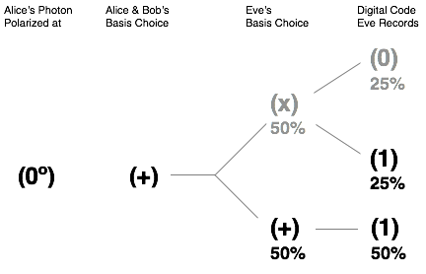

“Say Alice polarizes her photon at 0° and Bob correctly measures in the + basis. One hundred percent of the time, the photon will pass through his filter and he will record a digital code of 1. Eve, on the other hand, will correctly measure in the + basis only 50% of the time, but when she does, she will correctly guess digital code of 1 every time. However, on the occasions when she chooses the basis incorrectly, by chance, the photon will pass through her filter and she will record the correct digital code (1) one half of the time. One half of 50% is another 25%. Thus, Alice will guess the digital code (1) 75% of the time—50% of the time when she chooses the basis correctly and 25% when she doesn’t.”

Danny erased and rewrote some of the numbers and symbols in his diagram:

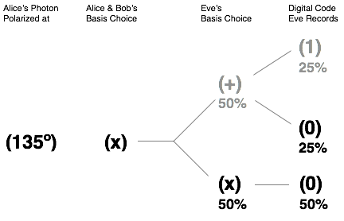

“Let’s take another example,” he said. “Say Alice polarizes her photon at 135° and Bob correctly measures in the X basis (set at 45°). One hundred percent of the time, the photon will fail to pass through his filter and he will record a digital code of 0. Eve, on the other hand, will correctly measure in the X basis only 50% of the time, but when she does, she will correctly guess the digital code of 0 every time. However, on the occasions when she chooses the basis incorrectly, by chance, the photon will not pass through her filter and she will record the correct digital code, 0, one half of the time. One half of 50% is another 25%. Thus, again, Alice will guess the correct digital code (0) 75% of the time.

“We could repeat the argument for photons polarized at 45° and 90°, but I hope you’ll trust me when I say that the result will be the same: Eve will guess correctly 75% of the time.

“So what are the chances that Eve will correctly guess the entire secret key? Well, it depends on how long the key is. If the key is one digit long then the chance of Eve guessing it is 75%. Two digits long and it’s (0.75) x (0.75) = (0.75)2 = 0.56 = 56%. Three digits and it’s lower: (0.75) x (0.75) x (0.75) = (0.75)3 = 0.42 or 42%.”

“I see a pattern here,” interjected Tenacce.

“That’s because there is one,” said Danny. “The formula to determine the likelihood that Eve will resolve the entire secret key (PE) is:

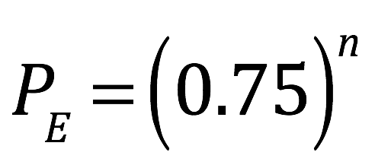

where n is the number of photons evaluated in which Alice and Bob use the same basis.

“If, for instance, Alice and Bob, use 48 photons for their key, then the chance that Eve will guess it is:

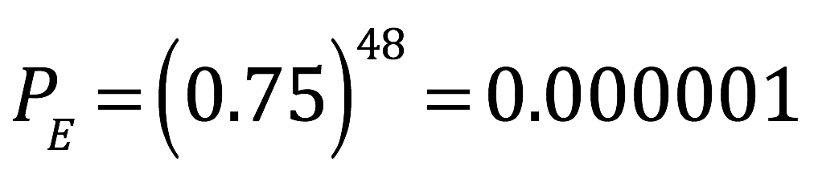

“That’s about a 1 in a million.

“Alice and Bob can also use such an analysis to tell whether someone is eavesdropping. What they would do is take a sample of data from the photons where they agreed on a basis. Theoretically, they should record the same digital code 100% of the time. Therefore, if they find any discrepancies at all, they know that someone is listening in. This is because discrepancies can only occur if Eve guesses wrong. An example of how this could happen is as follows:

“Alice sends out a 0° photon. Eve guesses wrong and uses an X filter. The photon hits the X filter in a fifty-fifty superimposition of the 45° and 135° states. Eve sets her filter at 45°. Then 50% of the time, the photon gets through, now polarized at 45° and gets to Bob. But Bob is using the + filter, so 50% of 50% (or 25%) of the time, he measures a 0 instead of a 1. If Eve weren’t there, Bob would measure 1 correctly 100% of the time. However, with Eve around, Bob gets 75% right and 25% wrong—same as Eve.

“Now, [the total number of photons Alice and Bob evaluate] = [the number of photons where Alice and Bob agree (A)] + [the number of photons where Alice and Bob disagree (D)]. To express this as probabilities, divide both sides by [the total number of photons evaluated]. Mathematically:

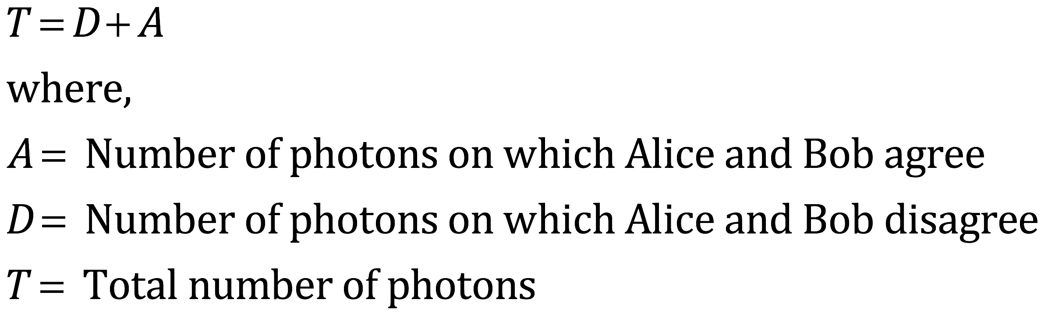

and

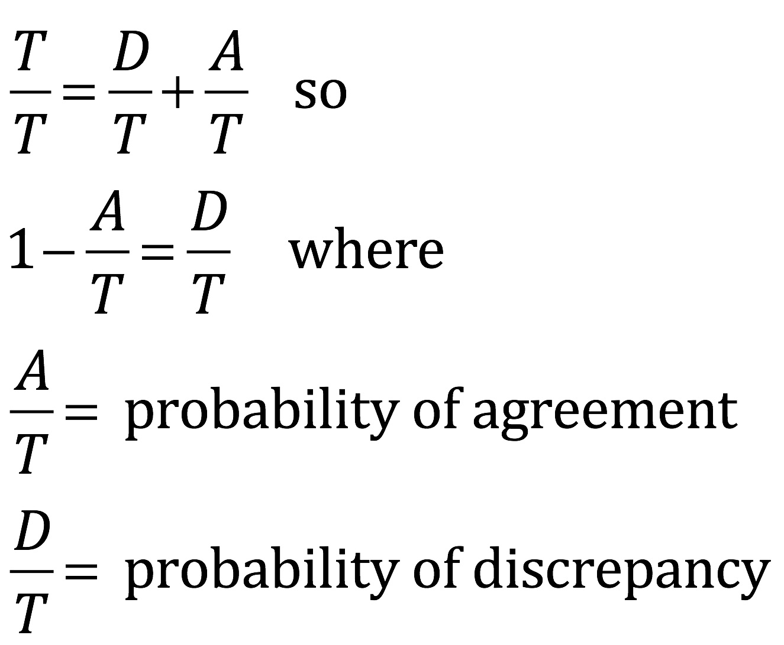

“It follows then that the probability of finding a discrepancy, and thus detecting the presence of Eve (), equals one minus the probability of agreement. But we already said, the probability of agreement between Alice and Bob when Eve is listening in equals the probability that Eve guesses right. And I already told you that that probability equals (0.75)n. Therefore:

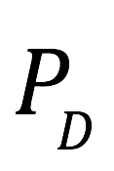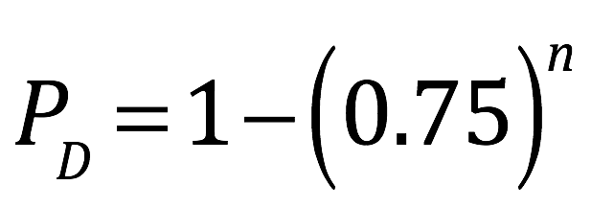

“So for example, if Alice and Bob wanted to make the probability of detecting Eve () = 0.999999, they’d use n = 48 (i.e., sample data on 48 of the photons in which they employed the same basis; recall that = 0.000001; 1 – 0.000001 = 0.999999). If they found discrepancies, then they’d know Eve was eavesdropping. If not, then they could be 99.9999% certain that Eve was not listening. If this degree of certainty were acceptable to them, then they’d use their data for a secret key (although they would throw out the 48 data points that they used to check for an eavesdropper since that analysis would have been done publicly).

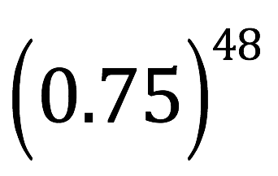

Tenacce scratched his facial stubble. “How is Bob gonna compare notes with Alice—or in this case, Mary—if Alice, or Mary, died two thousand years ago.”

“Maybe Mary left—more accurately, hid—her part of the information somewhere.”

“Probably did a pretty good job of it, too, judgin’ from our previous dealin’ with her. Next question. How is she gonna send us these photons, or entangled particles, or whatever, if she’s dead.”

Salito joined the conversation. “And why would most of the book be encrypted in one way, and the last section in another?”

Danny Tenacce shrugged. “These are all good questions. I don’t know. Actually, I’m not even sure if I’m dealing with quantum encryption. Or some type of superencryption. Or just a very long public key encryption code that would be impossible to crack without a quantum computer—which has yet to be invented. Either way, I need help. That’s why I contacted Rajiv Namboothiri.”

“You did what!” Tenacce was wild-eyed and standing now. “Whatta ya wanna do? Get us killed? These guys got ….”

Tenacce could feel Salito’s glare, the one instigated by memories of evading bullets in Central Park and crawling through raw sewage. His eyes focused on Salito as he restarted. “What I meant ta say was, these guys got a knack for trackin’ cellphones. Even burners.”

“Father Frank contacted him. Not by phone. By email.”

“And you don’t think that The Knights might be watchin’ and listenin’ ta him?”

“He’s a Brother. Remember? He’s got software that makes it impossible to trace the IP address from which he sends a message. We’re talking Tor on steroids.”

“Tor?” Tenacce stared blankly.

Salito explained. “Tor is a web browser used by people in the deep web that hides the location of your IP address by bouncing your message from server to server. The last server along the chain is where it looks like the message originated. I guess what Father Frank has must be better.”

“Father Frank made sure he used the same software to communicate back,” Danny reassured. “And no one has reason to suspect a connection between Raji and Father Frank anyway.”

Salito detected a characteristic twitch in Tenacce’s shoulder, a twitch that she knew meant that Tenacce was disturbed; disturbed not by her possession of knowledge, but rather, that knowledge existed that could be useful in solving a crime, and that he did not possess it. As always, he recovered quickly.

“Why da ya have ta know what the equation says? You already know the important part.”

“Because I want to understand it. All of it. Completely.”

Tenacce noted his resolve and altered his course. “Who is this Raja Nabootagarten anyway.”

Danny smiled at his father’s intentional mispronunciation. “He’s a friend from Princeton. A computer guy who specializes in quantum computing. A world authority, actually. And he’s harmless. The only thing he thinks about is quantum computing. And running. The guy’s come close to winning the New York marathon. Believe me, his only motive in coming here is to see if he can solve this quantum encryption problem.”

“He’s coming here!” Tenacce railed. He started forward. Salito stopped him.

There was a knock.

“Speak of the devil.”

“I hope not,” Tenacce muttered.

Danny opened the door. Frank DeAngelo ushered in a slight, bronze-skinned man that looked about seventeen, with thick, black-rimmed glasses and a crop of unkept black hair. He sported the Princeton uniform: kaki’s, a long-sleeve striped Polo shirt and brown loafers. Innocuous-looking is the word that Tenacce would have used to describe his initial assessment, if he had known it.

“Look who I found,” Father DeAngelo pronounced.

“Thanks, Father,” said Danny to DeAngelo. Then he turned to his friend. “Raji, thanks for coming.”

The little man responded with an utterance that, to Tenacce, sounded like his tongue had been tied into a knot. Danny Tenacce and Salito, however, appeared to understand. Danny made the necessary introductions. To Tenacce, the man’s limp handshake seemed to confirm his primary appraisal. A brief conversation about matters of little importance ensued; Danny had already discerned, from his previous email correspondences, that he had been suspended from Princeton and that he was regarded as a fugitive. The niceties ran their course in short order.

Danny Tenacce faced his former Princeton colleague. “Well, Raji, we’d better get going. We—or should I say, you—have got your work cut out for you.”

Danny started for the doorway. The little man reached for his suitcase.

Tenacce, who never trusted his initial impressions completely, slid past the arm Salito had extended to deter him. “Whoa, whoa! Not so fast. What’s in the bag?” Now he was walking toward the man and his valise.

Danny Tenacce and Salito began talking at Tenacce simultaneously.

“I just have some clothes and the necessary equipment,” the little man tootled, stepping back.

Father DeAngelo stopped the commotion. “I tossed him and searched the suitcase before he came down.”

“Does he have a weapon?”

“No Joe, no weapon,” Frank assured.

Tenacce halted his march.

Danny regarded them all with incredulity. “You frisked him? Come on, Raji.” Danny picked up the case and pulled his friend from the room.

All eyes were on Tenacce. Tenacce shook his head. “I don’t like it. We don’t know this guy from Adam.”

“Danny knows him,” Salito returned.

“Yeah, and love is blind.”

Salito opened her mouth to express her shock but there was no sound.

“Trust in the Lord, Joe,” said DeAngelo.

“You’re a priest. That’s what you always say.”

DeAngelo nodded in the affirmative with that serene, condescending, clergyman smile that tended to leave the salty law enforcement veteran annoyed.

“Yes, I do,” said the lanky priest as he ducked under the archway and closed the door behind him.