The Chevy sat in the descending darkness—lights out, engine on—at the side of the aging white house on Mercer Street.

“Why didn’t ya just call him and ask when he was gonna be home?” asked Salito, warming her hands in front of the heater. The swelter that had left them perspiring at two, in four hours, had morphed, implausibly, into a bony chill.

“Because he woulda come up with some excuse why he couldn’t see me.”

“Did ya ever think he might not wanna see ya because you clearly favor his older brother?”

“I’m sure that’s it.”

“Why *do* you favor his older brother?”

“Because he’s more my kinda guy.”

“You mean the macho tough-guy football player type?”

“Exactly.”

“Danny’s a martial arts expert, isn’t he?”

“I seen ballerinas who can do what he does.”

“I’m a martial artist and you don’t talk that way about me.”

“That’s ‘cause you can actually fight.”

“How do you know he can’t?”

“Probably ‘cause I know ‘im.”

“Is ability to fight how you judge a person?”

“One o’ the ways.”

“Your wife doesn’t fight and you have a high opinion of her.”

“She’s a woman. Besides, there’s lots o’ things she can do well.”

“Well, Danny’s a genius. You’ve admitted that yourself. Doesn’t that count for somethin’?”

“That’s another thing. A guy with a brain like his oughtta have the world at his feet. Instead, he lives in a shithole like this, barely makin’ ends meet.”

“Money ain’t everything, Joe.”

“Yeah, but what he does is totally useless. And I think he does it just ta piss me off. He talked about becomin’ a doctor for a while. I shoulda told him not to. Then he mighta done it.”

“There’s still time. How old is he anyway?”

“I don’t remember. Hey, here he comes.”

The Camry pulled under the carport. With briefcase under his arm, Danny Tenacce exited the vehicle and disappeared into the house.

“What a dump,” Tenacce growled as he and Salito stepped over branches and brushed through tall strings of grass that had grown up between cracks in the uneven sidewalk. “You’d think a guy would take a little more pride in his home than this.” Tenacce rapped on the door.

Danny Tenacce peered through the blinds, surprised that someone would be there. He was more astonished at who it was but opened the door anyway.

“What brings you to Princeton? And who is this?” He pointed at the woman standing next to his father.

“My partner, Jen Salito.”

Salito offered her hand and he accepted it.

“It’s a pleasure. I’ve heard many good things about you,” she said.

“I doubt you heard them from him.”

The elder Tenacce had already barged his way inside, and after looking at what he had done to the living room with disdain, made his way into the kitchen. Salito and Danny Tenacce followed.

“Since you brought your partner, I assume that this is business, but I can’t imagine what the issue could be. So please, don’t keep me in suspense.”

“Ok, I’ll get right to it. Do you know a guy named Allan Peterson, Professor o’ Archeology at NYU?

“Of course I know him. I took his course on cryptography, Cryptanalysis and Religion, as an elective while he was at Princeton. He’s the reason I went into Religious Cryptography.”

“Yeah, well he was the reason I left my party.”

“He was murdered?”

His father’s affirmation shocked Danny Tenacce into momentary silence. Then the reason for their visit dawned on him. “So you want to know about the email.”

“Bingo.”

“Well, on the second, I was in a hurry, trying to get my workout in and get to Brooklyn for dinner, so I never read it until the next day. I tried to call him back. He didn’t answer. Now I know why.”

“How many times did ya try?”

“To call him? I don’t know. Three or four, maybe.”

“Try seven. Why were you so interested in talkin’ ta him?”

“Because I hoped that he was contacting me to tell me that he had made a discovery that would help me with my research.”

“What was your relationship with Dr. Peterson?”

“What was our relationship? I was his student.”

“Was that all?”

“What do you mean, was that all? What are you asking me?”

“You know what I’m askin’ ya.”

“Hey, screw you, old man!” Danny bristled. He advanced his lean but muscular frame to within inches of his father, arms dangling loose but ready, standing straight to emphasize the fact that he was at least three inches taller.

At Danny’s last step in, Joe Tenacce threw his jab and followed it immediately with a straight right hand, both intended for Danny’s philtrum. However, Danny deflected the jab with a left outer knifehand block and caught the right with open hands, forearms crossed, right over left. He slid his right foot to the left, releasing his hold with the left hand, retaining his grip on Joe’s right wrist with his right. Then stepping to his left with this left foot, he swung his bent left forearm forward and hard, in unison with his torquing torso and hips, toward the back of Joe Tenacce’s extended right arm. When Salito saw the arm bar coming, she launched her body into the fray, flexing Joe Tenacce’s arm at the elbow, breaking Danny Tenacce’s right hand grip, propelling both combatants far enough apart for her to intercede.

“Whoa, easy,” she cried. Her outstretched arms pushed each of them back another step.

“Fuck you.” Danny Tenacce seethed. “We’re through. Get out. Either arrest me or get the fuck out!”

Salito looked at her partner. “I think he answered your question, Joe.”

“Yeah, well I got some more for ‘im.” Tenacce tossed a magnified photograph of the diagram Peterson had drawn on his abdomen as he was dying onto the kitchen table. “The guru from Harvard that the department experts thought was better than you—or at least who they heard of—he said that this blood drawin’ was a woman’s vagina. Maybe you can do better. Then again, maybe not.”

Danny Tenacce looked at the picture. “It’s a pleric pentambiagram.”

“Say what?” Tenacce exclaimed.

“A pler-ic pent-am-bia-gram.”

“I got that but what’s it for?”

“It specifies two vectors which, when operated upon by predetermined matrices, are transformed into two new vectors.” The two cops stared at him vacuously. “The bottom line is, Peterson was trying to specify a location.”

Tenacce seemed irked. “Why didn’t the supposed expert at Harvard know about this?”

“Probably because he was an art major.”

“Can ya tell us more about this pleric pentambiagram?” asked Salito.

“It was supposedly used by a group called The Brotherhood of Trigh to encrypt locations of meeting places, hiding places and such.”

Danny Tenacce saw the incredulous expression on the face of the two detectives and shrugged. “That’s the way the legend goes, anyway.”

“You mean you heard o’ this Brotherhood o’—”

“Trigh. Yes. They’re an active focus of my research.”

Joe Tenacce had difficulty restraining his elation. “Whatta ya know about this group?”

“There’s been some stuff written … alternate interpretations of history ….” Danny Tenacce was dancing now, buying time, attempting to formulate a message that would sound believable. “Legend has it that the relationship between Jesus Christ and Mary Magdalene was .... special. Some authors have claimed that they may have even been married and had children.”

Tenacce contorted his face like he had just bitten into the rotten part of an apple. “Not that crap again.”

“I know. I have a difficult time buying that one, too. However, a small portion of a document supposedly written by Mary Magdalene indicates that Christ may have told her things that he didn’t talk about with the other disciples and that the disciples may have resented it. This and other sources have led to speculation that she wrote a much more elaborate text, a text that contains unfathomable secrets. The precise nature of these secrets is uncertain but they’re believed to constitute proof regarding Jesus’ divinity, or lack thereof. Most scholars believe that Magdalene’s book proves the latter.

Tenacce shifted restlessly. “What does all this got ta do with The Brotherhood?”

“There are two major theories regarding Christ’s relationship with Mary Magdalene and the nature of the book. I alluded to the most popular of these a moment ago: namely, that Magdalene and Christ were married. The theory asserts that Mary was pregnant with a child at the time of the crucifixion, escaped to France and gave rise to a lineage, the Merovingian dynasty, a line of kings that ruled significant portions of France from c. 457 to c. 754. It states that Magdalene left a document, buried under the ruins of the Temple in Jerusalem, that reveals details of her relationship with, and the mortal nature of, Christ. Per this theory, Christ’s status was elevated to that of a deity, by the Catholic Church, only after the First Council of Nicaea, in c. 325. It also states that a descendant of Mary Magdalene, King Godefroi de Bouillon of Jerusalem, founded a group called the Priory of Sion. The Priory commissioned a military arm, the Knights of Templar to retrieve the document, which they did during the First Crusade. They re-hid the document, moving it multiple times over the ages. The document’s location today is unknown, but speculation has it that its current resting place is somewhere in the United Kingdom. At any rate, with it in their possession, The Knights became immensely powerful, holding – as you can imagine – considerable leverage over the Catholic Church. In addition, King Philip IV of France was in considerable debt to The Knights. Wishing to extricate themselves from their compromised positions, the church and King Phillip banded together in the early 1300’s, persecuting The Knights, forcing false confessions with torture and such, until Pope Clement V disbanded The Knights in 1312. However, the Priory of Sion is believed to still exist – under deep cover – possessing the document and guarding its secret. The evidence supporting this theory is, in my estimation, flimsy, depending largely on cryptic symbols in art and such, especially in the work of Leonardo da Vinci. The theory makes no mention of The Brotherhood of Trigh, thus, is of little interest in this case.

“On the other hand, the second theory *is* pertinent to this case. According to this theory, the life, death and resurrection of Jesus Christ was a colossal con, orchestrated by a clandestine cult to save a civilization that they were convinced was on a collision course with oblivion. The cult was so secretive that, as far as is known, they had no name, or if they did, it has never been revealed. For the purposes of this discourse, I’ll call them The Group.

“All of the major players in the Christian story – Mary, Joseph, Mary Magdalene, selected disciples, even Christ himself – were involved. The Group was said to have possessed technology and skill far ahead of their time. How it came to acquire these capabilities is the subject of considerable conjecture – often wild conjecture – a troupe of genetic mutants, extraterrestrials and the like. But the use of these capabilities was crucial to the execution of its scheme.

“The theory purports that Mary was artificially inseminated while a second woman served as a surrogate for Jesus’ identical twin. The other woman’s twin was groomed – brainwashed would have been a more apt term – to be the pre-resurrection Jesus and the other twin was raised, initially, by Mary and Joseph. They were switched at age twelve. You know the story from there: at thirty, pre-resurrection Jesus began his ministry. The disciples and Mary Magdalene were instrumental in perpetrating the scam: staging ‘miracles,’ spreading propaganda, communicating with the leadership of The Group, etc. However, their greatest feat was the staging of the resurrection. This was accomplished by simulating an earthquake (how this was accomplished is unknown). The guards charged with securing the tomb left their post during the commotion and Jesus’s body was removed. Then enter the resurrected Jesus, that is, the twin whose indoctrination for the role began at the time of the switch. He put the finishing touches on the ruse.

“Now The Group communicated in encrypted documents. Mary Magdalene was the keeper of those documents. In addition, she wrote her own account of the affair and collated the entire collection into a book. A disgruntled member of The Group informed the Jews of the scam and told them about the book. The Jews and Romans, desiring to destroy the Christian movement, sought the book to corroborate the informant’s story. Mary Magdalene caught wind of this, buried the book, and she, the Christ twin and their followers fled to what is now the south coast of France. There, it is said, Mary and Christ’s twin married and established a lineage, as suggested in the more popular theory on the matter I described earlier.

“As in the first theory, the second theory states that, in the early portion of the second millennium, the descendants of Mary Magdalene enlisted the help of the Knights Templar in retrieving the book. And as in the first theory, The Knights did, indeed, find it, in the ruins of the Temple. However, in contrast to the first theory, the second theory asserts that The Knights who accomplished the task were hunted down and killed. However, before they were captured, they hid the book, somewhere in Israel. And because all of the Knights who went on that expedition died, knowledge of the book’s location died with them. They hid it well; the book has never been found to this day.”

Danny Tenacce paused for dramatic effect. Joe Tenacce toyed with the idea of telling him about Peterson’s discovery, but sensing that his son had more to divulge, he kept it to himself.

“So let me ask ya again: where does The Brotherhood of Trigh fit inta all this?”

“The Brotherhood fits in as follows: as I’ve discussed, King Phillip IV of France and Pope Clement V united against The Knight culminating in their dissolution. Toward this end, the Catholic Church and King Phillip employed the aid of a group of knights. Their name? The Brotherhood of Trigh.

“The Knights were disbanded, but there were a few holdouts, the residua of The Group, who became synonymous with The Knights of Templar and carried on their mission, attempting to find the book. It’s said that they survived and still operate, in secret, today. The motive of their quest, in present times, is uncertain. Some have claimed that they seek the book to destroy it, thus suppressing evidence that would upend Christianity. Others state that the goal of The Knights is to recover the book and keep it hidden, as a memento to honor their legacy.

“The Brotherhood of Trigh is also said to still be active, also clandestinely, in current times. They also seek the book. Their nature and purpose, however, are more of an enigma. Some say that they are in league with the Catholic Church and endeavor to find the book and destroy it to eliminate evidence that would be damaging to the church. Others believe that The Brotherhood had a falling-out with the church; that their current agenda is to find the book and publish it to debunk what they believe is the Christian myth.”

Salito had been listening in silence, listening like a lidded pot on a hot oven. At hearing those final proclamations, she could contain her revulsion no longer. “That’s a horrible story,” she exclaimed.

“If ya ask me, the first one is pretty horrible, too,” said Tenacce.

“Sometimes the truth is horrible,” Danny stated, without emotion.

“Who says it’s the truth,” said Tenacce. “Do ya have any proof?”

“Allan Peterson does … did.”

“Like what?”

“Like the papyruses he found. Several were fragments that just alluded to the existence of The Group. However, two described the operations of The Group in significant detail.

“The first of these was discovered in the late seventies, in southern France, and dated to around the eleventh century by carbon 14. The author identifies himself as a Brother of Trigh, indicates that his charge is tracking down Templar Knights and describes some of the encryption techniques uses by The Knights as well as some of their own techniques. One of them was the pleric pentambiagram.”

“Why was The Brotherhood usin’ encryption?

“To hide from The Knights.

“And The Knights?”

“To hide from The Brotherhood. And to conceal the content of documents. Like Mary’s book. It’s believed that the book is encrypted.”

“Why would one of The Brothers write such a document?”

Danny shrugged. “A manual of techniques, perhaps.”

Tenacce paused briefly to finish transcribing what he had heard, then continued. “What other evidence ya got?”

“Another papyrus, found near Jerusalem in the late eighties, dated by carbon 14 to around the first century AD. It includes a description of some of the techniques outlined in the document found later in south France, including a reference to the pleric pentambiagram.”

“If the goal o’ The Knights and The Brotherhood is ta find the book, what are they? A bunch o’ archeologists?

“Archeologists, cryptographers, doctors, lawyers, politicians, teachers, factory workers …. You name it. Both groups are said to have infiltrated all aspects of society.”

“Cryptographers? Are you one of ‘em?” Tenacce smirked.

“Don’t be absurd.”

Tenacce continued to smile sardonically. “Well, if they’re everywhere, like you say, how come nobody knows about ‘em?”

“Because they’re good at hiding.”

“Where did *you* find out about ‘em?”

“Allan Peterson.”

“And how did ya say you knew him?”

“Are we back to that again?”

“That’s right, you took his course. Was he one of ‘em?”

“He never said he was. But sometimes I wondered.”

“Is that where ya came across this cleric pentagram … ?” Tenacce waved his hands, as if it might make the right words come out.

“Pleric pentambiagram? Yes. In that cryptanalysis course I took from him, I was the only person who ever got to the extra credit problems on his problem sets. One of the problems was about The Brotherhood. It was the pleric pentambiagram problem. I was the only one who ever solved it. He called me to his office to congratulate me. I asked about The Brotherhood. He told me.”

“Did he lecture about The Brotherhood in your class or other classes?”

“Not in the course I took or in other ones that I know of. The only time I came across any reference to them, where Peterson was concerned, was in the depths of that problem set and in his office that day.”

Tenacce raised his skeptical brows. “So you were the only one he ever told?”

“I don’t know who else he discussed this stuff with.”

“Did Peterson tell ya about the other papyrus, too?”

“More like I told him.”

“How’s that?”

“The document was encrypted. He and the team he had assembled were unable to decipher it. He called me. I was a disgruntled third year PhD candidate in physics, uncertain about what to do for my thesis. I deciphered the papyrus, developing a newer, faster algorithm for factoring prime numbers along the way. I used that algorithm for my PhD thesis in mathematics. It was the event that caused me to leave physics and pursue a career in a new academic discipline, a discipline that I created.”

Tenacce exhaled in a manner that plainly displayed his disgust.

“But why was the papyrus encrypted?” Salito asked.

“The papyrus was essentially a manual of covert techniques used by The Brotherhood. Presumably, it was encrypted to prevent enemies from gaining knowledge of those techniques.”

“More important,” said Tenacce, “if Mary’s book was about how Christianity is a scam, why would it be encrypted? If she wrote that book ta expose the scam, ya’d think far from encryptin’ it, she woulda wanted ta make her message as clear as possible. And if she wanted ta hide the secret, why would she have written the book in the first place?”

“Furthermore, if the book contained evidence that Jesus was God,” reasoned Salito out loud, “you wouldn’t think she’d wanna encrypt it; she woulda wanted ta tell it to the world.”

“Maybe the book contained some other secret.”

“Like Jesus was married and had kids?”

“Or maybe there’s no book at all.”

“Confusing,” commented Salito.

Danny Tenacce sighed. “Tell me about it.”

“So do ya think you can figure out what location Peterson may have been tryin’ ta tell us about?” Salito asked.

“I need to boot my laptop. Give me a minute.”

He flipped the top and pushed a button. The computer’s screen illuminated and the familiar buzz ensued. There was a silence that lingered to the point of discomfort.

“So I hear you’re a martial artist,” said Salito finally.

“I do a little martial arts,” Danny replied.

Salito pointed to what should have been the living room. “Looks like more than a little. That’s quite a setup ya got in there. What style?”

“Taekwondo and hapkido,” he said, drumming his fingers on the table.

“I’ve done taekwondo and jiu jitsu. It’s good stuff.”

“Yes, it’s a good workout. Keeps me busy. Ah, it’s up,” said Danny Tenacce thankfully, tapping adroitly on the laptop’s keyboard.

“I gave a lecture on this once. It wasn’t very well received. Maybe I can do better with you. The figure Peterson was attempting to draw was a circle:

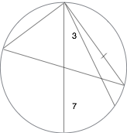

“So the little squigglies next to the lines were numbers,” Salito exclaimed.

“Yes. Written in Hebrew. The symbol to the right of the straight up and down diameter line stands for 7. The squiggle next to the left of the second right-most line means 3. Because it’s written next to the upper half of the line, it means -3. If it had been written next to the lower half of the line, it would have meant +3. A number to the left of a diagonal or vertical line, or below a horizontal line, specifies a multiplication factor; the meaning of this will become evident later. A number to the right of a vertical or diagonal diameter line, or above a horizontal diameter line, tells you into how many equal pieces you should divide the circle. In this case, the 7 indicates that the circle should be divided into seven equal parts, like so:

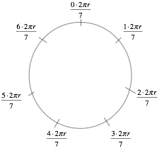

“If you were to start at the top and walk around the entire circle—that is, travel around its circumference—the distance you would have traveled would be given by 2 times π (which equals about 3.14159) times the radius of the circle (which is half the diameter). In mathematical terms, circumference equals 2πr. Now divide the circle into seven equal parts with tick marks. The distance between each tick mark is one seventh of the whole circumference, which is 2πr. The distance from the top of the circle, labeled 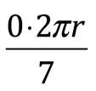, to the first tick mark equals one-seventh the circumference of the circle:  times 2πr, or 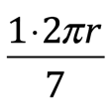. The distance from the top of the circle to the second tick mark is  times 2πr, or 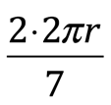, and so on. That gives us integer multiples of 2 multiplying . In such cases, The Brotherhood’s protocol dictates that each tick mark should further be divided in half. The result of such further manipulation would look like this:

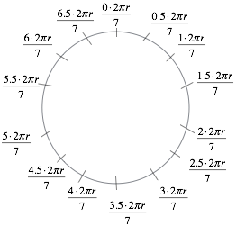

“Simplifying the expressions by multiplying the top numbers together, you get:

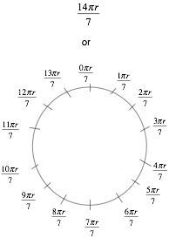

“Note that the tick mark at the top can be labeled either 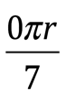 or 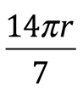, depending on whether you’re at the beginning or end of your journey, respectively. Now disregard the  part:

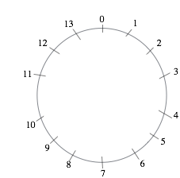

“Next, put the lines back in. The a, b, c and d are just labels that I’ve put in so I can refer to them in my discussion:

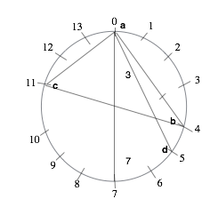

“The lines inside the circle are there to specify vectors. The line with the perpendicular tick mark through it (on the right-hand side in this case) is always the line you start with and you always start at zero. Line segments **ab** and **bc** together specify one vector and line segments **ca** and **ad** together specify another. This is how it works:

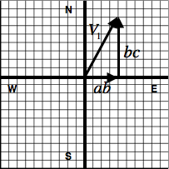

“The end of the line from **a** to **b** on the circle is on the fourth tick mark, traveling clockwise from the top, at zero. This is telling us to go 4 units east. In the diagram above, it corresponds to the the vector **ab**, which extends 4 units to the right, toward the east, from the origin.”

“Units? You mean units of length?” Salito inquired.

“Yes.”

“What units are we talkin’ about? Inches? Feet? Miles?”

“He doesn’t specify. Normally, there would be a symbol adjacent to a diameter line to indicate the units. There’s no such symbol in this case. We’ll have to see what the final vectors add up to then attach the units that make the most sense.”

Salito seemed satisfied.

Danny Tenacce turned back to his computer. “The end of the line from **b** to **c** is on the eleventh tick mark. You need to go seven units around the circle to get there from the fourth tick mark. This is telling you to travel seven units north (the second line of a pair always tells you how far to go in the north-south direction; the first line of a pair tells you how far east or west to travel). Anyway, this corresponds to the vector **bc** on the diagram above. To add two vectors together, you place them end-to-end. Vector **ab** added to vector **bc** yields vector, .

“Let’s move on to the second set of line segments and their corresponding graph:

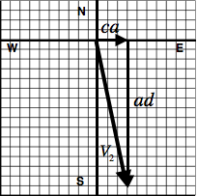

“The end of the line segment **ca** is at 14, which, as discussed previously, refers to the same point as 0. To get there, you have to travel 3 units around the circle from the eleventh tick mark. This means ‘travel 3 units east’ and corresponds to the vector, **ca**, on the graph. The next segment, **ad**, is a little different. Its end is on the fifth tick mark. To get there from 0 (i.e. the end of line segment **ca**), you have to travel 5 units. But there’s a 3 to the left of the upper half of line segment **ad**. This means that you should multiply the number of units you traveled around the circumference of the circle from **a** to **d**, in this case 5, by -3. 5 x -3 = -15. This is telling us to go 15 units in a direction opposite to north, better known as south. This is represented on the graph by the downward (or southward-pointing) vector, **ad**. Like on the other graph, the eastward-directed vector, **ca**, and the southward-directed vector, **ad**, add together to form the resultant southeast-pointing vector, .

“So you might think that you just add vectors  and  to find the location that the creator of the diagram intended to specify.”

Tenacce sighed anxiously. “You mean that’s not what happens?”

Joe Tenacce’s irritation pleased Danny. He spoke more slowly. “Unfortunately not. That would be too easy for an adversary to decode. Instead, the  and  vectors are modified by linear operators.”

“Linear operators?” Salito was confused but interested.

“Yes, the vectors are multiplied together with matrices to yield the vectors, that when added together, specify the desired location. As will become evident in a minute, the matrices used in defining a location are like a secret key. They’re agreed upon between two communicating parties beforehand and, back in the day, were varied on an irregular schedule to provide maximum security. If the parties involved have had no previous communication, as in our case, then the default matrices to be used are what, today, are known as Pauli matrices. They are named after a twentieth century physicist, however, they were actually developed and used by The Brotherhood two thousand years earlier. To understand how they work, I need to give you a crash course on matrix multiplication.”

Tenacce could contain his frustration no longer. “Linear operators. Matrices. Can ya just get ta the point?”

“For cryin’ out loud,” Salito scolded, “let the guy finish.”

“Thank you. Where was I. Oh yeah, matrices.” He turned to Tenacce. “Let me give you the short version.

“The Pauli matrices I’m going to describe are collections of four numbers. In quantum mechanics, they act on the spin states of particles such as electrons or protons to produce new spin states. In our case, here, they mix up the components of the  and vectors to produce new vectors and confuse an enemy.

“The sigma 1 matrix, , is the matrix by which we’re going to multiply .It’s given by 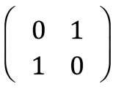. The sigma 3 matrix, , is the matrix by which we’re going to multiply . It’s given by 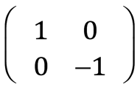. Our vectors are represented like this: 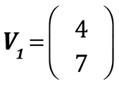; 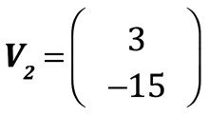. The x or east-west component of the vector is displayed on the top; the y or north-south component of the vector goes on the bottom. Multiplication is done as follows:

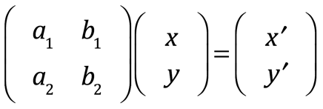

means

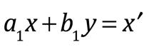

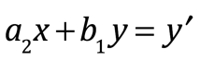

You can picture it as follows: flip the x-y values from vertical to horizontal, multiply it by the matrix element underneath, then add the two products together. That should give you new values for x and y, labeled  and  in the equations above. You do that first for the first row, then for the second.

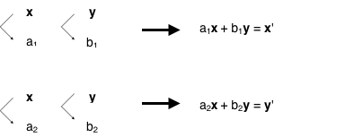

“In our case, for :

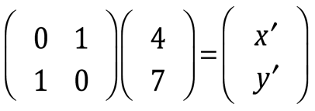

That translates to





Therefore,





So the  matrix transforms the vector from 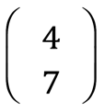 to 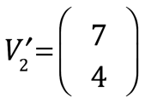.

“For :

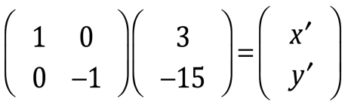

and

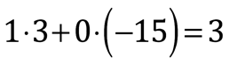

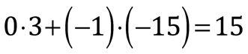





The  matrix transforms the vector from 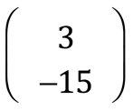 to  = 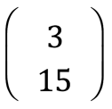.

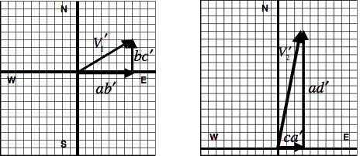

“The new vectors,  and , are what you’ve got to add together to figure out where Alton Peterson was trying to send you.”

“So let’s do it,” Tenacce demanded.

Danny Tenacce produced two additional diagrams on his laptop screen:

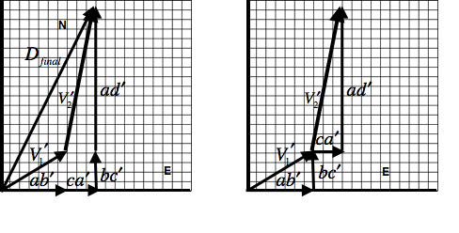

“You can see from the graphs that you can add the new vectors either by adding their components end-to-end or by laying them end-to-end. Either way, you come out with ten units east and nineteen units north.”

Tenacce emitted an irascible frown. “What I can see is why these guys were so hard ta find.”

“So I guess now we gotta pick a starting point and see where we wind up ta figure out the units,” stated Salito, ignoring her partner.

“True.”

“Let’s start at the murder scene,” Tenacce said. “Where does that put us?”

Danny clicked at his computer keys for several seconds.

“Well, if we use miles as our units, we’d end up at a golf course in Scarsdale.”

“And if we use blocks?”

“At a Nightclub in Harlem.”

“Any Banks around?”

“Not within five blocks.”

“How about startin’ from his office at NYU. Where does that wind up?”

“In the East River.”

“This ain’t gettin’ us nowhere,” groused Tenacce.

“Let’s start at the Third Precinct,” offered Danny.

“Why would we do that?”

“Because, hopefully, it’ll put us in an area that has a lot of banks.”

“What help is that gonna be. There’s a bank on every corner in Manhattan.”

“Just humor me.”

“I ain’t in the mood for no jokes.”

Salito could sense Tenacce’s exasperation building. “Where does the path end if we start at the precinct?” she asked calmly.

“At an office building on the Upper East Side.”

“Any banks nearby?”

More clicking.

“Eight.”

“Can ya tell if any of ‘em have safety deposit boxes?” Tenacce inquired impatiently.

The younger Tenacce worked on his computer again.

“Three.”

“What bank is closest ta the location that the diagram specified?” Salito asked.

“Bank of Manhattan.”

Tenacce interrupted. “How far?”

“Less than a block.”

“And is it one o’ the one’s that has safety deposit boxes?”

“… Yes.”

“What are the others?”

“Citibank and Bank of America.”

Tenacce recorded the last of the information that Danny had provided then placed the pocket-sized pad and pen back into his jacket. He gathered up the photograph and began walking toward the door.

Salito called after her partner. “Isn’t there something you wanna tell your son, Joe?”

“Yeah, tell him he’s lucky you were here or he woulda got his ass kicked.”

Tenacce bolted through the door leaving a blast of cold air in his wake. Salito smiled apologetically at Danny Tenacce and followed. Tenacce started the car and fumbled with the heat. There was silence until Salito broke it.

“What’s wrong with you?”

“Nothin’,” Tenacce grumbled.

“I mean, ya took a swing at your own son.”

“He deserved it.”

“Like hell. He gave us the biggest lead we got in this case so far. The least ya coulda done was say thank you.”

“We ain’t got nothin’ yet. We don’t know if there’s a box buried in a golf course or in a bank. If it’s in a bank, we’re not sure which bank ta go to. We don’t know which box the key’ll open or if it’ll open any box at all. And we got no idea what’s in that box if we open it. Peterson may have been leavin’ a love charm as a partin’ gift for his boyfriend, for all we know.”

“You’re brutal.”

“Yeah, and I’m also lost. See if you can fire up that GPS thing and get us back ta Manhattan, will ya?”