Tenacce, Salito and McCleary sat silently around the long wooden table as the staff that had been chosen to assist them laid trays full of food before them. The sight of Danny Tenacce—bright-eyed, showered, shaved—entering the room was a surprise to them all. He took the seat that had been reserved for him, but which had remained empty since their arrival, and placed the paper he had been carrying on the empty placemat in front of him. The optimism that permeated the room at the sight of the paper was almost palpable.

“Any luck with the papyrus?” Joe Tenacce cautiously inquired.

“Luck—no. Success—yes.”

“So what does it say?”

“What do you want first: the good news or the bad news?”

Salito was quick to respond. “The good news. We haven’t had much o’ that around here lately.”

“I was able to decipher part of the papyrus.”

McCleary’s eyes widened. “How did you do that?”

“By listening to the sounds.”

Three pairs of perplexed eyes pierced Danny Tenacce simultaneously. Tenacce vocalized their consternation.

“Just like the poem said. But it don’t make no more sense ta us now than it did when we first heard it.”

“All the hours I spent waiting for algorithms to run. Lying there, listening to nothing but the monotonous drone of those computers. Then it dawned on me. Not that that sound was the answer, but it made me realize what those enigmatic words about voices and songs were urging me to consider.”

“And what was that?”

“Acoustic cryptanalysis. The coils and capacitors on a computer’s motherboard emit low amplitude high frequency sound while it’s working, not audible to the human ear but detectible nonetheless. Different CPU operations emit characteristic configurations of sound or acoustic spectral signatures. Operations carrying out RSA encryption that use specific secret keys give off unique acoustic spectra, unique spectra that can identify the key. I ran a few trials of RSA encryption with different keys that I made up and looked for a pattern. When I found some, I listened to the sounds that the computer was making when it tried to decrypt the key from the papyrus. Not me, per se. I didn’t listen. I wrote a program so that the computer would listen to its own ultrasonic emissions. And as you would say, Pop—Bingo!”

Tenacce shook his head. When he recovered from his admiration and disbelief, he turned back to Danny with a frown. “You said you deciphered *part* o’ the message.”

“That’s the bad news. The part of the message I decrypted says that I need another key to decipher the rest of the papyrus.”

“You gotta be kiddin’ me.”

“Good Lord,” McCleary added.

“It gets worse.”

“How could it.”

“The key that needs to be decrypted to read the papyrus is a 256-bit key.”

“What’s so bad about that? Ya just cracked one 2048 bits long.”

“There’s only one number.”

The realization engendered by the words wiped the ubiquitous smile from McCleary’s face. “It’s a symmetric key.”

“Which means what?”

“You want the mathematical explanation?”

“Might as well.”

“A symmetric key is just a long number which, when multiplied by the number representing the plaintext—or message—yields the encrypted message or ciphertext. Problem is, there are no end-arounds with a symmetric key. The only way to decrypt it, at least in this case, is by brute force.”

“How long?”

Anticipating their curiosity, Danny had already calculated the numbers and written them down. He held up his paper for emphasis.

“Let’s see. A 256-bit key means combinations,  FLOPs per combination,  FLOPs per second per computer, computers. That’s …” He strolled over to the whiteboard in the dining room that had yet to be used and uncapped the marker that rested on its ledge. “Here, let me write it out for you:”

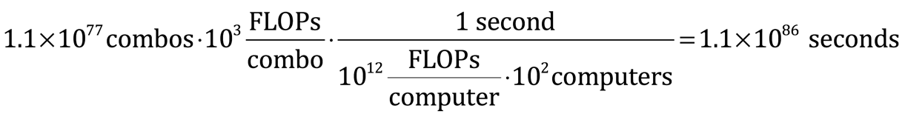

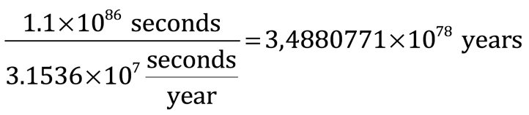

“Basically, a lot longer than we have.”

“So what’s your strategy,” asked Salito.

“I don’t have one. Start grinding and … I don’t know. Blind luck is probably my best chance.”

“Or fate,” chimed McCleary.

He locked eyes with the large priest as he folded his paper. McCleary started at him again but Danny cut him short.

“Yeah, I know, Father. You’ll pray for me.”

Danny Tenacce placed his marker on the easel of the whiteboard and exited the room without eating.